

ALY6130 - Risk Management Analytics
Module 4: Risk Assessment

Quantitative Risk Assessment Using Indicators & Warning (I&W) Analysis
ServiceNow-Armis Acquisition: Competitive Risk Assessment
ALY 6130 Enterprise Risk Analytics | Group 4 | March 2026
Group 4: Adwoa Bempomaa, Sara Mathai, Lawrence Dass
Northeastern University Vancouver | College of Professional Studies

Date: 18th March 2026

1. Introduction and Method Selection Rationale
This report quantitatively assesses three competitive risks identified in ServiceNow's $7.75 billion acquisition of Armis using the Indicators and Warning (I&W) analysis technique. The I&W framework was selected because it translates qualitative risk assessments into measurable Key Risk Indicators (KRIs) with quantitative Green/Amber/Red thresholds, enabling continuous monitoring and early warning detection (Jalilvand & Moorthy, 2023).
Why I&W Analysis: The I&W technique is particularly appropriate for competitive risks because it establishes leading indicators that signal risk escalation before financial impacts materialize. This approach aligns with the Decision Tree Analysis principle where Expected Value = Probability of Occurrence × Impact (MindTools, 2024). The I&W framework is complemented by Monte Carlo simulation (10,000 iterations) to model uncertainty and Random Forest machine learning (trained on 500 synthetic observations) to predict risk escalation patterns. The three risks assessed in this analysis are consistent with the high-priority risks identified in the Module 3 Risk Assessment, ensuring continuity between qualitative and quantitative evaluation.

2. I&W Framework Implementation Steps
Step 1: Define Key Risk Indicators (KRIs) with Thresholds
Each risk was assigned a leading indicator metric with Green/Amber/Red thresholds based on their causal relationship to risk outcomes. These thresholds were set as management action thresholds to distinguish normal variation from early warning conditions that would require intervention:
Risk | KRI Metric | Green | Amber | Red
Risk 1: Competitive Displacement | Win Rate in OT/IoT Deals | >35% | 25-35% | <25%
Risk 2: AI Platform Convergence | AI Capability Gap Index | ≥85% | 70-84% | <70%
Risk 3: Regulatory Tailwinds (+) | Pipeline Growth Rate QoQ | >25% | 10-25% | <10%
Table 1: I&W Framework KRI Thresholds
Step 2: Establish Probability and Impact Parameters
Probability of occurrence was derived from likelihood scores in the risk register. Because the course likelihood scale is ordinal, each score was converted to an approximate occurrence probability by dividing by 10 for scenario modeling purposes (Score 7 = 70%, Score 9 = 90%). Financial impacts were modeled using triangular distributions with the $1B Security and Risk ACV as exposure base. Triangular distributions were selected because they are appropriate for expert-driven scenarios where minimum, most likely, and maximum values can be reasonably estimated despite limited historical data.
Parameter | Risk 1 | Risk 2 | Risk 3
Probability of Occurrence | 70% | 70% | 90%
Impact (Min / Mode / Max) | 3% / 10% / 15% | 4% / 12% / 20% | $60M/$250M/$350M
Table 2: Monte Carlo Simulation Parameters
Step 3: Execute Monte Carlo Simulation
The simulation (10,000 iterations, seed=42) follows a two-stage process: (1) determine if each risk occurs based on probability, (2) if it occurs, sample from the triangular impact distribution; otherwise impact = $0. This correctly implements Expected Value = Probability × Impact.

3. Quantitative Assessment Results
Metric | Value | Interpretation
Risk 1 Expected Loss (Competitive) | $66.2M | Probability-weighted
Risk 2 Expected Loss (AI Convergence) | $83.0M | Probability-weighted
Risk 3 Expected Upside (Regulatory) | +$199.0M | Probability-weighted
Net Expected Annual Impact | +$49.8M | Moderately positive
90% Simulation Interval (5th-95th %ile) | -$167M to +$231M | Wide uncertainty
Probability of Net Loss | 31.1% | Significant tail risk
Current KRI Status (Portfolio) | AMBER | Elevated monitoring
Table 3: Monte Carlo Simulation Results (n=10,000, seed=42)

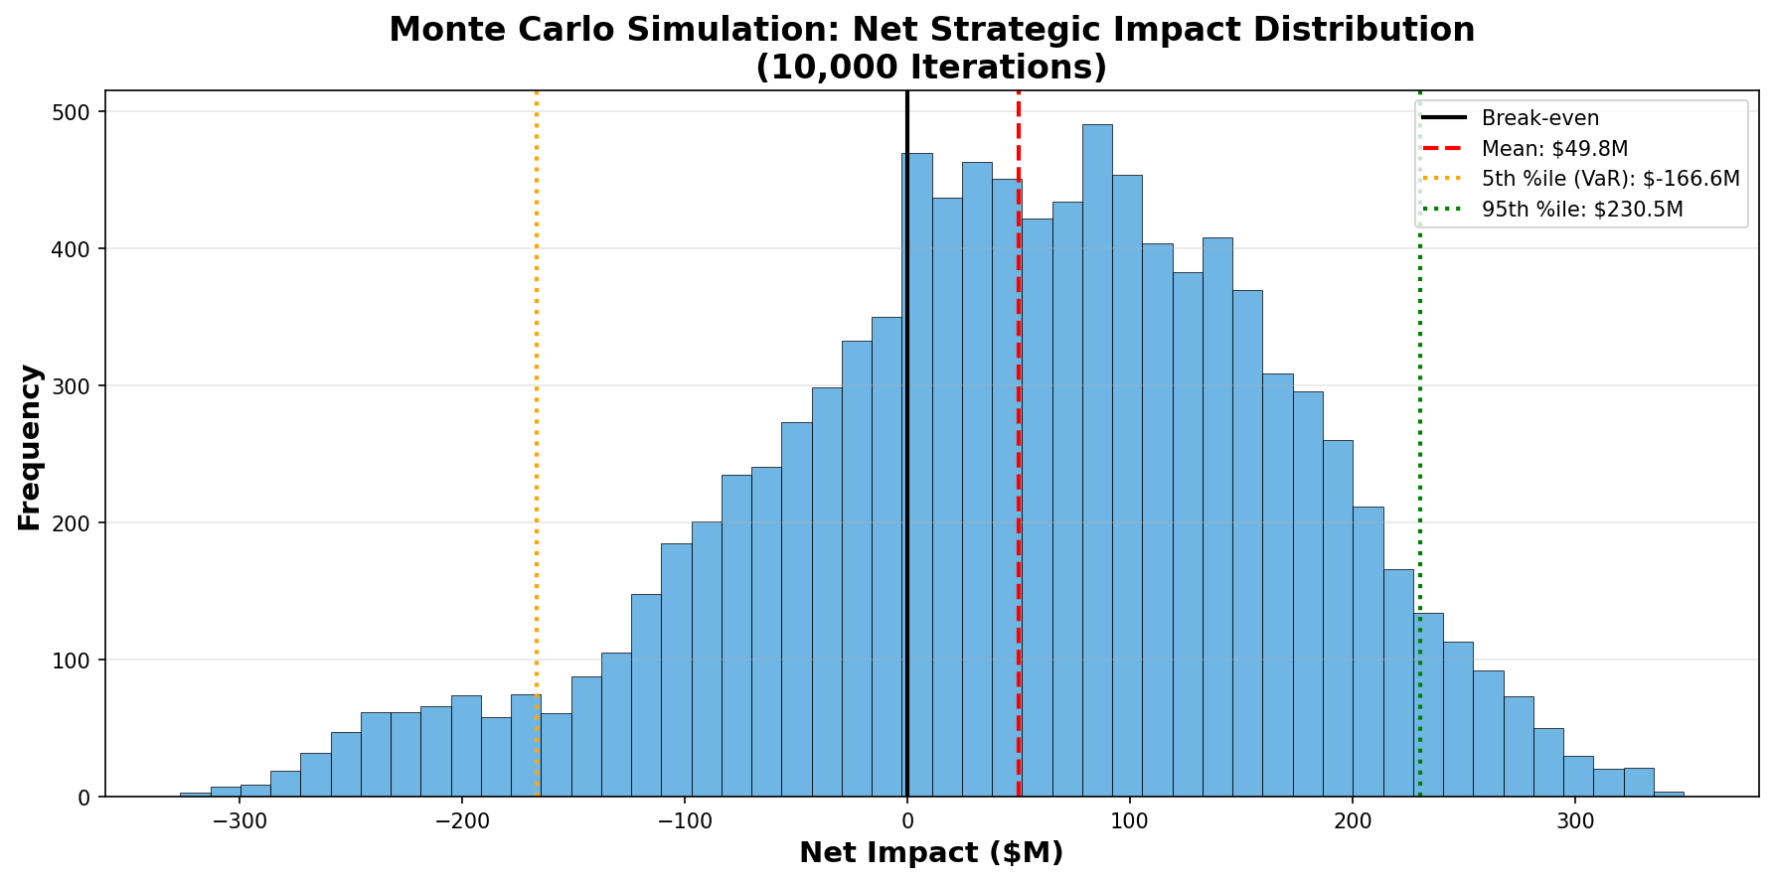
Figure 1: Monte Carlo Net Impact Distribution (Mean: +$49.8M, 90% Interval: -$167M to +$231M)
Figure 1 illustrates the net strategic impact distribution across 10,000 simulations. While the mean outcome is positive (+$49.8M), the distribution spans a wide range with material downside tail risk, as shown by the 31.1% probability of net loss. Based on these quantitative results, the Risk Treatment (RT) and Response Plan (RP) were updated with: (1) Monte Carlo simulation outputs including expected value and 5th/95th percentile ranges for each risk; (2) Machine Learning escalation probability from the Random Forest classifier; and (3) escalation triggers and monitoring actions aligned to the I&W framework.

4. Machine Learning Risk Escalation Model
A Random Forest classifier trained on 500 synthetic scenario-based KRI observations achieved approximately 89.6% mean cross-validation accuracy in predicting risk escalation. Feature importance analysis (Figure 2) showed that competitive win rate (31.2%) and AI capability parity (29.2%) were the strongest predictors, followed by regulatory pipeline growth (15.6%) and competitor presence (9.3%).
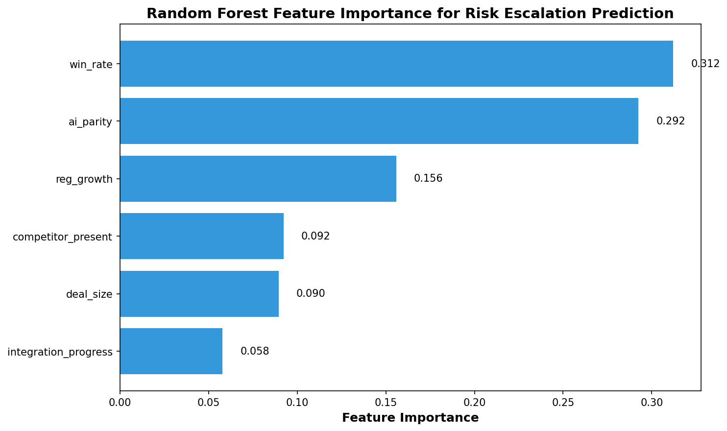
Figure 2: Random Forest Feature Importance for Risk Escalation Prediction
Using the current indicator values (win rate: 31%, AI parity: 78%, pipeline growth: 32%), the model estimated an escalation probability of approximately 76%, indicating elevated monitoring needs. Because the training data were synthetically generated from expert assumptions aligned with the I&W thresholds, the model is best interpreted as a scenario-based decision support tool rather than an empirical forecast.

5. Conclusions and Risk Mitigation Recommendations
The I&W quantitative assessment reveals that ServiceNow-Armis faces significant but manageable competitive risks. While the expected net impact is positive (+$49.8M), the 31.1% probability of net loss and wide simulation interval (-$167M to +$231M) indicate material uncertainty. Key recommendations: (1) Accelerate platform integration to reduce the competitive vulnerability window during 2026 budget cycles; (2) Prioritize AI capability development to close the feature parity gap from 78% to target ≥85% (Green zone); (3) Invest in regulatory compliance bundles (CMMC, NIS2, CIRCIA, HIPAA) to maximize the $199M expected upside; (4) Implement automated KRI dashboards with Amber/Red escalation triggers for proactive intervention.

References
Jalilvand, A., & Moorthy, S. (2023). Triangulating risk profile and risk assessment. Journal of Risk and Financial Management, 16(11), 473.
Khadem, M., Piya, S., & Shamsuzzoha, A. (2018). Quantitative risk management in gas injection project. Journal of Industrial Engineering International, 14(3), 637-654.
MindTools. (2024). Decision tree analysis. https://www.mindtools.com/az0q9po/decision-tree-analysis

