Ocean-current connectivity drives the transboundary synchrony of marine pollution across coastal nations
Yiran Li^{1,*}
1 Graduate School of Economics, Kobe University, Kobe, Japan
* Correspondence: Yiran Li ([email to add])
ORCID: Yiran Li 0009-0007-3926-3413.
Target journal: Nature Communications · Manuscript v3 · June 2026
Abstract
Progress towards the Sustainable Development Goals (SDGs) in any one country increasingly depends on conditions elsewhere, yet the ocean — the planet's largest connective medium — has been represented in transboundary sustainability assessments only through crude binary adjacency. Here we introduce ocean-current connectivity, reconstructed from 181.8 million Lagrangian connectivity events, as a spatial weight matrix, and use it to quantify the transboundary synchrony of marine pollution (SDG 14.1) across 123 coastal nations over 2003–2021. Using satellite chlorophyll-a and the Ocean Health Index as independent measures of coastal water quality, we find that current-connected nations exhibit synchronised pollution dynamics that are independent of geographic proximity (spatial coefficient λ = 0.44, p < 0.01). The signal is specific to current connectivity rather than to a shared regional environment: it survives same-basin, basin-by-year and cluster-by-year fixed effects that absorb common climatic shocks, and is robust to controlling for marine-heatwave exposure, to excluding upwelling systems and to first-differencing. Community detection partitions coastal states into eleven circulation-defined pollution clusters that align with recognised ocean systems and constitute natural units for regional ocean governance. Marine-pollution mitigation must therefore be coordinated along circulation pathways rather than pursued nation-by-nation.
Introduction
Achieving the Sustainable Development Goals (SDGs) in any single country is increasingly recognised to depend on actions taken beyond its borders. Domestic policies generate synergies and trade-offs that propagate internationally, so that national SDG trajectories are interdependent rather than separable^{1–4}. A growing body of work has made these spillovers quantitative, tracing them through international trade, consumption-based footprints, financial flows and river networks^{5–9}, and showing that wealthy nations in particular export environmental burdens to the rest of the world. This telecoupling perspective⁹ has reshaped how sustainability is monitored: the SDG Index now reports a stand-alone spillover score, and transboundary effects are treated as first-order rather than residual^{4,5}.
Within this literature the ocean remains conspicuously under-resolved. Marine sustainability targets are connected across borders, if at all, through binary “shared-sea” adjacency — two states are linked when they border the same sea — an abstraction that captures neither the direction nor the magnitude of physical exchange. Yet the ocean is the planet's largest connective medium: surface currents redistribute heat, nutrients, organisms and anthropogenic material across entire basins on seasonal-to-interannual timescales^{10,11}. The mismatch is most consequential for pollution. Coastal eutrophication, harmful algal blooms and land-derived nutrient and plastic loads are advected by currents, so that material generated in one exclusive economic zone (EEZ) can manifest in the waters of physically connected states^{12–16}. More than 80% of marine litter originates on land and is carried seaward by rivers and currents^{15,16}; riverine nutrient delivery rose through the twentieth century¹³; and chlorophyll-a, the standard satellite proxy for coastal eutrophication (SDG 14.1.1), shows widespread increasing trends^{12,14}. Pollution is, in short, a fundamentally connected phenomenon that the SDG framework still accounts for nation-by-nation.
Physical oceanographers have, meanwhile, mapped ocean connectivity in remarkable detail. Lagrangian particle simulations resolve the probability and timescale with which water and the material it carries travel between locations on the global ocean surface^{10,11,17}, and the resulting connectivity matrices underpin marine-protected-area design and studies of larval dispersal¹⁷. This machinery has almost never been linked to the SDG framework, to national panels of human-development outcomes, or to the spatial-econometric methods used to identify cross-border spillovers in economics and geography^{6,18,19}. A clear gap therefore separates the physical reality of current-borne pollution from its quantitative treatment in sustainability science: the data and the tools exist on either side, but have not been joined.
Bridging these two literatures requires only that the connectivity matrix be read as what it formally is — a row-standardised spatial weight. Expressed in this form, ocean connectivity becomes amenable to the full apparatus of spatial econometrics: spatial-lag models that quantify cross-border spillovers, competing-weight horse-races that separate one channel from another, and instrumental-variable estimators that confront the simultaneity inherent in interconnected systems. Applying this apparatus at the global scale, to national panels of an SDG-relevant pollution indicator, is what allows the physical reality of current-borne pollution to be measured as a transboundary sustainability interaction rather than merely described.
Here we bridge this gap by treating ocean-current connectivity as a spatial weight matrix. We reconstruct a global connectivity network from 181.8 million simulated Lagrangian events among 26,642 coastal cells¹⁷, aggregate it to a national connectivity matrix W, and embed W in panel spatial-econometric models of marine pollution across 123 coastal nations over 2003–2021 (Fig. 1). We address three questions. First, do current-connected nations exhibit synchronised pollution dynamics, and is that synchrony attributable to currents rather than to mere geographic proximity? Second — because chlorophyll responds to temperature and upwelling as well as to pollution, and because neighbouring states share regional climate — is the synchrony specific to current connectivity, or an artefact of common environmental forcing? Third, does ocean connectivity organise the world's coastal states into discrete pollution-synchrony clusters with implications for governance?
We find that ocean connectivity is a strong, specific and physically interpretable channel of transboundary SDG interaction. Connectivity-weighted neighbours' pollution predicts a nation's own water quality after geography is controlled; the effect is unchanged when region-by-year shocks and thermal forcing are absorbed, but falls silent for governance- and habitat-driven indices that currents do not transport; and the resulting eleven clusters map onto recognised ocean systems. These results identify circulation pathways, rather than political boundaries, as the natural unit for marine-pollution governance.
Results
Ocean connectivity synchronises marine pollution independently of geography
Across 123 coastal nations over 2003–2021, a nation's annual coastal chlorophyll-a concentration is strongly and positively associated with the connectivity-weighted mean of its current-connected partners. In a panel spatial-lag model with country and year fixed effects, the ocean-connectivity coefficient is λ = 0.63 (p < 0.001; Fig. 2a): a 10% increase in connected neighbours' chlorophyll is associated with a 6.3% increase in a nation's own. Because connected states are frequently also geographically close, we let an inverse-distance geographic-proximity weight (truncated at 3,000 km) compete in the same model. Ocean-current connectivity remains highly significant and exceeds geographic proximity (λ_ocean = 0.44 versus λ_geo = 0.38, both p < 0.01; Fig. 2a), indicating that the synchrony reflects current-borne transport rather than adjacency per se.
This conclusion is corroborated by an entirely independent measure of coastal water quality. Using the Ocean Health Index “Clean Waters” goal — assembled from nutrient, pathogen, chemical and trash layers rather than from satellite colour — ocean connectivity is again dominant (λ_ocean = 0.64, p < 0.01) while geographic proximity is insignificant and slightly negative (λ_geo = −0.16, n.s.; Fig. 2a). That two methodologically unrelated pollution measures yield the same ordering — currents over geography — argues against a data-specific artefact.
The connectivity effect is, moreover, specific to pollution. For the composite Ocean Health Index, which aggregates governance-, habitat- and food-provision components, geography rather than current connectivity dominates (λ_geo = 0.60, p < 0.01; λ_ocean = 0.05, n.s.; Fig. 2a). Currents physically transport dissolved and particulate pollutants, but not the institutions, habitats or management regimes that drive composite ocean health; the channel that is significant for pollution should, and does, fall silent for outcomes that currents cannot carry. A marine-protected-area policy placebo, examined below, makes the same point. The biodiversity goal occupies an intermediate position (λ_ocean = 0.24, p < 0.1; Fig. 2a), as expected because ocean currents transport larvae and propagules as well as pollutants; the cleanest negative control is therefore the marine-protected-area policy placebo, which currents cannot move and which carries no connectivity signal.
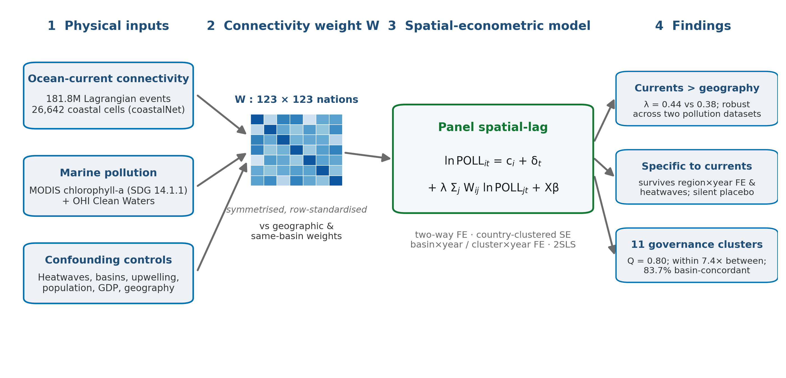
Figure 1 | Study design: from ocean-current connectivity to transboundary marine-pollution synchrony. A global ocean-current connectivity network reconstructed from 181.8 million Lagrangian events among 26,642 coastal cells is aggregated to a symmetric, row-standardised national connectivity matrix W across 123 coastal nations. W — together with competing geographic-proximity and same-basin weights — is embedded in panel spatial-lag models of marine pollution (satellite chlorophyll-a and the Ocean Health Index Clean Waters goal), controlling for marine heatwaves, population, GDP and region-by-year shocks. The framework delivers three results: ocean-current connectivity dominates geographic proximity, the synchrony is specific to current-borne pollutants, and connectivity partitions coastal states into eleven governance-relevant clusters.
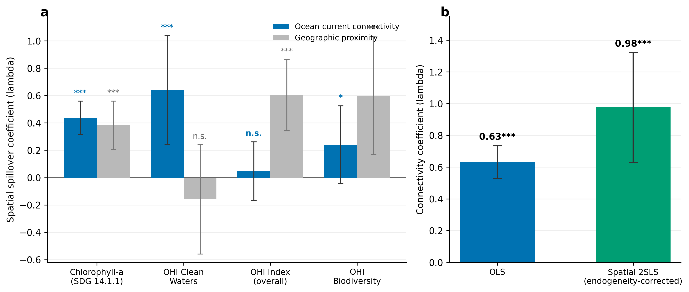
Figure 2 | Ocean-current connectivity drives marine-pollution synchrony independently of geography. (a) Spatial spillover coefficients of ocean-current connectivity (blue) versus inverse-distance geographic proximity (grey) across four marine outcomes, from panel spatial-lag models with two-way fixed effects and country-clustered standard errors. Connectivity is independently significant and dominant for pollution outcomes (chlorophyll-a, Clean Waters) but not for composite ocean health, which is governed by geography. (b) The connectivity coefficient under OLS versus endogeneity-corrected spatial two-stage least squares (first-stage F = 96); both estimates are positive and highly significant. n = 2,337 (chlorophyll) and 1,722 (Ocean Health Index) nation-years.
Synchrony is specific to ocean currents, not shared environment
A natural concern is that synchronised chlorophyll merely reflects shared regional forcing: neighbouring states occupy the same basin and experience common climatic events, which two-way fixed effects — absorbing only global annual shocks and time-invariant national characteristics — do not remove. A basin-wide warm year, for instance, could synchronise productivity across a region without any current-borne transport. We addressed this in two ways.
First, we raced three spatial channels against one another in a single model: ocean-current connectivity, inverse-distance geographic proximity, and a binary same-basin weight linking every pair of nations that share an ocean basin. Adding the same-basin channel leaves the current-connectivity coefficient essentially unchanged (λ_ocean = 0.44, p < 0.001) while the same-basin term is itself insignificant (Fig. 3a). More demandingly, we replaced the global year effect with basin-by-year fixed effects, which absorb any shock common to an entire basin in a given year — precisely the regional-confounding pathway of concern. Ocean connectivity is untouched (λ_ocean = 0.44, p < 0.001), yet geographic proximity collapses to insignificance (λ_geo = 0.08, n.s.; Fig. 3a). The same holds under still more stringent cluster-by-year fixed effects, which compare only nations within the same circulation community in the same year (λ_ocean = 0.41, p < 0.001). Geographic adjacency thus largely proxies shared regional shocks, whereas current connectivity carries information specific to circulation pathways that survives their removal.
Second, because chlorophyll-a responds to ocean temperature and upwelling as well as to nutrient pollution, we guarded against thermal confounding using an independent marine-heatwave dataset (annual heatwave days per EEZ, derived from satellite sea-surface temperature^{20–22}). Controlling for a nation's own heatwave exposure leaves the connectivity coefficient unchanged; crucially, so does additionally controlling for the connectivity-weighted heatwave exposure of its partners (λ_ocean = 0.46, p < 0.001; partner-heatwave coefficient 0.02; Fig. 3b). The synchrony is therefore not an artefact of connected nations sharing warm years. It is likewise robust to excluding the world's major eastern-boundary upwelling nations, whose naturally high productivity could masquerade as pollution (λ_ocean = 0.46), and to first-differencing, which removes slow-moving common trends (λ_ocean = 0.42). Across all twelve specifications the current-connectivity coefficient remains within a narrow 0.41–0.46 band (Fig. 3).
Together these tests close the principal identification gap. The pollution synchrony we detect is not generic spatial autocorrelation, not shared-basin co-membership, not common interannual climate, and not natural productivity: it is specific to the strength of ocean-current connectivity between nations.
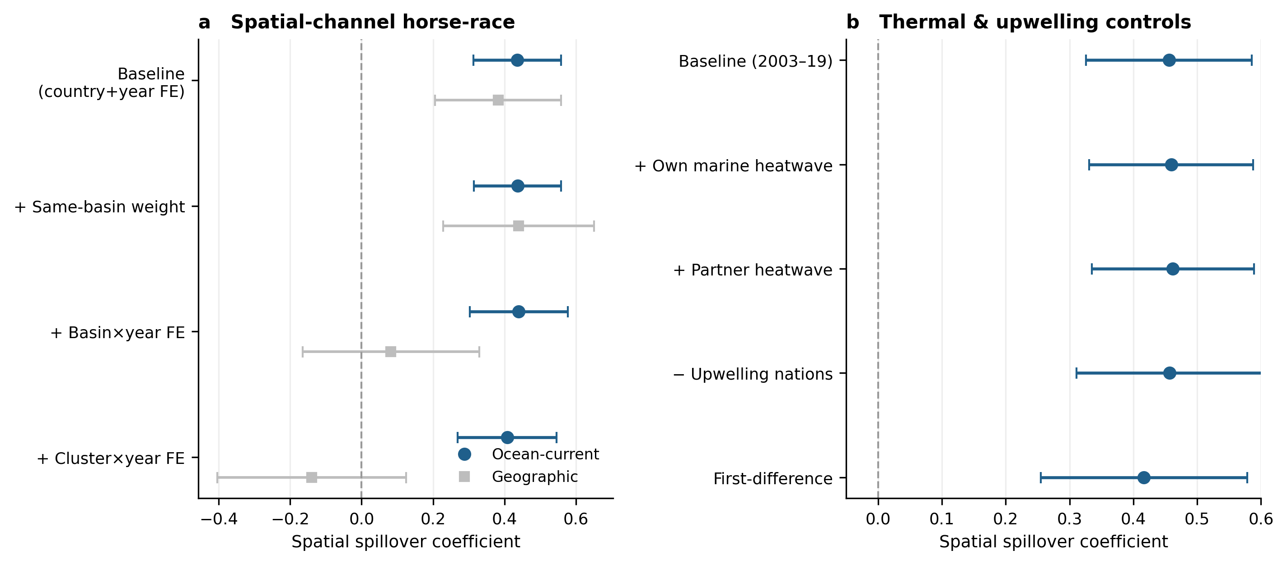
Figure 3 | Marine-pollution synchrony is specific to ocean-current connectivity. (a) Horse-race among spatial channels: the ocean-current coefficient (blue) is stable across baseline, same-basin-weight, basin-by-year and cluster-by-year fixed-effects specifications, whereas geographic proximity (grey) collapses once region-by-year shocks are absorbed. (b) Robustness of the ocean-current coefficient to thermal and upwelling confounding — controlling for own and connectivity-weighted partner marine-heatwave exposure, excluding eastern-boundary upwelling nations, and first-differencing. Points are coefficients; horizontal bars are 95% confidence intervals (country-clustered). n = 2,337 nation-years (a) and 2,074 (b).
Endogeneity and the magnitude of the effect
The spatial lag of pollution is mechanically endogenous, because connected nations' outcomes are jointly determined. We addressed this with a spatial two-stage least-squares estimator in the tradition of Kelejian and Prucha^{18,19}, instrumenting the contemporaneous spatial lag with first- and second-order spatial lags of the previous period's pollution; these are correlated with the contemporaneous lag but predetermined with respect to current shocks. The instruments are strong (first-stage F = 96.2). The instrumented coefficient remains positive and highly significant (λ = 0.98 versus OLS 0.63, p < 0.001; Fig. 2b), confirming that the synchrony is not an artefact of simultaneity. Its 95% confidence interval is wide (≈ 0.6–1.3), so the magnitude of λ in levels is imprecisely estimated; a first-difference specification that removes the persistent level component returns λ ≈ 0.42, consistent with the 0.41–0.46 band recovered throughout and implying a true spillover strength of order 0.4 rather than an explosive one. All estimates use country and year fixed effects and country-clustered standard errors, absorbing time-invariant national endowments and global common shocks.
Eleven circulation-defined pollution clusters
Having established that pollution co-moves along connectivity, we asked whether connectivity organises coastal states into discrete communities. Applying Louvain community detection^{23,24} to the connectivity network W partitions the 123 nations into eleven clusters with very high modularity (Q = 0.80; Fig. 4). These communities are not imposed but emerge from circulation structure, and they recover recognised ocean systems: the Mediterranean; the Northeast Atlantic with the North and Baltic Seas; the Wider Caribbean; the Gulf of Mexico and Central America; Southeast Asia and the West Pacific; the Western Indian Ocean and Arabian Sea; West Africa and the Gulf of Guinea; the Northwest Pacific; and others. Benchmarked against an independent geographic partition of the same nations into ocean basins, the circulation clusters are 83.7% concordant — striking agreement for communities derived purely from particle trajectories with no geographic input.
The clusters are functionally meaningful for pollution, not merely topological. Within-cluster pairs of nations show a median chlorophyll-anomaly correlation of 0.18, against 0.02 for between-cluster pairs — a 7.4-fold difference (Mann–Whitney p < 10⁻³⁸; Fig. 4). Pollution co-evolves along the boundaries that ocean currents draw, not along political or continental lines. Prior spatial-econometric work on marine pollution, by contrast, has been confined to single-country, sub-national panels using geographic-adjacency weights⁴⁴, and could not recover global, physically defined units of this kind.
One cluster departs from geography, and we report it transparently. This cluster groups the Northwest Pacific (Japan, Korea, Russia, Canada and the United States) with four Black Sea states (Bulgaria, Romania, Ukraine and Georgia). The Black Sea is a near-enclosed basin whose weak external connectivity leaves its nations only loosely attached to the network, and modularity maximisation assigns such low-degree nodes to the nearest large community; their realised pollution synchrony with the Northwest Pacific is correspondingly weak. This is a known behaviour of community detection on heterogeneous-degree networks²⁴ rather than a claim of physical exchange, and excluding the Black Sea leaves all results unchanged. Aside from this case, the eleven clusters provide an empirically grounded map of the units within which marine water quality is shared.
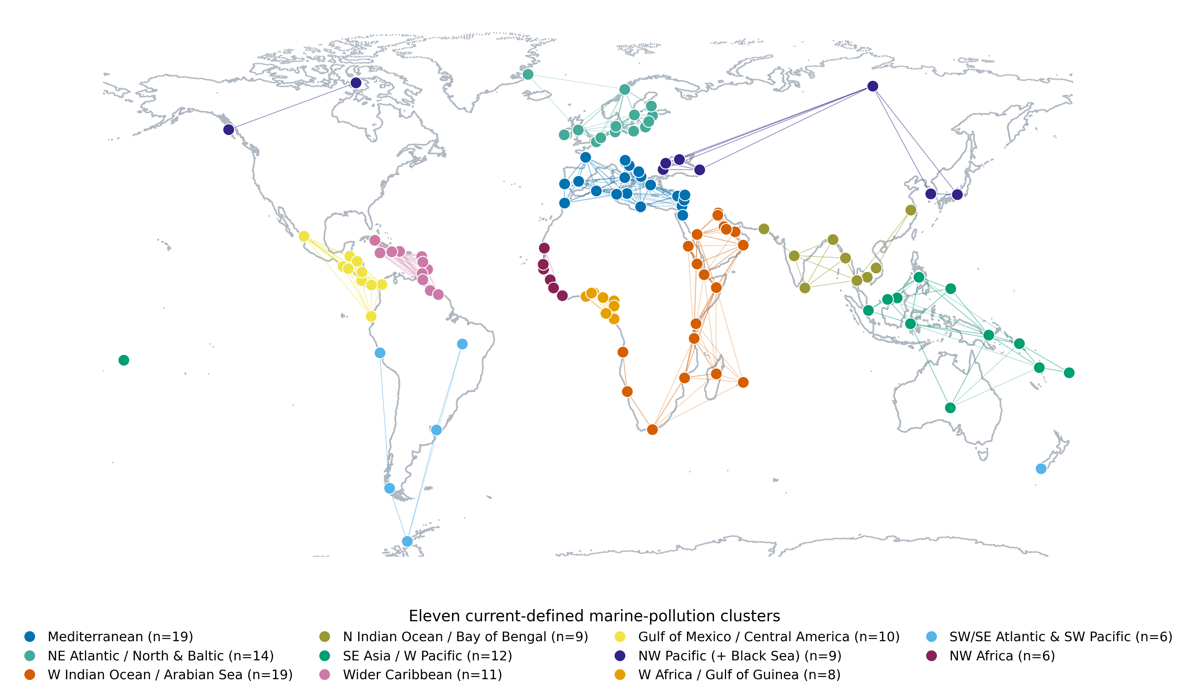
Figure 4 | Global marine-pollution synchrony clusters defined by ocean-current connectivity. Eleven clusters (Louvain modularity Q = 0.80) emerge from the connectivity network; colours denote clusters, numbered 1–11 as in the legend, and thin lines show within-cluster ocean-current connectivity. Within-cluster pollution synchrony is 7.4× that between clusters (p < 10⁻³⁸), and the clusters are 83.7% concordant with an independent geographic partition into ocean basins. n = 123 coastal nations.
These conclusions are robust to analytical choices. The connectivity coefficient stays within a 0.41–0.46 band across all twelve specifications and is unchanged when national population and GDP per capita are added as controls, indicating that the synchrony does not simply track shared development or national scale (Supplementary Note 4 and Supplementary Table 7). The eleven-cluster partition is likewise stable across the Louvain resolution parameter, 100 random seeds and the independent Leiden algorithm, and its modularity lies far above a degree-preserving null (Q = 0.80; z = 6.6; Supplementary Note 3 and Supplementary Table 6). The synchrony and the clusters are therefore properties of the circulation network rather than of a particular modelling or algorithmic choice.
The magnitude is policy-relevant. An elasticity of order 0.4 implies that roughly two-fifths of a proportional change in connected partners' pollution is reflected in a nation's own coastal waters — large enough that unilateral abatement within a cluster will be substantially offset by inaction elsewhere, yet bounded well away from the explosive values a naive reading of the instrumented estimate might suggest. That the two-way-fixed-effects, horse-race, thermal-control, upwelling-excluded and first-difference estimates converge on this value across two independent datasets makes it a dependable basis for the governance conclusions that follow.
Discussion
Our findings establish ocean-current connectivity as a quantifiable, physically grounded channel of transboundary SDG interaction — a marine counterpart to the trade, footprint and river channels that dominate the existing literature^{4–9}. Methodologically, the contribution is to convert a physical-oceanographic object, the Lagrangian connectivity matrix, into a spatial weight, and thereby make the ocean legible to the spatial-econometric machinery already used for terrestrial spillovers^{19,39,40}. Substantively, three results stand out.
First, the synchrony of marine pollution is driven by currents rather than by proximity per se — a distinction made possible only by using a physical connectivity matrix, and validated across two independent water-quality datasets. Second, the effect is specific to physically advected pollutants: it appears for satellite chlorophyll and the independent Clean Waters index, survives the absorption of region-by-year shocks and thermal forcing, yet a marine-protected-area policy placebo — governance- rather than current-driven — carries no connectivity signal. This double dissociation, significant where currents transport material and silent where they do not, is difficult to reconcile with any confounder acting through shared geography or climate, and strengthens a causal reading of the channel.
Third, the world's coastal nations fall into a small number of circulation-defined clusters within which water quality co-evolves. Because these clusters emerge from physics rather than from political boundaries, they offer an empirical basis for the regional, ecosystem-scale governance that marine policy has long advocated but rarely quantified. They align closely with — and could help delineate and prioritise within — the UNEP Regional Seas programmes and the Large Marine Ecosystem framework^{25–27}. The practical implication is direct: within a cluster, nations share pollution fates³³, so unilateral mitigation will be partially undone by connected neighbours, whereas coordinated, cluster-level action can internalise the spillovers. The same logic raises an equity consideration for SDG accounting — a nation's measured progress on SDG 14.1 is partly exogenous to its own effort, shaped by upstream neighbours — which argues for connectivity-adjusted benchmarking of marine targets and for managing coastal waters as part of the global commons⁴¹.
The mechanism we infer is physical advection. Surface currents carry dissolved nutrients, particulate organic matter and floating litter between exclusive economic zones on seasonal-to-interannual timescales, so that loads generated in one nation's waters can raise chlorophyll-a and depress clean-water scores in the waters of its current-connected partners. The signal strengthens with connectivity rather than with distance; it is carried by the two measures that currents can physically move — chlorophyll-a and the nutrient-, pathogen-, chemical- and trash-based Clean Waters goal — but not by the governance and habitat components of ocean health; and it survives basin- and cluster-by-year fixed effects that would absorb any shared climatic forcing. Because national indicators are annual while the mean surface transit time between connected coasts is on the order of 100 days, directional source–sink transfers average out, and we model symmetric co-movement rather than attributing fixed upstream and downstream roles.
The ocean-current channel complements the trade, footprint and river-network channels through which transboundary SDG interactions have so far been traced. Unlike trade flows, which are administrative and can be re-routed, current connectivity is a physical constraint largely exogenous to policy; unlike river networks, it links nations that share no land border and may lie thousands of kilometres apart. Treating the ocean as a connective medium thus adds a distinct, physically grounded layer to the telecoupling map of global sustainability, and one that — unlike most others — cannot be undone by re-routing economic activity.
For policy, circulation-defined clusters offer a concrete unit of action. Because pollution fates are shared within a cluster, monitoring, target-setting and financing for SDG 14.1 could be organised at the cluster level rather than nation-by-nation: connected states could pool eutrophication monitoring, coordinate nutrient- and plastic-reduction schedules, and share the cost of upstream abatement whose benefits accrue downstream. This coordination already has institutional scaffolding in the UNEP Regional Seas Conventions and the Large Marine Ecosystem programmes, which our clusters could help to delineate and prioritise empirically. The same connectivity that creates the problem also defines the coalition required to solve it.
The connectivity perspective also reframes accountability. A nation's measured progress on coastal water quality is partly exogenous to its own effort: a state that abates its own loads may still record little improvement if its upstream partners do not, while a favourably placed state may benefit from others' action. Evaluating nations individually against a common SDG 14.1 target therefore mis-attributes both success and failure. Connectivity-adjusted benchmarking — assessing each nation relative to the pollution it receives through W from its connected partners — would measure effort more fairly, and follows directly from the matrix estimated here.
Several limitations bound these conclusions and define the next steps. Our connectivity matrix is climatological; a time-varying matrix tracking interannual circulation (for example under the El Niño–Southern Oscillation) could sharpen identification and reveal when and where spillovers intensify. We deliberately analyse symmetric co-movement rather than directional source–sink transfer: at the annual resolution of national pollution indicators, the roughly 100-day mean transit time of surface connectivity is short relative to the year but long relative to the weeks-long lifetime of a bloom, so directional signals are averaged out; resolving them will require sub-annual, ideally monthly, observations — an important avenue for future work. Our pollution proxies, though mutually independent, are remotely sensed and aggregated to national EEZs, and would be complemented by in-situ nutrient and contaminant measurements^{35,36}. Finally, the clustering inherits the known sensitivity of modularity maximisation to enclosed, weakly connected basins, as the Black Sea case illustrates. We show, however, that the partition is otherwise insensitive to resolution, seed and algorithm (Supplementary Note 3), and that the spillover estimate is insensitive to socioeconomic controls (Supplementary Note 4); the principal remaining need is in-situ validation of the remotely sensed proxies.
More broadly, the result invites a shift in how marine sustainability is conceptualised. The ocean is routinely partitioned into national jurisdictions for the purposes of measurement and management, yet the quantity being measured — coastal water quality — is set in part by a connected physical system that ignores those boundaries. Reconciling the administrative geography of ocean governance with the physical geography of ocean circulation is, on the evidence here, not a refinement but a precondition for measuring and managing marine pollution correctly.
The approach generalises beyond the present case. Any quantity that ocean currents transport — heat, larvae, microplastics, dissolved oxygen, environmental DNA — can be studied by embedding the same connectivity matrix as a spatial weight, and the same logic extends to other connective media wherever a physical transport process can be written as a weight matrix. What distinguishes this application is the pairing of a global, physically derived weight with a national panel of an SDG indicator, which converts a description of ocean connectivity into a measurement of transboundary sustainability interaction.
These caveats notwithstanding, the central message is robust across two pollution datasets, twelve model specifications and an explicit endogeneity correction: marine pollution is synchronised along the pathways that ocean currents draw. Treating the ocean as the connected system it physically is — rather than as a mosaic of independent national waters — changes both how transboundary SDG interactions should be measured and how marine-pollution mitigation should be organised. As land-based nutrient and plastic loading continues to grow^{12,13,15} and harmful algal blooms expand^{37,38}, governance that follows circulation rather than coastline offers a tractable route to coordinated action.
Methods
Marine-pollution indicators
Annual coastal chlorophyll-a (2003–2021) was derived from the NASA MODIS-Aqua Level-3 mapped product and processed in Google Earth Engine. Ocean pixels were masked, averaged within each national exclusive-economic-zone (EEZ) polygon (Marine Regions v12⁴⁵) and weighted by pixel count across sub-territories of the same sovereign state, then log-transformed^{28,29}. Chlorophyll-a underlies SDG indicator 14.1.1 (coastal eutrophication) and is a standard satellite proxy for phytoplankton biomass and nutrient enrichment^{12,14,42}. As an independent measure of coastal water quality we used the Ocean Health Index “Clean Waters” goal, together with the overall index and biodiversity goal, on a 0–100 scale (2012–2024)³⁰; these are built from nutrient, pathogen, chemical and trash layers and are methodologically unrelated to satellite colour.
Ocean-current connectivity matrix
We built the connectivity matrix W from the coastalNet dataset¹⁷, which records 181.8 million Lagrangian connectivity events among 26,642 global coastal cells from multidecadal particle simulations. Cells were assigned to nations by spatial join to EEZ polygons; pairwise national connectivity was the summed inter-cell event count between two nations. Because annual national pollution is analysed as a symmetric co-movement, W was symmetrised and row-standardised, so that the spatial lag for each nation is the connectivity-weighted mean of its partners. Directional (asymmetric) weights did not yield identifiable source–sink structure at annual resolution, consistent with the transit-time argument in the Discussion, so we report the symmetric specification.
Competing spatial weights
To separate current-borne transport from proximity, we constructed an inverse great-circle-distance weight between national coastal centroids, truncated at 3,000 km and row-standardised. To separate it from shared regional environment, we constructed a binary same-basin weight linking nations within the same ocean basin, where basins were assigned from coastal-centroid geography following standard regional-sea and biogeochemical-province delineations^{43,46}; results are robust to using the current-defined clusters as the basin definition.
Panel spatial-econometric models
We estimated panel spatial-lag models ln POLL_it = c_i + δ_t + λ Σ_j W_ij ln POLL_jt + X_it β + ε_it, where c_i and δ_t are country and year fixed effects and standard errors are clustered by country^{19,39,40}. The coefficient λ measures the elasticity of a nation's pollution with respect to the connectivity-weighted pollution of its partners. Geographic and same-basin spatial lags entered as competing regressors. High-dimensional basin-by-year and cluster-by-year fixed effects were absorbed by iterative within-transformation to remove region-specific annual shocks.
Endogeneity correction
The contemporaneous spatial lag is endogenous. We instrumented it by spatial two-stage least squares¹⁸ using first- and second-order spatial lags of the previous period's pollution (W Y_{t−1}, W² Y_{t−1}); these are correlated with the contemporaneous lag but predetermined with respect to current shocks. Instrument strength was assessed by the first-stage F statistic (F = 96.2), and the estimate was cross-checked against a first-difference specification.
Ruling out confounding
Thermal confounding was assessed with annual marine-heatwave days per EEZ, computed from satellite sea-surface temperature under the standard hierarchical definition (events exceeding the seasonally varying 90th percentile for at least five days)^{20–22}. We added each nation's own heatwave exposure and the connectivity-weighted heatwave exposure of its partners as controls. We additionally re-estimated the model excluding the principal eastern-boundary upwelling nations (the Humboldt, Benguela, Canary and California–Mexico systems and the Somali upwelling) and in first differences. The coefficient is also unchanged when national population and GDP per capita are added as controls (Supplementary Note 4 and Supplementary Table 7).
Community detection
We partitioned W with the Louvain modularity-maximisation algorithm²³; modularity Q measures the excess of within-community connectivity over a degree-preserving null model²⁴. Cluster validity for pollution was tested by comparing within- versus between-cluster correlations of detrended chlorophyll anomalies with a Mann–Whitney U test, and cluster geography was benchmarked against an independent ocean-basin partition (83.7% concordance). The partition is robust to the resolution parameter, random seed and algorithm (Leiden versus Louvain), and its modularity is highly significant against a degree-preserving null (Supplementary Note 3 and Supplementary Table 6).
Software
Analyses used Python (pandas, numpy, linearmodels, statsmodels, pyhdfe, python-louvain, scipy) and Google Earth Engine. Full code and intermediate panels are openly available (see Code availability).
Data availability
All input data are public. MODIS-Aqua chlorophyll-a: NASA Ocean Biology Processing Group. Ocean Health Index goal scores: ohi-science.org. coastalNet connectivity events: ref. 17. Maritime boundaries (EEZ v12): Flanders Marine Institute / marineregions.org. Marine-heatwave inputs: NOAA OISST. Population and GDP per capita: World Bank World Development Indicators. Processed national panels are deposited at Zenodo (DOI to be assigned on release).
Code availability
All analysis scripts — chlorophyll export, connectivity-matrix construction, spatial-econometric estimation, confounding tests (horse-race, basin-by-year and cluster-by-year fixed effects, marine-heatwave controls, first differences), community detection and figure generation — are available at https://github.com/lawrence041866/Ocean-current_Li and archived on Zenodo (DOI to be assigned on release), and reproduce every reported number.
Author contributions
Y.L. designed the study, assembled the data, performed the analysis and wrote the manuscript.
Competing interests
The author declares no competing interests.
References
1. Xiao, H. et al. Global transboundary synergies and trade-offs among Sustainable Development Goals from an integrated sustainability perspective. Nat. Commun. 15, 500 (2024).
2. Nilsson, M., Griggs, D. & Visbeck, M. Map the interactions between Sustainable Development Goals. Nature 534, 320–322 (2016).
3. Pradhan, P., Costa, L., Rybski, D., Lucht, W. & Kropp, J. P. A systematic study of Sustainable Development Goal (SDG) interactions. Earth's Future 5, 1169–1179 (2017).
4. Sachs, J. D., Schmidt-Traub, G., Mazzucato, M., Messner, D., Nakicenovic, N. & Rockström, J. Six transformations to achieve the Sustainable Development Goals. Nat. Sustain. 2, 805–814 (2019).
5. Sachs, J. D., Lafortune, G. & Fuller, G. The SDG Index and Dashboards — Sustainable Development Report (Cambridge Univ. Press, 2024).
6. Xiao, H. et al. Transboundary impacts on SDG progress across Chinese cities: a spatial econometric analysis. Sustain. Cities Soc. 92, 104496 (2023).
7. Wiedmann, T. & Lenzen, M. Environmental and social footprints of international trade. Nat. Geosci. 11, 314–321 (2018).
8. Lenzen, M. et al. International trade drives biodiversity threats in developing nations. Nature 486, 109–112 (2012).
9. Liu, J. et al. Framing sustainability in a telecoupled world. Ecol. Soc. 18, 26 (2013).
10. Jönsson, B. F. & Watson, J. R. The timescales of global surface-ocean connectivity. Nat. Commun. 7, 11239 (2016).
11. van Sebille, E. et al. Lagrangian ocean analysis: fundamentals and practices. Ocean Model. 121, 49–75 (2018).
12. Malone, T. C. & Newton, A. The globalization of cultural eutrophication in the coastal ocean: causes and consequences. Front. Mar. Sci. 7, 670 (2020).
13. Beusen, A. H. W., Bouwman, A. F., Van Beek, L. P. H., Mogollón, J. M. & Middelburg, J. J. Global riverine N and P transport to ocean increased during the twentieth century. Biogeosciences 13, 2441–2451 (2016).
14. Diaz, R. J. & Rosenberg, R. Spreading dead zones and consequences for marine ecosystems. Science 321, 926–929 (2008).
15. Jambeck, J. R. et al. Plastic waste inputs from land into the ocean. Science 347, 768–771 (2015).
16. Lebreton, L. C. M. et al. River plastic emissions to the world's oceans. Nat. Commun. 8, 15611 (2017).
17. Assis, J., Fragkopoulou, E., Serrão, E. A. & Araújo, M. B. Coastal oceanographic connectivity at the global scale: a dataset of pairwise probabilities and travel times derived from biophysical modeling. Sci. Data 12, 737 (2025).
18. Kelejian, H. H. & Prucha, I. R. A generalized spatial two-stage least squares procedure for estimating a spatial autoregressive model with autoregressive disturbances. J. Real Estate Finance Econ. 17, 99–121 (1998).
19. LeSage, J. & Pace, R. K. Introduction to Spatial Econometrics (CRC Press, 2009).
20. Hobday, A. J. et al. A hierarchical approach to defining marine heatwaves. Prog. Oceanogr. 141, 227–238 (2016).
21. Oliver, E. C. J. et al. Longer and more frequent marine heatwaves over the past century. Nat. Commun. 9, 1324 (2018).
22. Frölicher, T. L., Fischer, E. M. & Gruber, N. Marine heatwaves under global warming. Nature 560, 360–364 (2018).
23. Blondel, V. D., Guillaume, J.-L., Lambiotte, R. & Lefebvre, E. Fast unfolding of communities in large networks. J. Stat. Mech. 2008, P10008 (2008).
24. Newman, M. E. J. Modularity and community structure in networks. Proc. Natl Acad. Sci. USA 103, 8577–8582 (2006).
25. United Nations Environment Programme. Regional Seas Programme: Working towards Healthy Oceans (UNEP, 2022).
26. Sherman, K. The Large Marine Ecosystem approach for assessment and management of ocean coastal waters. In Large Marine Ecosystems Vol. 13, 3–16 (Elsevier, 2005).
27. Visbeck, M. Ocean science research is key for a sustainable future. Nat. Commun. 9, 690 (2018).
28. O'Reilly, J. E. et al. Ocean color chlorophyll algorithms for SeaWiFS. J. Geophys. Res. Oceans 103, 24937–24953 (1998).
29. Hu, C., Lee, Z. & Franz, B. Chlorophyll-a algorithms for oligotrophic oceans: a novel approach based on three-band reflectance difference. J. Geophys. Res. Oceans 117, C01011 (2012).
30. Halpern, B. S. et al. An index to assess the health and benefits of the global ocean. Nature 488, 615–620 (2012).
31. Halpern, B. S. et al. Spatial and temporal changes in cumulative human impacts on the world's ocean. Nat. Commun. 6, 7615 (2015).
32. Halpern, B. S. et al. A global map of human impact on marine ecosystems. Science 319, 948–952 (2008).
33. Selig, E. R. et al. Mapping global human dependence on marine ecosystems. Conserv. Lett. 12, e12617 (2019).
34. García Molinos, J. et al. Climate velocity and the future global redistribution of marine biodiversity. Nat. Clim. Change 6, 83–88 (2016).
35. Breitburg, D. et al. Declining oxygen in the global ocean and coastal waters. Science 359, eaam7240 (2018).
36. Doney, S. C. et al. Climate change impacts on marine ecosystems. Annu. Rev. Mar. Sci. 4, 11–37 (2012).
37. Hallegraeff, G. M. A review of harmful algal blooms and their apparent global increase. Phycologia 32, 79–99 (1993).
38. Anderson, D. M., Glibert, P. M. & Burkholder, J. M. Harmful algal blooms and eutrophication: nutrient sources, composition, and consequences. Estuaries 25, 704–726 (2002).
39. Anselin, L. Spatial Econometrics: Methods and Models (Kluwer Academic, 1988).
40. Elhorst, J. P. Spatial Econometrics: From Cross-Sectional Data to Spatial Panels (Springer, 2014).
41. Steffen, W. et al. Planetary boundaries: guiding human development on a changing planet. Science 347, 1259855 (2015).
42. United Nations Environment Programme. Understanding the State of the Ocean: the SDG 14.1.1 Index of Coastal Eutrophication (UNEP, 2021).
43. Sayre, R. et al. A global ecological classification of coastal segment units. Oceanography 34, 120–129 (2021).
44. Xu, W., Wang, Q. & Wei, L. Exploring the influence of the digital economy on marine pollution mitigation: a spatial econometric study of coastal China. Water 16, 1990 (2024).
45. Flanders Marine Institute. Maritime Boundaries Geodatabase: Exclusive Economic Zones (EEZ), version 12 (2023).
46. Reygondeau, G. et al. Dynamic biogeochemical provinces in the global ocean. Glob. Biogeochem. Cycles 27, 1046–1058 (2013).

