Lab ?: ??????????

# Design Explanation

## Ping Pong Counter

Reverse the direction when it meets end (at bottom & decreasing or at top & increasing). Reversal can be applied by XOR.

Increment when direction is 1 and decrement when direction is 0.

Apply the previous procedures when clock is triggered.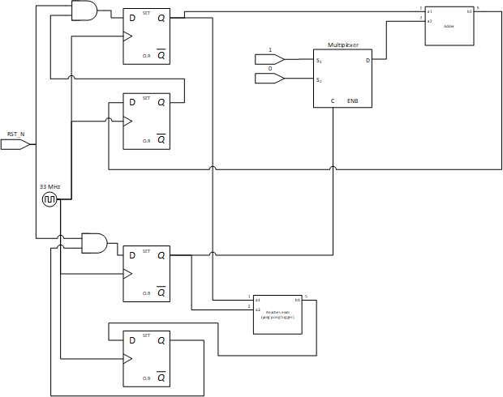

## ???

## Memory Bank

We design 2 modules, each has 4 children.

In the first module, 4 naïve memory bank is connected. Corresponding signals are attached by mux and demux.

In the second module, 4 single memory bank is connected. Correspond signals are attached by demux. The second module is nearly identical to the first module.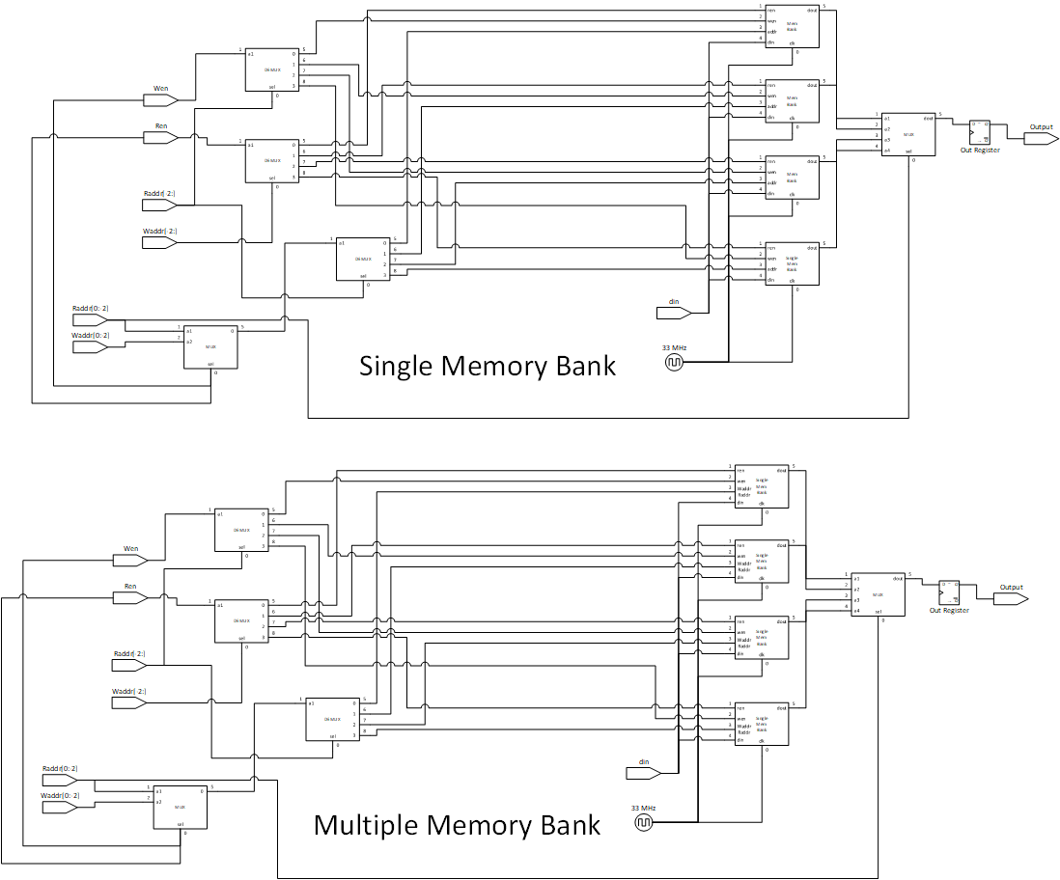

## ???

## Parameterized Ping Pong Counter

Reverse the direction when it meets end (at bottom & decreasing or at top & increasing). Reversal can be applied by XOR.

Increment when direction is 1 and decrement when direction is 0.

Apply the previous procedures when clock is triggered.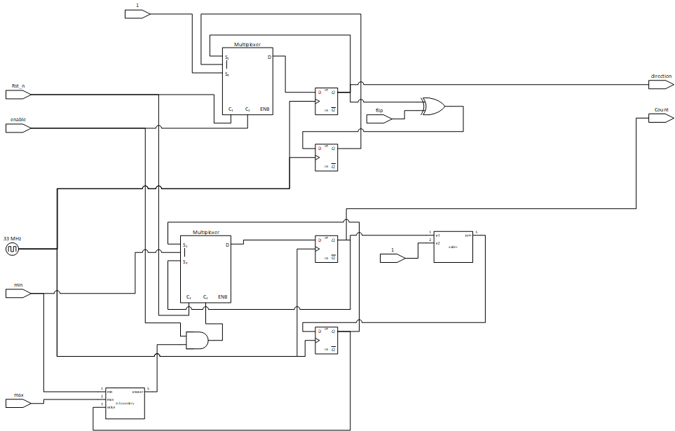

## FPGA Design

Design struggle:

As we all know, messing around with clock signals is never a recommended development approach. But the soul of science and the ambition of exploration drives me to alter the clock signal.

To slow down the process for demonstration in naked eyes, I decided to slow down the clock for Parameterized Ping Pong Counter to 1Hz and the clock for 7 segment display to 100Hz.

Clock divider can be easily achieved by registers and equality. Apply clock divider, we shall gain the desired frequency.

But the output in simulator was different to the output in FPGA. After trials and error, experiments and inductions, I found glitches in the circuit.

Extra current is specially provided for clock so parallel energy consumption would not lead to unstable outputs. After messing around with clock signals, the power output on a XOR gate was insufficient to drive all the circuit, therefore the glitches were presented.

Remove the XOR gate and replace it with a register, the circuit works exactly as expected!

Design concepts:

There is 3 modules for FPGA Demo. The first one is clock divider, which handles the clock signals and to slow down the circuit for naked eyes demonstration. The second one is main chip, which is parameterized ping pong counter. The third one is the 7 segment display module, which handles the transcription between main chip and display.

# Design Verification

## Ping Pong counter

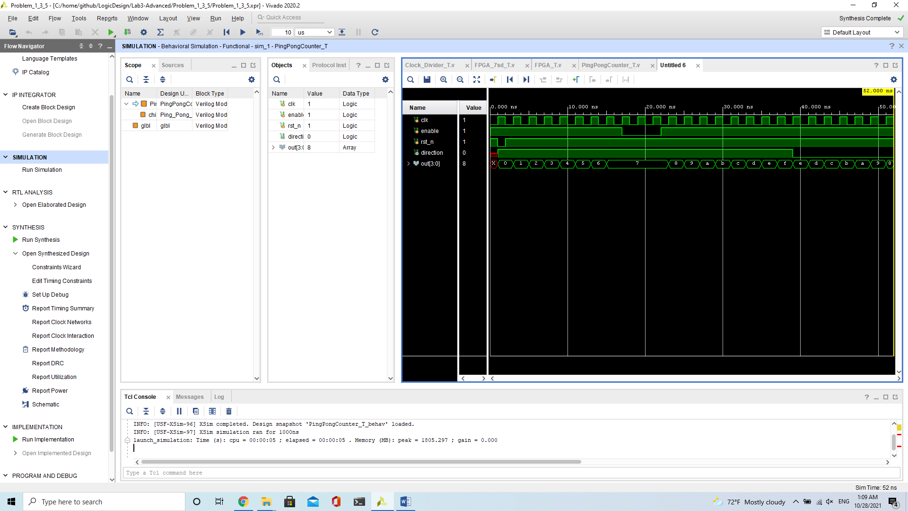Reset and let it ping pong.

## DMUX

## Memory Bank

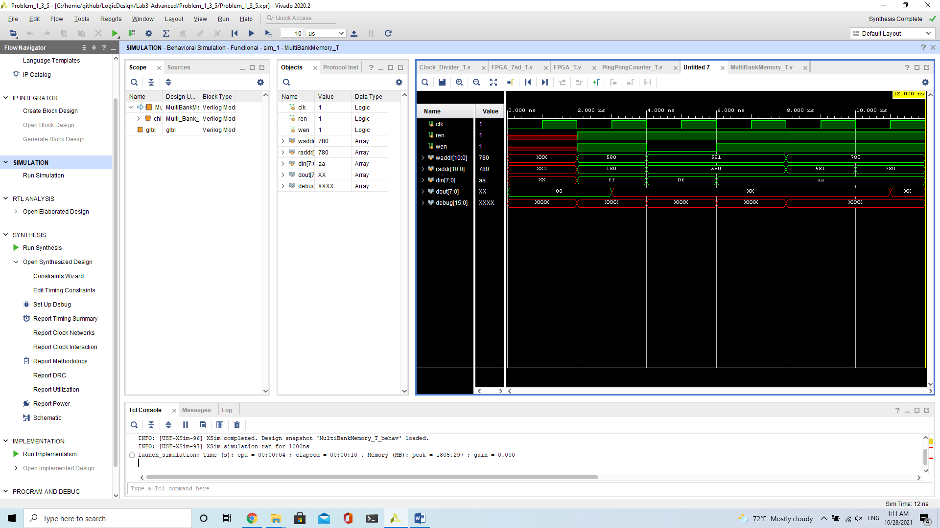Randomly write some info in and write some info out.

## DMUX

## Parameterized Ping Pong Counter

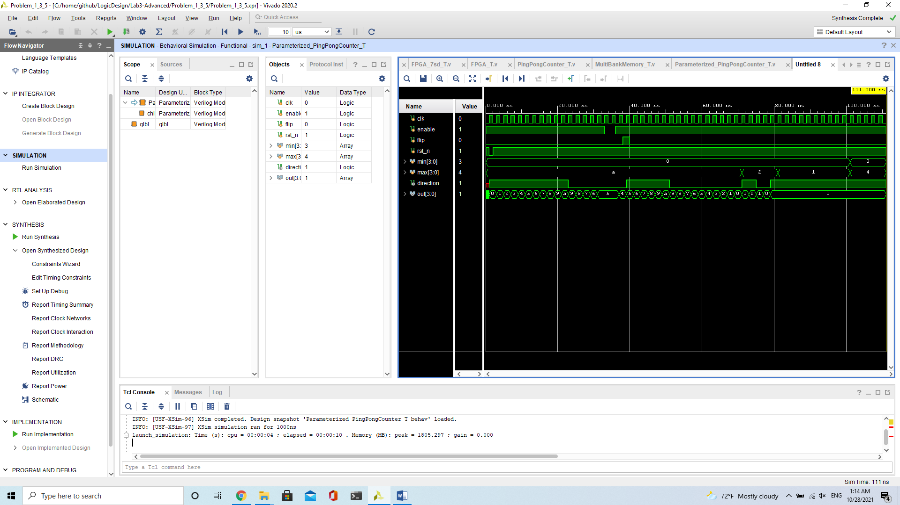First, we test the reset signals. Second, we test the enable signal. Third, we test the flip signal. Last, we test the min/max signals and the boundary conditions.

## FPGA

* 1. Clock Divider testbench

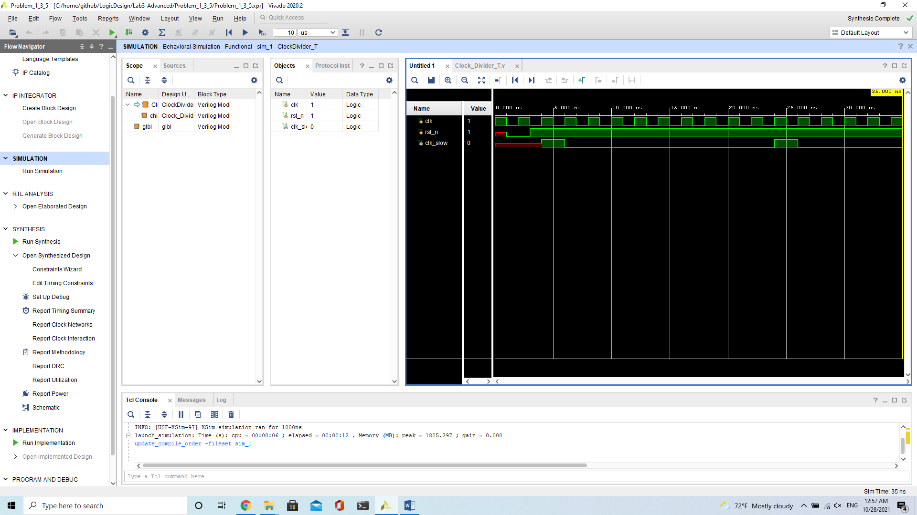Divide the clock cycle into 1/10. Manual validation is needed.

* 1. FPGA testbench

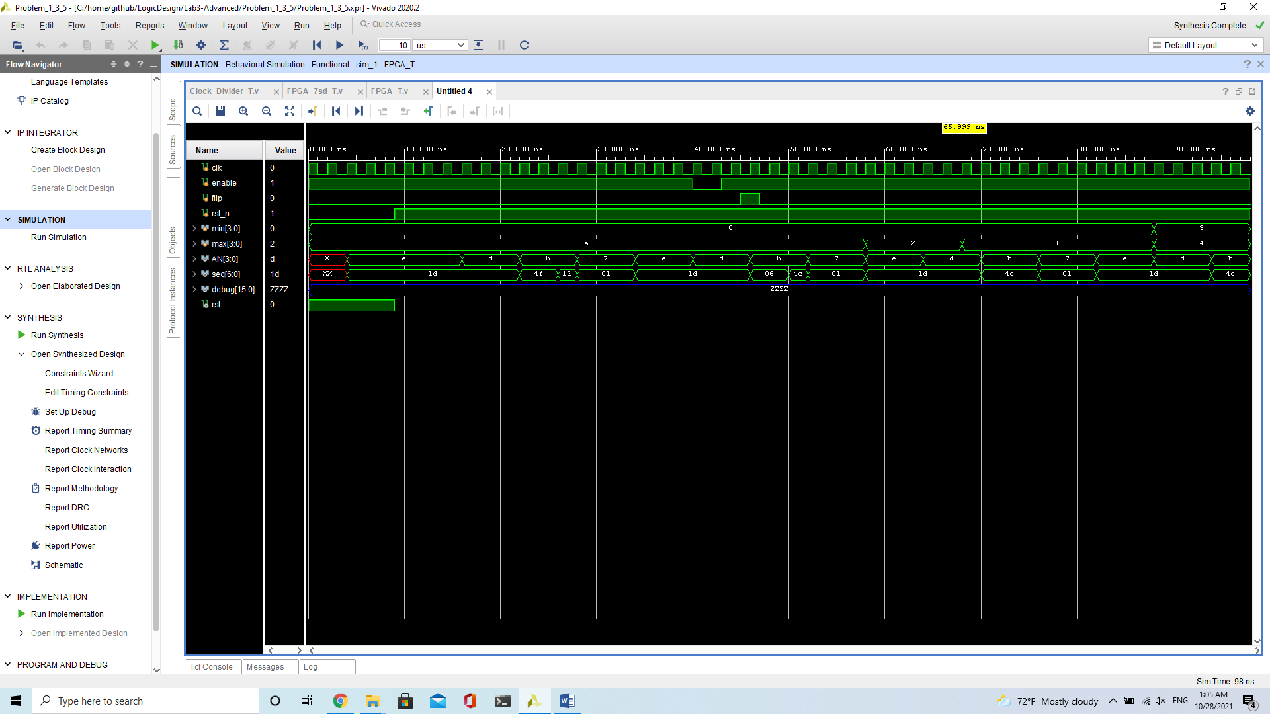Identical to parameterized ping pong counter.

* 1. 7 segment display testbench

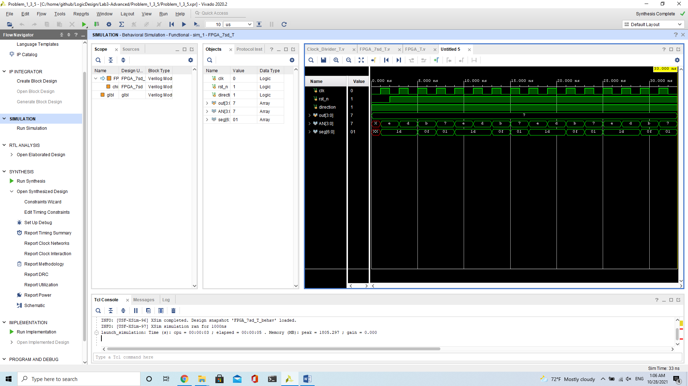Randomly give some circuit output and check the transcription manually.

# Contribution

## Lawrence Wu

Problem 1, Problem 3, Problem 5 and FPGA demonstration.

## Ariel Chang

# What have we learned?

1. Never ever mess around with clock signals

2. Always respect those hardware engineers

3. Splitting modules is important

4. Don’t be rude to TA

5. Behavior on FPGA and Behavior on Simulator might be different

6. Follow the KISS (Keep It Simple and Stupid) rule and it will save your weekend

7. Generating bitstream takes a long time, so always debug on simulator when possible

8. Always fill the default case, otherwise synthesizer would do stupid stuff

9. Insufficient sleep + bug = more bugs