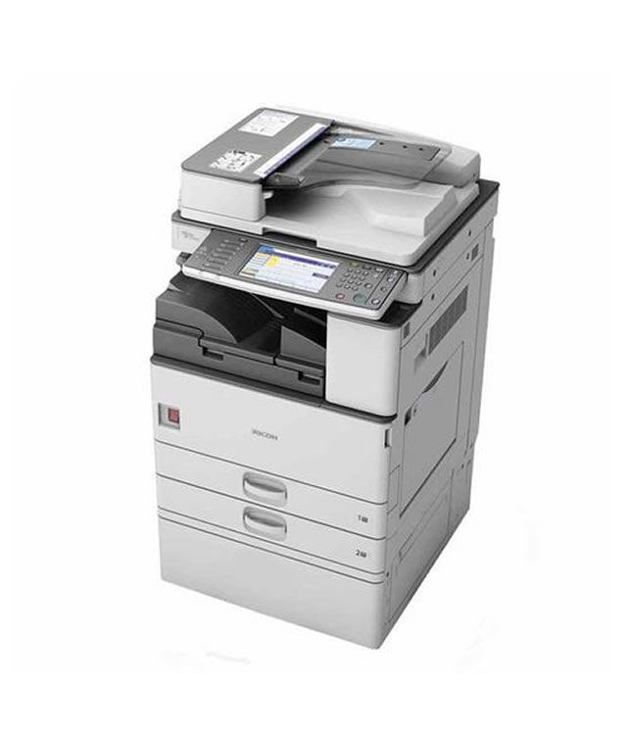
Ricoh aficio mp 2352
specs
- 23 papers per minute
- Functions: Print, Copy, Scan, Fax
- Up to 2 GB RAM/ 320 GB HDD
Price 75,00

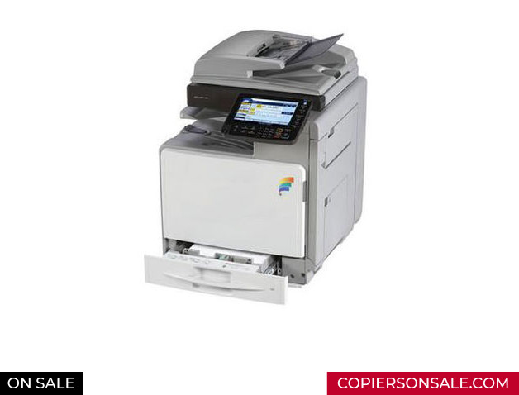
Ricoh Aficio Mpc 300
specs
Prints up to 32 ppm
print scan copy fax
67,000

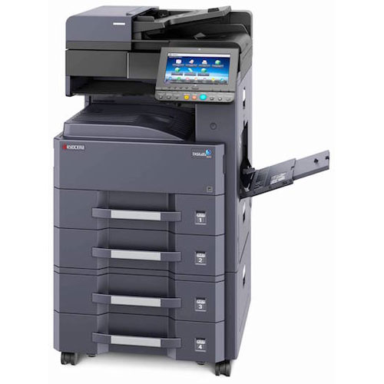
Kyocera Taskalfa 3011i
-up to 30 a4 pages per minute
-2 gb ram,320gb hdd
Price - 115,000

Kyocera 2560
-up to 25 a4 pages per minute
price 76,000

