|  |  |
| --- | --- |
| How to | Earth observations – surface water extent |
| Description | View the latest processed satellite images showing surface water extents |
| Comments | The *italic* phrases correspond to the red markings in the screenshots.  Please be aware that the screenshots may deviate slightly from the application |
| version | 2018-02 |

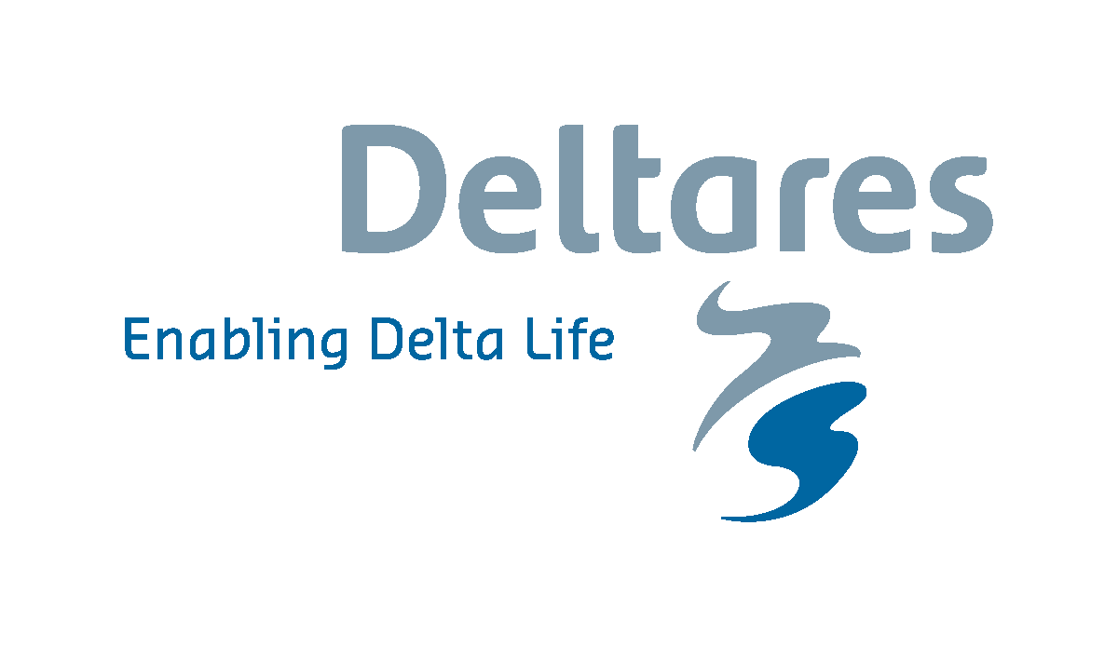  
Geoscience Australia has developed a product based on the Sentinel-2 data that determines the surface water extent. This is the Normalised Difference Water Index (ndwi)- a derived index that correlates well with the existence of water. Please note that this data shows both normal water bodies like lakes and rivers, but also event based surface water like flood extents.

They provide this as a 90-day rolling archive of daily Sentinel-2 Near Real Time data. The Near Real-Time capability provides analysis-ready data that is processed on receipt using the best-available ancillary information at the time to provide atmospheric corrections. The satellite covers only a strip of Australia at the time as it passes over on a daily basis. This is reflected in the data shown in Delft-FEWS, which shows the data as it was observed.

You can view this data in the *Spatial* display > Obs. (Flood Ops) > Sentinel Satellite data

