|  |  |
| --- | --- |
| How to | Archive of data |
| Description | Step by step guide to archiving of all data in ROWS |
| Comments | The *italic* phrases correspond to the red markings in the screenshots.  Please be aware that the screenshots may deviate slightly from the application |
| version | 2018-02 |

  
Description of the archiving of data. Tagging of data as events is described in a separate document.

**Non-simulated data:** The workflow Export_ToArchive runs several modules, archiving all non-simulated data (both RiverOps and FloodOps). This task is scheduled to run daily automatically but can be forced from the OC as well.

**Simulated data:** Archive tasks are coupled to the official model workflows. The different models are exported to different subfolders, each containing the files Runinfo.xml and metaData.xml, as well as the folder /timeseries / with the simulated data. This has been implemented for:

* URBS
* RTC-Tools
* MDBC_OPS
* ..
* ..

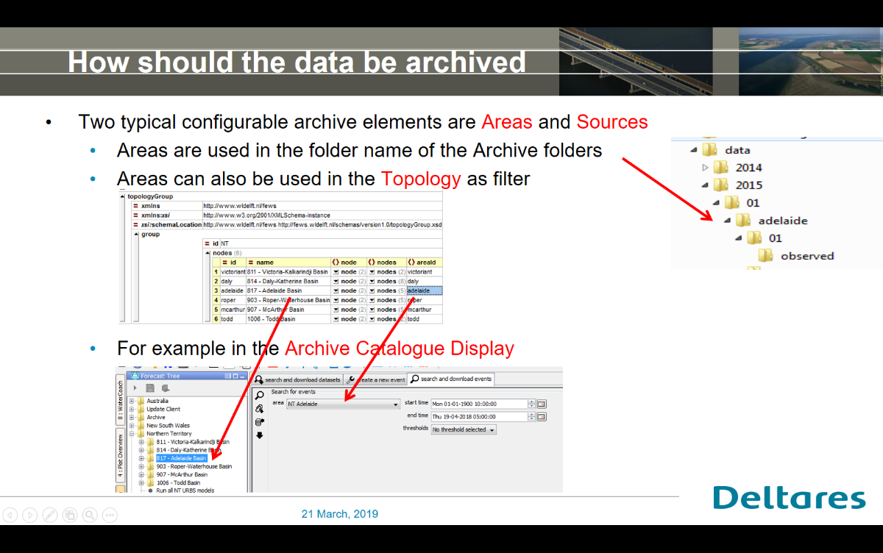**Snapshot:** The workflow Export_ToArchive_Snapshot archives a copy of the current localDataStore to the archive. This task has to be run manual, and with care.

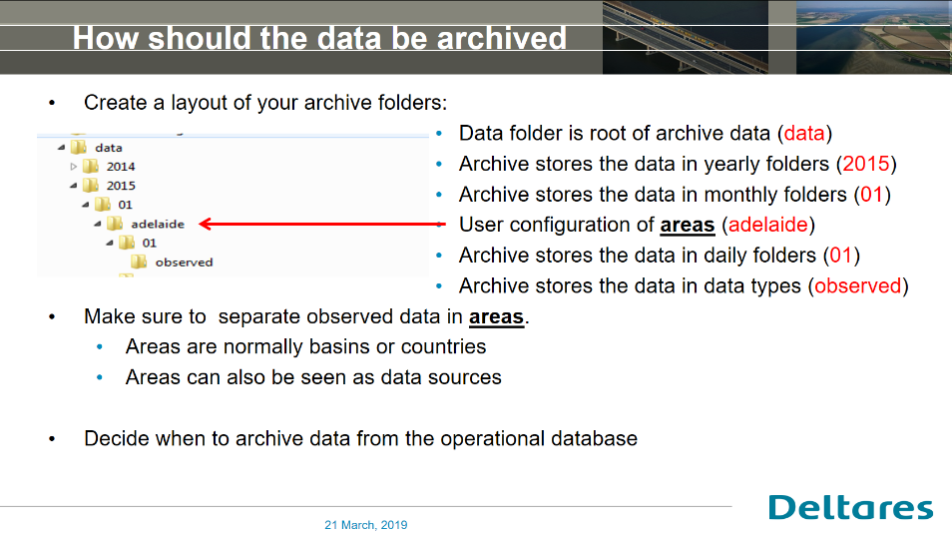

**AreaId**

* mdba - all data uses this areaId

**SourceId**

* RiverOps / FloodOps
* 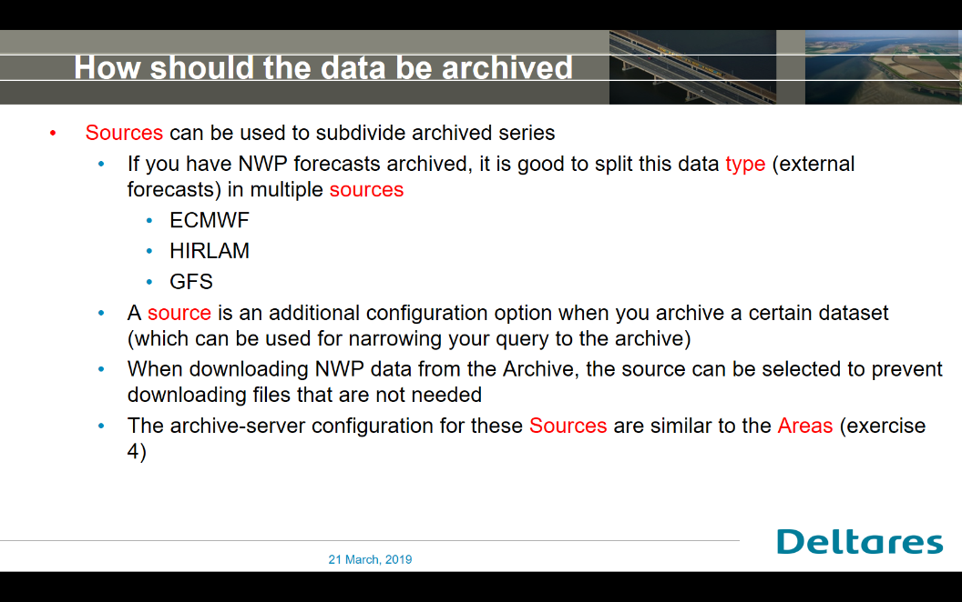ACCESSR/ ACCESSG/ ADFD/ PME