|  |  |
| --- | --- |
| How to | Overview of documentation on the Open Archive |
| Description | Step by step guide to configure archiving tasks for data in ROWS |
| Comments | The *italic* phrases correspond to the red markings in the screenshots.  Please be aware that the screenshots may deviate slightly from the application |
| version | 2018-02 |

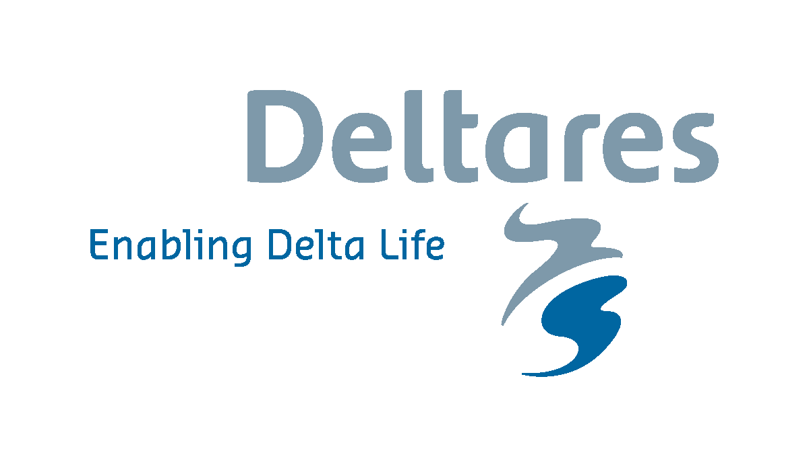

Archiving a flood event

* User guide - [publicwiki - 25.+Using+the+Deltares+Open+Archive](https://publicwiki.deltares.nl/display/FEWSDOC/25.+Using+the+Deltares+Open+Archive)
* OC - [publicwiki - 10+Archiving+Display](https://publicwiki.deltares.nl/display/FEWSDOC/10+Archiving+Display)
  + Tagging of events by the operators
* Archive Files - \\cbrnas05.prod.local\rows\data\ArchiveServer

Archive tasks

* Configuration - [publicwiki - 22+Exchange+with+the+Deltares+Open+Archive](https://publicwiki.deltares.nl/display/FEWSDOC/22+Exchange+with+the+Deltares+Open+Archive)
  + Datasets are exported to the archive in a workflow using the ExportArchiveModule. This workflow needs to be scheduled on a regular interval to archive all relevant data.
  + Once downloaded, the data can be imported using the ImportArchiveModule. The original timeseries definition is included in the netcdf files during the archive export process.
* Admin Interface - [publicwiki - Archive+Admin+Console+User+Guide](https://publicwiki.deltares.nl/display/FEWSDOC/Archive+Admin+Console+User+Guide)   
  Scheduling of archive workflows, eg:
  + daily: config, notes, ratings, ext hist, ext fcst
  + forecast run: simulated, model states, reports, modifiers

Archive Server

* Installation - [publicwiki - Deltares+OpenArchive+2017.01+and+newer+-+installation](https://publicwiki.deltares.nl/display/FEWSDOC/The+Deltares+OpenArchive+%282017.01+and+newer%29+-+installation)
* Configuration Server - [publicwiki - Configuration+of+the+Delft-FEWS+Archive+Server](https://publicwiki.deltares.nl/display/FEWSDOC/Configuration+of+the+Delft-FEWS+Archive+Server)
  + The installation of the archive server is usually done by a system administrator.
  + The configuration of archive is usually done by a hydrologist
    - Areas: mdba
    - Sources: FloodOps, RiverOps,   
      ACCESSG, ACCESSR, ADFD, PMEt
    - Event types:
    - Task scheduling, Data management tool (expiry times in both CDB and archive)