|  |  |
| --- | --- |
| How to | D:\projecten\1210326 MDBA ROWS (local, See N)\C. Report - advise\Workshops\2015-02 workshop 3 UAT, end user training\Screenshots\DELTARES_ENABLING_RGB.pngArchive – download and import data |
| Description | Find and download the correct data from the archive |
| Comments | Please be aware that the screenshots may deviate slightly from the application |
| version | 2016-01 |

After a (flood) event, the relevant data should be archived and marked as a watercoach event.   
This How-To describes how to download and import data stored in the archive.

## Prepare Stand Alone system

1. Remove the LDS by removing the folder localDataStore before you start ROWS
2. Clean out the download archive folder
3. Start ROWS in Stand Alone mode

## Archive Catalogue display

1. Go to the tab “Search for events”
2. Find data and download the events marked as a watercoach event (event type = watercoach event, see screenshot)
3. Find data from each river basins and download the events marked as a watercoach event

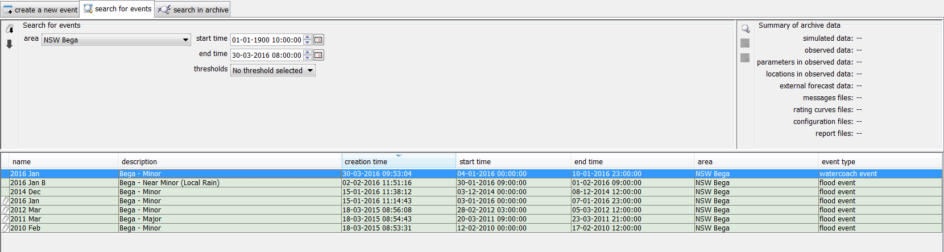 

1. Go to the tab “Search and download datasets”
   1. Find the latest rating curves and download them (Dataset: rating curve)
2. 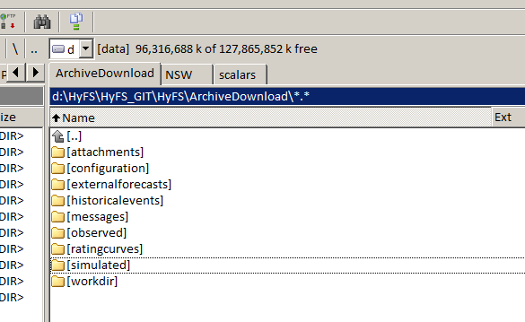In the archive download folder remove any datasets you don’t want to import.
   1. Remove the NWP datasets that are not relevant to the event from the folder “externalforecasts”. This is an important step to minimize the size of the LDS.
3. Import the archived data from the Forecast Tree   
   Note: Make sure you start with an empty LDS (see step 1)