|  |  |
| --- | --- |
| How to | D:\projecten\1210326 MDBA ROWS (local, See N)\C. Report - advise\Workshops\2015-02 workshop 3 UAT, end user training\Screenshots\DELTARES_ENABLING_RGB.pngConfiguration – Add a new Data Entry Group |
| Description | Step by step description of how extend the configuration with a new Data Entry Group |
| Comments | The *italic* phrases correspond to the red markings in the screenshots.  Please be aware that the screenshots may deviate slightly from the application |
| version | 2015-02 |

Overview of steps:

1. Update meta data with proper content of columns DATA\_ENTRY, DATA\_ENTRY\_SEQ, DATA\_ENTRY\_PARAMS for the new data entry group
2. Copy file LocastionSets\_de.xml and edit
   1. Search and replace 'de.' with '<region>.'
   2. Search and replace 'de2MDBC\_OPS' with '<region>2MDBC\_OPS'
   3. Search and replace 'de2HYDRO' with '<region>2HYDRO'
   4. Search and replace 'de2EWSRC\_RO' with <region>2EWSRC\_RO'
   5. For LocationSet Goolwa.sites change “<attributeExists id="DATA\_ENTRY\_PARAMS"/>” to <attributeTextContains id=" DATA\_ENTRY" contains="Goolwa"></attributeTextContains>
   6. (Un)comment parameter sections when a particular parameter is (not) available for this data entry group, but not for Menindee
3. Edit Filters\_DataEntry.xml
   1. Copy filter Menindee\_DataEntry and update
   2. Copy filters Menindee\_DataEntry\_<par> and update
   3. Add filters <region>\_DataEntry\_<par> when missing compared to the locationSets. Make sure to use the right timeSeriesSetsId, and to add the id of the new filter to <region>\_DataEntry under foreignKey
   4. (Un)comment parameter sections when a particular parameter is (not) available for this data entry group, but not for Menindee
4. Copy file TopologyGroup\_Menindee.xml and update
5. Edit file Topology.xml and update
6. Edit file DisplayGroups\_opoDataEntry.xml
   1. Copy DisplayGroup Menindee\_OPO and update
   2. (Un)comment parameter sections when a particular parameter is (not) available for this data entry group, but not for Menindee
7. Start application and review error messages on missing locationsets. Repeat step 2c, 3c and 6c to remove any errors.

This instruction uses XMLSpy. Relevant shortscuts:

Alt+V+G Grid View

Alt+V+T Text View

Ctrl+H Search and Replace

Ctrl+K Comment/Uncomment (when in text view)

Example when adding Dartmouth as new data entry group

Folder Config/MapLayerFiles

Ad. 1. Update ROWS\_Locations.csv

Folder Config/RegionConfigFiles/DataEntry

Ad 2: Copy file LocationSets\_de.xml 🡪 LocationSets\_Dartmouth.xml

Open file LocationSets\_Dartmouth.xml in XMLSpy

1. (Ctrl+H) Search and replace all (case sensitive, including dot) 'de.' 🡪 'Dartmouth.'
2. (Ctrl+H) Search and replace all (case sensitive) 'de2MDBC\_OPS.' 🡪 'Dartmouth2MDBC\_OPS.'
3. Your data entry group may have less parameters than Menindee. Select the full block for this parameter to comment (Ctrl+K) when a particular parameter is not available for this data entry group, while it is available for Menindee

Select the block in Grid View

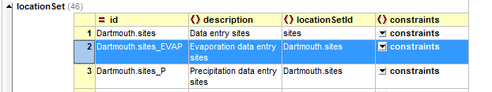

Go to Text View (Alt+V+T)

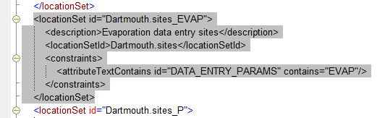

Comment (Ctrl +K)

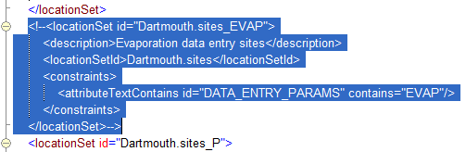

Back to grid view (Alt+V+G)

1. Your data entry group may have more parameters than Menindee. Select the full block for this parameter to uncomment (Ctrl+K) when a particular parameter is (not) available for this data entry group, but not for Menindee

Select the block in Grid View



Go to Text View (Alt+V+T)



Comment (Ctrl +K)



Back to grid view (Alt+V+G)

Folder Config/RegionConfigFiles/DataEntry

Ad 3: Open file Filters\_DataEntry.xml in XMLSpy

Go to Grid Mode (Alt+V+G)

1. Copy filter Menindee\_DataEntry and paste after this section. Select the filter just copied and replace within this selection: Menindee-->Dartmouth

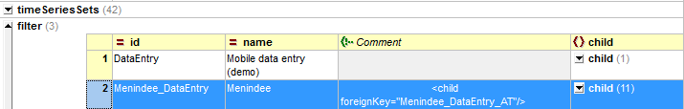

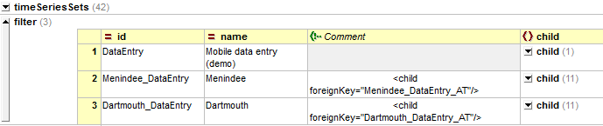

For each Parameter in the data entry group

1. Copy filter Menindee\_DataEntry\_<par> and paste. Select the filter just copied and replace within this selection: Menindee-->Dartmouth

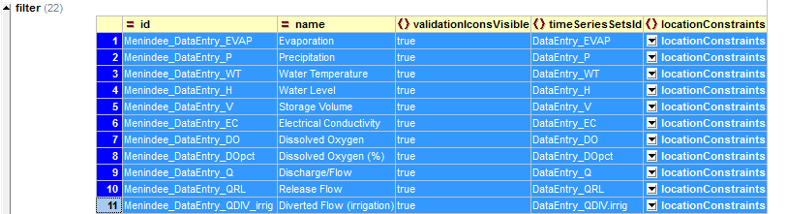

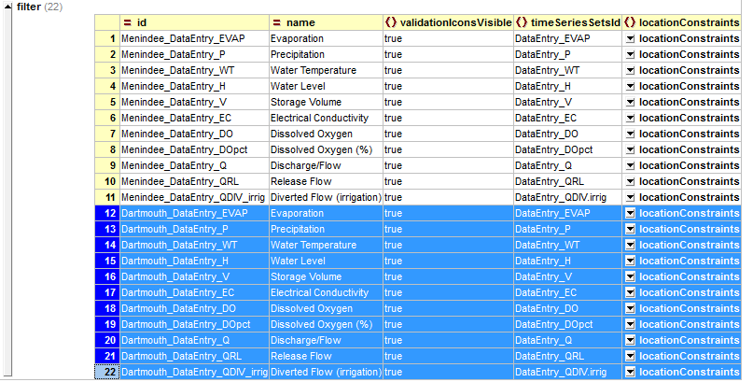

1. Your data entry group may have less parameters than Menindee. Select the full block for this parameter to comment (Ctrl+K) when a particular parameter is not available for this data entry group, but is available for Menindee
2. Your data entry group may have more parameters than Menindee. Copy filter Dartmouth\_DataEntry\_EVAP and paste. Within this new filter replace 'EVAP' by the new parameter. Make sure you use an entry as defined in the list of timeSeriesSets at the top of the file (see 3rd screenshot).

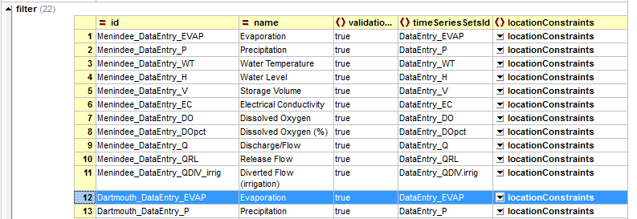

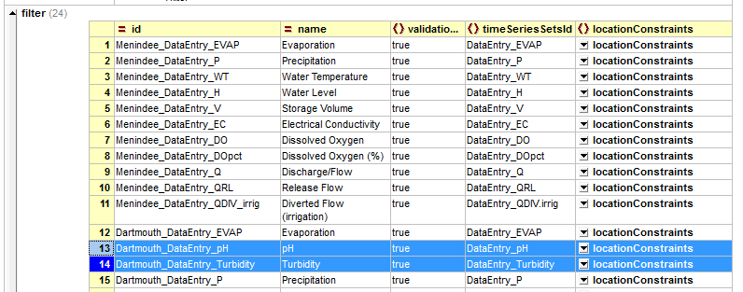

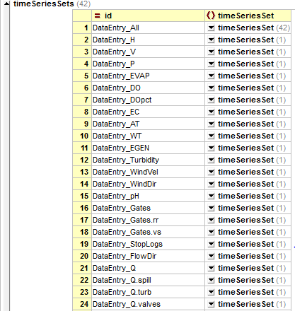

Folder Config/RegionConfigFiles/DataEntry

Ad 4: Copy file TopologyGroup\_Menindee.xml 🡪 TopologyGroup\_Dartmouth.xml

Open file TopologyGroup\_Dartmouth.xml in XMLSpy

1. (Ctrl+H) Search and replace all (case sensitive) 'Menindee' 🡪 'Dartmouth'

Folder Config/RegionConfigFiles

Ad 5: Open file Topology.xml in XMLSpy

1. Unfold in Grid View. Copy GroupId Menindee\_OPO and paste.
2. Update the groupId to Dartmouth\_OPO

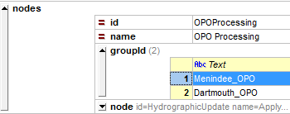

Folder Config/SystemConfigFiles

Ad 6: Open file DisplayGroups\_opoDataEntry.xml in XMLSpy

Go to Grid Mode (Alt+V+G)

1. Copy displaygroup Menindee\_OPO and paste after this section. Select the display group just copied and search and replace (ctrl+H) **within this selection only**: Menindee-->Dartmouth
2. Remove any display groups which do not exist for this location

