|  |  |
| --- | --- |
| How to | D:\projecten\1210326 MDBA ROWS (local, See N)\C. Report - advise\Workshops\2015-02 workshop 3 UAT, end user training\Screenshots\DELTARES_ENABLING_RGB.pngConfiguration – Add username to gain permission to the system |
| Description | Change what you see in ROWS, by selecting the right permissions |
| Comments | The *italic* phrases correspond to the red markings in the screenshots.  Please be aware that the screenshots may deviate slightly from the application |
| version | 2016-01 |

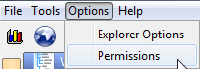Overview of the steps

1. Open the Permissions display via Options > Permissions
2. Activate the permissions you require:
   1. AllowDataEntry for ROWS
   2. AllowFlood for ROWS-Flood
3. 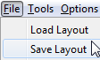Save your preferences via File > Save Layout

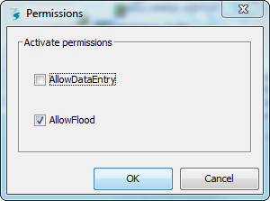Ad 2. The permissions display, in which you can select what is displayed in ROWS  
Note: The available permissions are linked to the login name (i.e. the windows login). To see how to add your user name to this list, please refer to the corresponding HowTo.

Ad 3 By saving your preferences, next time you start ROWS, it will open with the same permissions pre-selected.