|  |  |
| --- | --- |
| How to | D:\projecten\1210326 MDBA ROWS (local, See N)\C. Report - advise\Workshops\2015-02 workshop 3 UAT, end user training\Screenshots\DELTARES_ENABLING_RGB.pngConfiguration – Add username to gain permission to the system |
| Description | Step by step description of how add a username to the UserGroups.xml |
| Comments | The *italic* phrases correspond to the red markings in the screenshots.  Please be aware that the screenshots may deviate slightly from the application |
| version | 2016-01 |

1. Open the file ..\Config\SystemConfigFiles\UserGroups.xml in a text editor like notepad.
2. Copy an existing line defining an user and replace the user id with your Windows login name
3. Save the file and either
   1. Refresh ROWS-Flood : File > Reload Configuration (F5),
   2. Restart ROWS-Flood

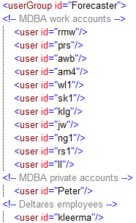Ad 2. This is what the content of UserGroups.xml looks like