|  |  |
| --- | --- |
| How to | D:\projecten\1210326 MDBA ROWS (local, See N)\C. Report - advise\Workshops\2015-02 workshop 3 UAT, end user training\Screenshots\DELTARES_ENABLING_RGB.pngRiver Operations – verify threshold crossings |
| Description | Step by step description of how to verify threshold crossings |
| Comments | The *italic* phrases correspond to the red markings in the screenshots.  Please be aware that the screenshots may deviate slightly from the application |
| version | 2016-01 |

Overview of steps

|  |  |
| --- | --- |
| 1. Run workflow 'Import from OPS Sheets' this workflow computes the threshold crossings on the MDBC\_OPS data 2. Open display 'Threshold Status Table' from Explorer toolbar 3. Pick from the reach of interest      1. Click on any value to go to the timeseries of the underlying threshold assessment. Both the parameter and the associated counter will show the same display. |  |

Ad 3: After step 3 a table overview is shown listing a row of sites. For each site, the table shows per parameter the actual value at the time of the slider and a counter of the total number of thresholds crossing since the beginning of the water year (June 1) until the slider time

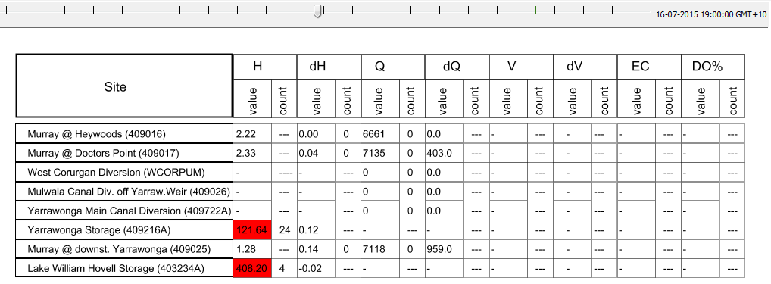

Figure Example showing list of sites, parameter values and threshold information

If a threshold crossing occurs at the time of the slider, the cell receives a color. A count cell showing '----' is an indication that no threshold has been defined for this location-parameter combination.

Given the extensive variation in threshold definitions for River Operator Objectives and Specific Objectives and Outcomes, the following color and code scheme has been applied:

|  |  |  |  |  |  |
| --- | --- | --- | --- | --- | --- |
| **Variable** | **SOFT** | **HARD** | **FSL** | **Salinity** | **DO%** |
| H | 101 | 102 | 103 |  |  |
| dH | 201 | 202 |  |  |  |
| Q / (Q-Qord) / Q related | 301 | 302 |  |  |  |
| dQ | 401 | 402 |  |  |  |
| V | 501 | 502 | 503 |  |  |
| dV | 601 | 602 |  |  |  |
| EC |  |  |  | 704 |  |
| DO% |  |  |  |  | 805 |

Table Threshold crossing code scheme

Ad 4:

The display is composed of at least two subplots. The top section shows the actual parameter value and the threshold definition. The bottom section shows the type of the threshold crossing (left axis, hits indicated by diamond dots), as well as the total count since the beginning of the water year (right axis).

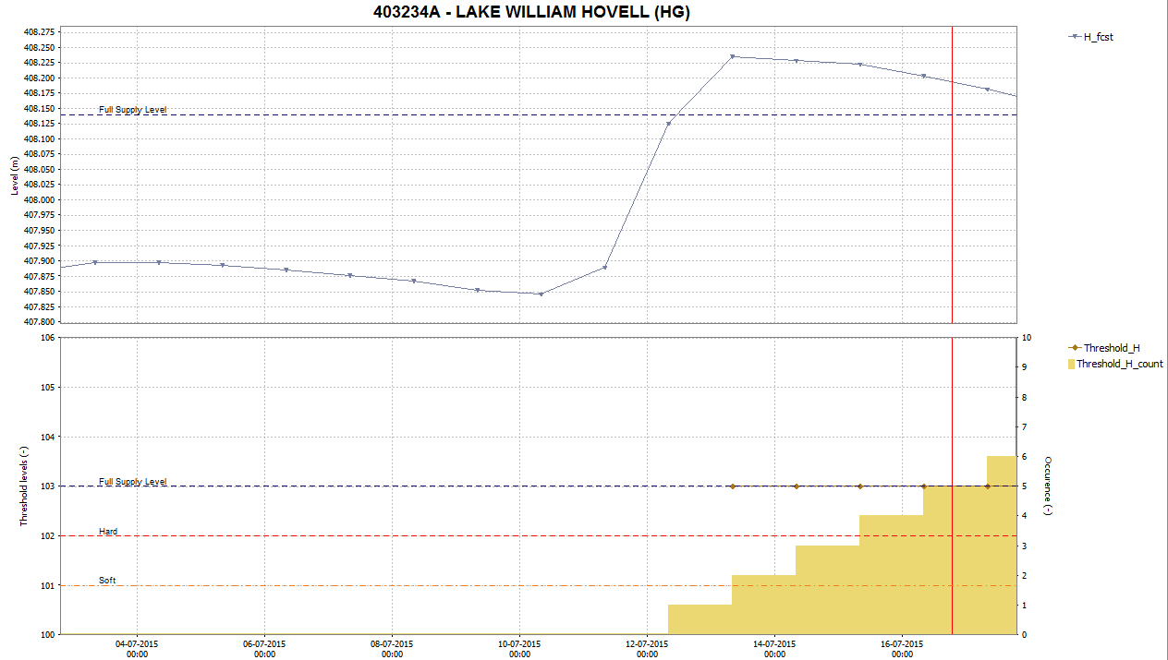

Figure 2 Example showing display crossing at Lake William Hovell