|  |  |
| --- | --- |
| How to | All threshold crossings in the system in a single system wide display |
| Description | Investigate threshold crossings that have occured when processing OPO data |
| Comments | “quotes” refer to the screenshots, which may deviate from the application |
| version | 2018-02 |

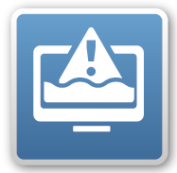  
A system wide display summarizes all threshold crossings currently in the system.  
Note: only workflows with the predefined activity ‘threshold event crossing’ are included in this display. Currently this is on ProcessOPO, but this can be easily extended.

1. Open the system wide threshold display via Tools > Threshold Display, or with CTRL + E.
2. This table display can be manipulated in the usual manner, e.g.:
   1. Sort on a column, by clicking on the header
   2. Find a value in a column, by clicking in the column and start typing (“Search for:” )
   3. Filter on a value by double clicking it (Filtered item gets blue background).  
      - filter (double click) on Module Instance "AssessThresholds<>_RO" to only show RO crossings
   4. Rearrange the order of columns by dragging them around.
   5. Open the time series display for a (couple of) line items with F9 (or context menu)

