|  |  |
| --- | --- |
| How to | D:\projecten\1210326 MDBA ROWS (local, See N)\C. Report - advise\Workshops\2015-02 workshop 3 UAT, end user training\Screenshots\DELTARES_ENABLING_RGB.pngView Water quality data in the Data Viewer |
| Description | D:\Software_delft-fews (local, See P)\Marketing\Icons (FEWS_logo_icon)\Delf-FEWS-256x256.pngImport and analyse water quality sample data |
| Comments | This is an excerpt of wiki page: https://publicwiki.deltares.nl/pages/viewpage.action?pageId=108954735 |
| version | 2016-01 |

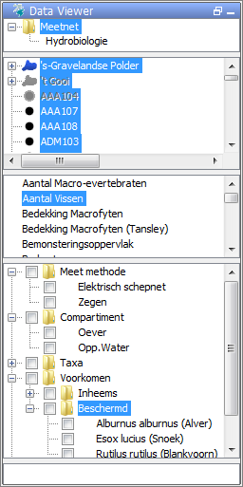  
**Data Viewer and qualifier tree**

in the Data Viewer, location(s), parameter(s), and qualifier(s) can be selected; qualifiers are used a sort of sub-parameters that define specific attributes of a parameter value, e.g. the parameter Mass of Fish (kg) can be further specified into different fish species (lucius esox, abramis brama, ...), gender (male, female), length class etc.; all these sub-parameters can be shown in a [qualifier tree](https://publicwiki.deltares.nl/display/FEWSDOC/23+Qualifiers" \l "id-23Qualifiers-QualifierTree), which can be configured by the user. The use of qualifiers helps to keep the parameter list small.

In the qualifier tree one can:  
\* toggle between different name conventions for the qualifiers, and  
\* use the on-the-fly summation tool to sum selected qualifiers for the active timeSeries (location(s) and parameter(s) selection)

D:\FEWS_2016.01\ROWS-MDBA_branchDeltares\Config\IconFiles\sample.pngIn the Water Quality Display (aka Sample Viewer) the user can view additional attributes that belong to the samples. See for more info: HowTo\_ROWS\_WaterQuality\_in\_SampleViewer

Example of a qualifier tree:

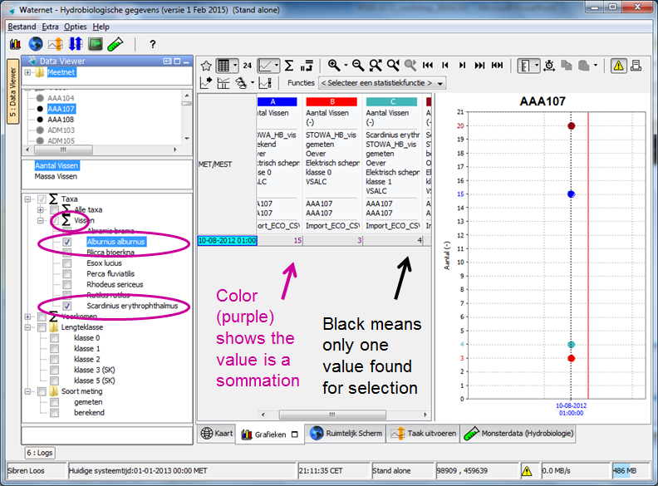Example of the on-the-fly summation feature: