|  |  |
| --- | --- |
| How to | D:\projecten\1210326 MDBA ROWS (local, See N)\C. Report - advise\Workshops\2015-02 workshop 3 UAT, end user training\Screenshots\DELTARES_ENABLING_RGB.pngView Water quality data in the Water Quality display |
| Description | D:\Software_delft-fews (local, See P)\Marketing\Icons (FEWS_logo_icon)\Delf-FEWS-256x256.pngAnalyse water quality sample data in the Sample Viewer of Delft-DEWS |
| Comments | This is based on the wiki page: https://publicwiki.deltares.nl/display/FEWSDOC/18+Sample+Viewer |
| version | 2016-01 |

**D:\FEWS_2016.01\ROWS-MDBA_branchDeltares\Config\IconFiles\sample.png**  
The sample viewer shows information about samples based on the selected locations in the Data Viewer. For the selected locations a list of samples is shown in the upper part of the sample viewer. In the lower part of the sample viewer the content of selected samples are shown.

**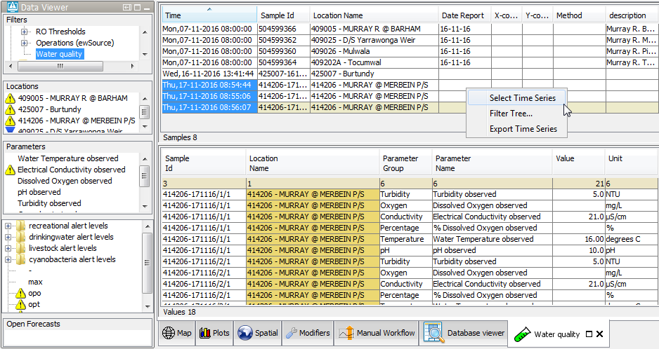Select samples:** Below the table with samples, all values of the time series of the selected sample(s) are shown. Multiple samples can be selected at the same time, increasing the list of displayed data.   
The samples selection can be copied to the filters in the Data Viewer when choosing the "select time series" option from the (right mouse) context menu (highlighted here with a red border). This also works the other way around: by selecting locations in the data viewer, the sample viewer automatically only shows samples for those locations.

**Filtering sample viewer:** 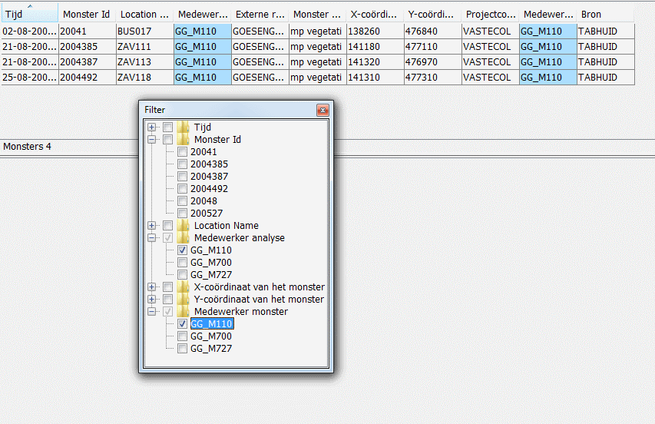The sample table can be filtered via the option Filter Tree in the (right mouse) context menu (see red bordered insert). This opens a window where you can select values for columns for which the entire table will be filtered (see image below). Columns on which filtering is applied will be shown with a light blue background. Filtering also works by double clicking on a cell in the sample table. Just as filtering from the filter window, this can be applied to multiple cells.

