|  |  |
| --- | --- |
| How to | D:\projecten\1210326 MDBA ROWS (local, See N)\C. Report - advise\Workshops\2015-02 workshop 3 UAT, end user training\Screenshots\DELTARES_ENABLING_RGB.pngRiver Operations – verify threshold crossings |
| Description | Step by step description of how to verify threshold crossings |
| Comments | The *italic* phrases correspond to the red markings in the screenshots.  Please be aware that the screenshots may deviate slightly from the application |
| version | 2016-01 |

Data used for Threshold Status Display is from MDBC\_OPS and OPS sheets. Hourly data for site 401211A Coleman’s is from telemetry. Data used for email alerts is from OPO. Workflows – Import MDBC\_OPS and Prepare Thresholds are scheduled once a day.

There are several ways to check the threshold breaches.

**Threshold Status Table**

1. Open display 'Threshold Status Table' from Explorer toolbar 
2. Pick from the reach of interest. SO&O and RO (operational) rules are split for each reach for river operators’ convenience.

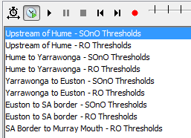

1. An overview table is shown listing a row of sites. For each site, the table shows per parameter the actual value at the time of the slider and a counter of the total number of thresholds crossing since the beginning of the water year (June 1) until the slider time. For checking the threshold rules used here, please find ‘Reference\_ROWS Threshold Rules’ document from ‘Document Overview’ tab.

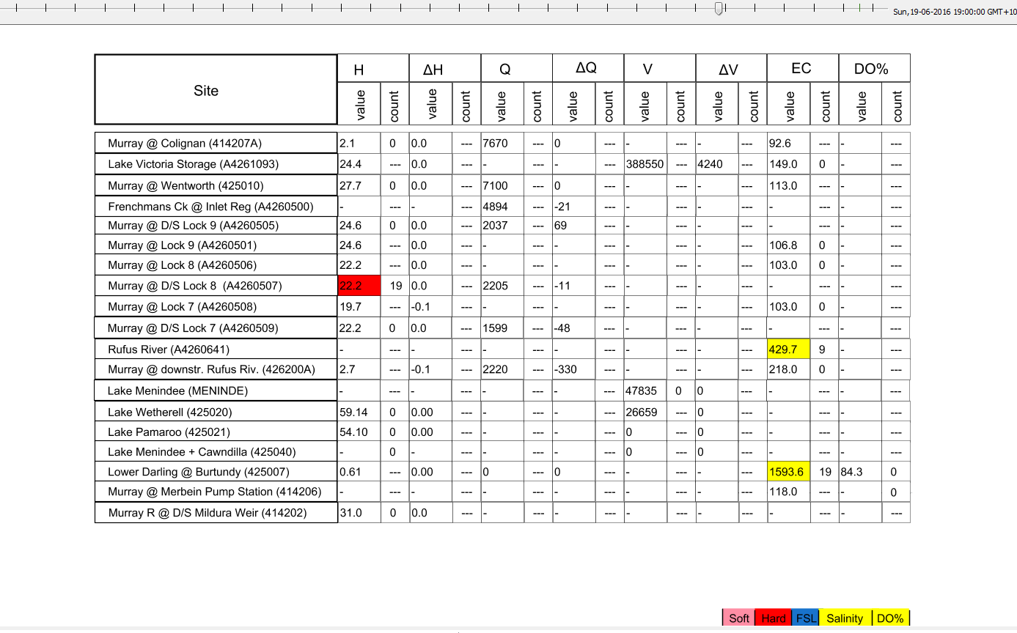

1. The default view period is last 30 days. It can be changed via ‘View Period of Time Slider’ window.

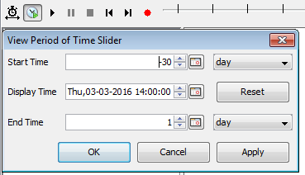

1. If a threshold crossing occurs at the time of the slider, the cell receives a color. The legend shows the different levels of the threshold breaches. A count cell showing '---' is an indication that no threshold has been defined for this location-parameter combination.

Note: It only counts the total breaches of “Hard”, “Salinity” and “DO%” since the beginning of the water year.



1. Click on any value to go to the time series of the underlying threshold assessment. Both the parameter and the associated counter will show the same display. The display is composed of at least two subplots. The top section shows the actual parameter value and the threshold definition. The bottom section shows all type of the threshold crossing (left axis, hits indicated by diamond dots), but only the “Hard”, “Salinity” and “DO%” breaches are taken into account of the total accounts since the beginning of the water year (right axis, bars). For example, the graph shown below shows one “Hard” crossing and many “Soft” crossings for site downstream Yarrawonga Weir. The annual total count is “1”.

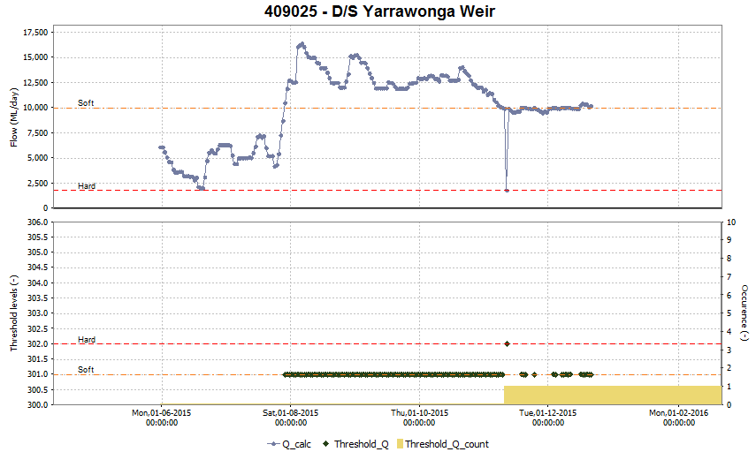

1. Given the extensive variation in threshold definitions for River Operator Objectives and Specific Objectives and Outcomes, the following color and code scheme has been applied:

|  |  |  |  |  |  |
| --- | --- | --- | --- | --- | --- |
| **Variable** | **SOFT** | **HARD** | **FSL** | **Salinity** | **DO%** |
| H | 101 | 102 | 103 |  |  |
| dH | 201 | 202 |  |  |  |
| Q / (Q-Qord) / Q related | 301 | 302 |  |  |  |
| dQ | 401 | 402 |  |  |  |
| V | 501 | 502 | 503 |  |  |
| dV | 601 | 602 |  |  |  |
| EC |  |  |  | 704 |  |
| DO% |  |  |  |  | 805 |

1. By clicking ‘Threshold Crossing’ in ‘Table’ button drop-down list. Cells in the table are colour coded for the threshold breaches.

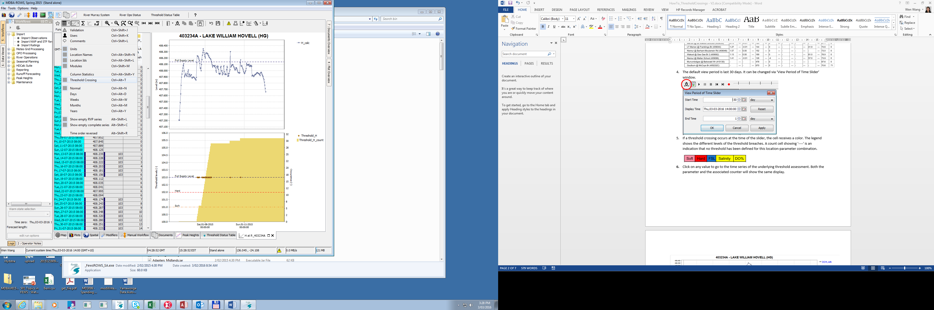

**Data Viewer Group**

The same threshold reach groups and plots can also be viewed from ‘Data Viewer’

1. Select the reach of interest from ‘Data Viewer’ tab. SO&O and RO rules are split for each reach for river operators’ convenience.
2. Select the location and parameters of interest.
3. Choose ‘Plots’ tab to view the display.

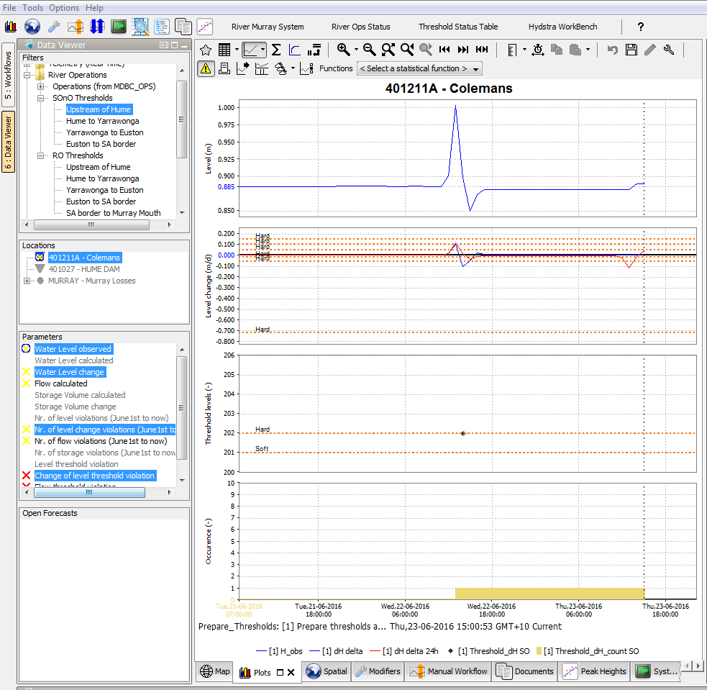

**Threshold reporting**

The threshold reports list breach values and relevant ‘Operator Notes’ made by river operators. The threshold reports include SO&O, RO and combination reports.

1. Select workflow – Export threshold crossings HTML report from ‘Workflows’ tab, and then click “edit run options” button

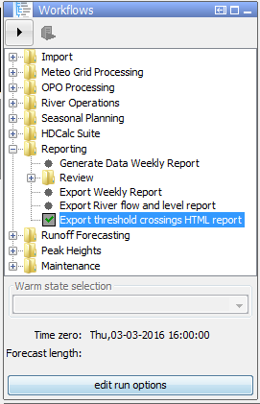

1. Check box “Select initial state” and select “Cold state”. Specify the start date of the reporting period. Then click “OK” button

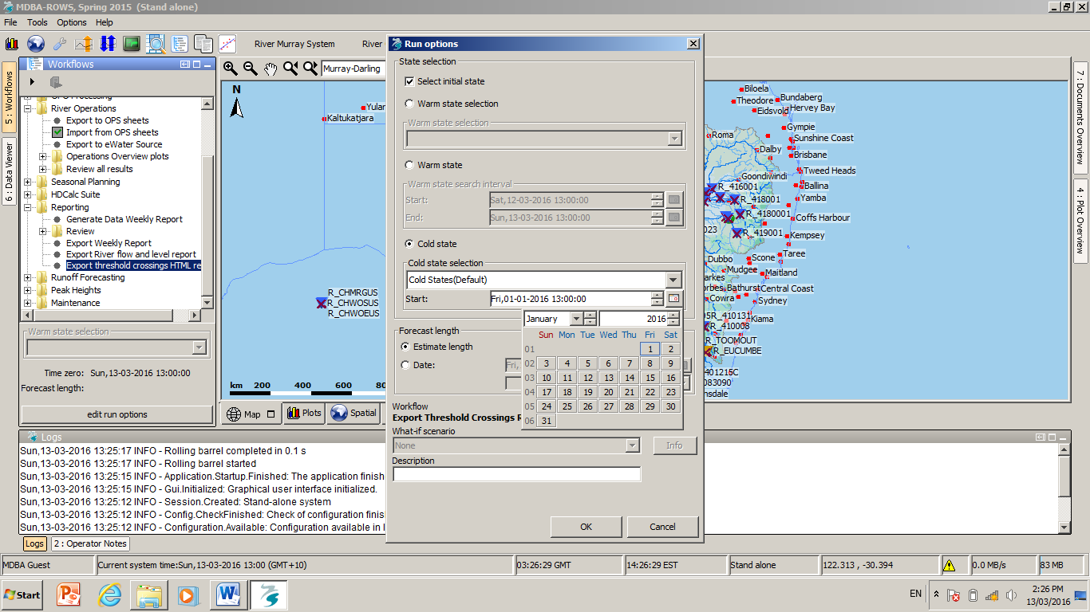

1. Workflow – Export Threshold Crossings Report reports runs locally. The reports are exported to directory C:\ROWS\FewsROWS\_OC-LDS\Export\Reports

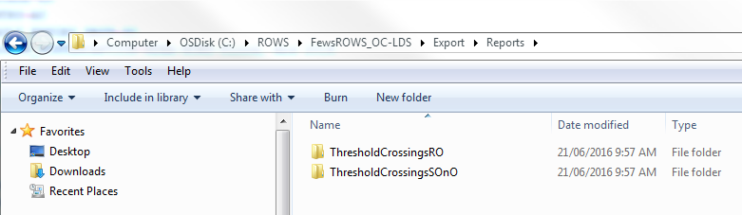

**Email alerts**

ROWS sends alerts via email when a threshold is triggered from a user defined site/parameter combination daily operations “opo” data is generated from raw observed telemetry data. Currently only DO% threshold (50%) is configured in the email alerts. The email notification should be limited to once per day incorporating all incidents.