|  |  |
| --- | --- |
| How to | D:\projecten\1210326 MDBA ROWS (local, See N)\C. Report - advise\Workshops\2015-02 workshop 3 UAT, end user training\Screenshots\DELTARES_ENABLING_RGB.pngImport observed data |
| Description | Step by step description of how to perform a specific task in ROWS. |
| Comments | The *italic* phrases correspond to the red markings in the screenshots.  Please be aware that the screenshots may deviate slightly from the application |
| version | 2015-02 |

Overview of steps

1. Execute workflow *Import Observations*,
2. Check in the *Logs* display that the task has completed succesfully
3. Import data manually if necessary. *Execute* corresponding *workflow* in *Workflow display*. 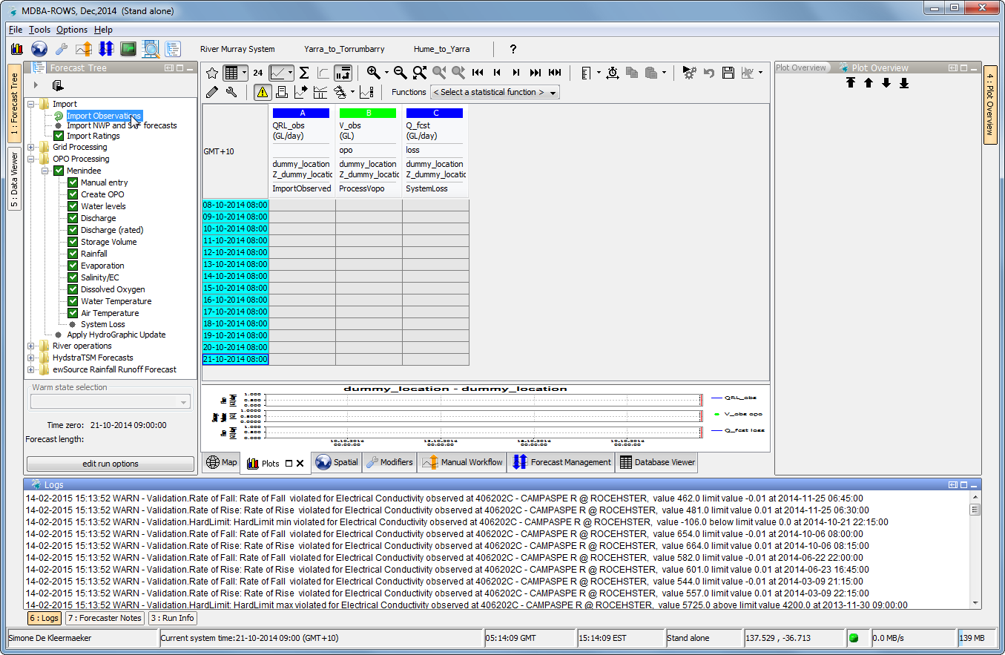
4. In *Logs display* you can see the workflow has *completed* successfully.