|  |  |
| --- | --- |
| How to | D:\projecten\1210326 MDBA ROWS (local, See N)\C. Report - advise\Workshops\2015-02 workshop 3 UAT, end user training\Screenshots\DELTARES_ENABLING_RGB.pngQuality Control - Create OPO: process observed data |
| Description | Step by step description of how to perform a specific task in ROWS. |
| Comments | The *italic* phrases correspond to the red markings in the screenshots.  Please be aware that the screenshots may deviate slightly from the application |
| version | 2015-02 |

Shortcuts:

|  |  |  |
| --- | --- | --- |
| **Shortcut** | **What** | **Where** |
| CTRL-ALT-E | Switch to edit mode | Plots |
| SHFT-F4 /F3 | Next / Previous location | Plot overview |
| Keyboard arrows | Similar behaviour to Excel | Plots, in Table view, while in edit mode |
| Enter | Store changes permanently in database | Plots, while in edit mode |

  
Overview of steps

1. Select and execute workflow *Quality Control*,
2. Open *Plot Overview* display (for navigation and overview);  
   Go to the *Plots* display ; Enable the *Table View*;
3. Investigate the raw telemetry data, the automatic validation and the resulting OPO series.



1. Select and execute workflow *Quality Control <SHFT-F9>*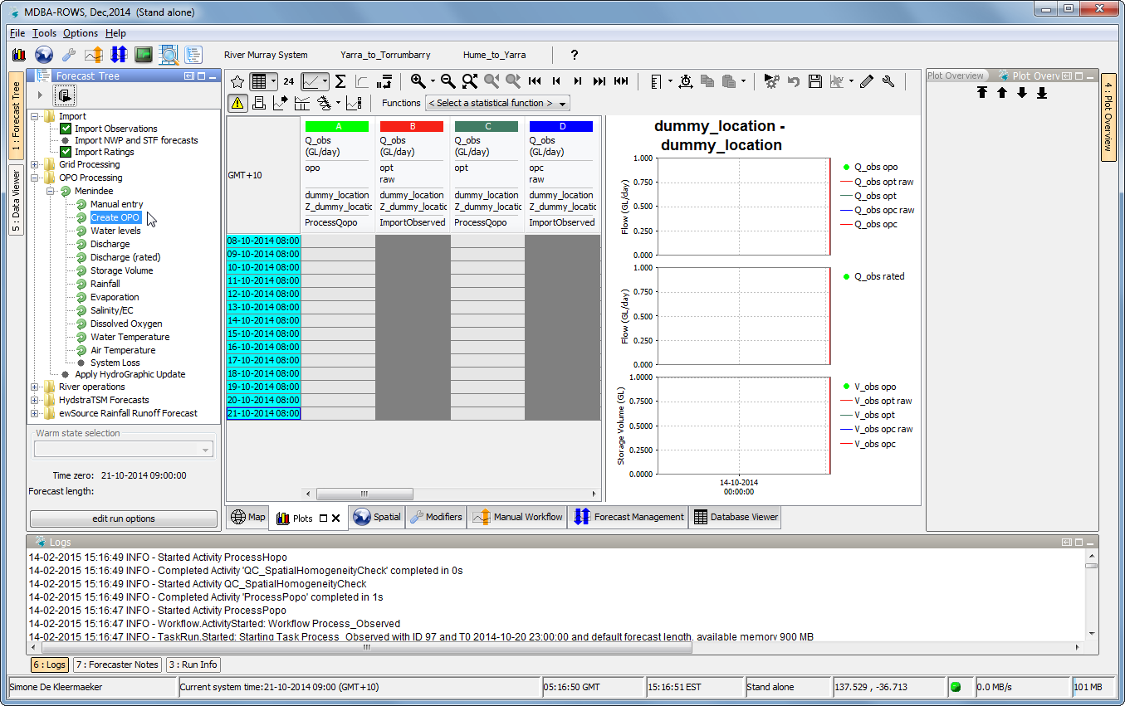
2.  Open both the *Plot*  and *Plot Overview Display* (right side of the screen). Plot overview gives an overview of the available data (useful for quick quality control scan).   
   Enable *Table View* in the *Plots display*. You can *pivot* graphs and Tables with*. 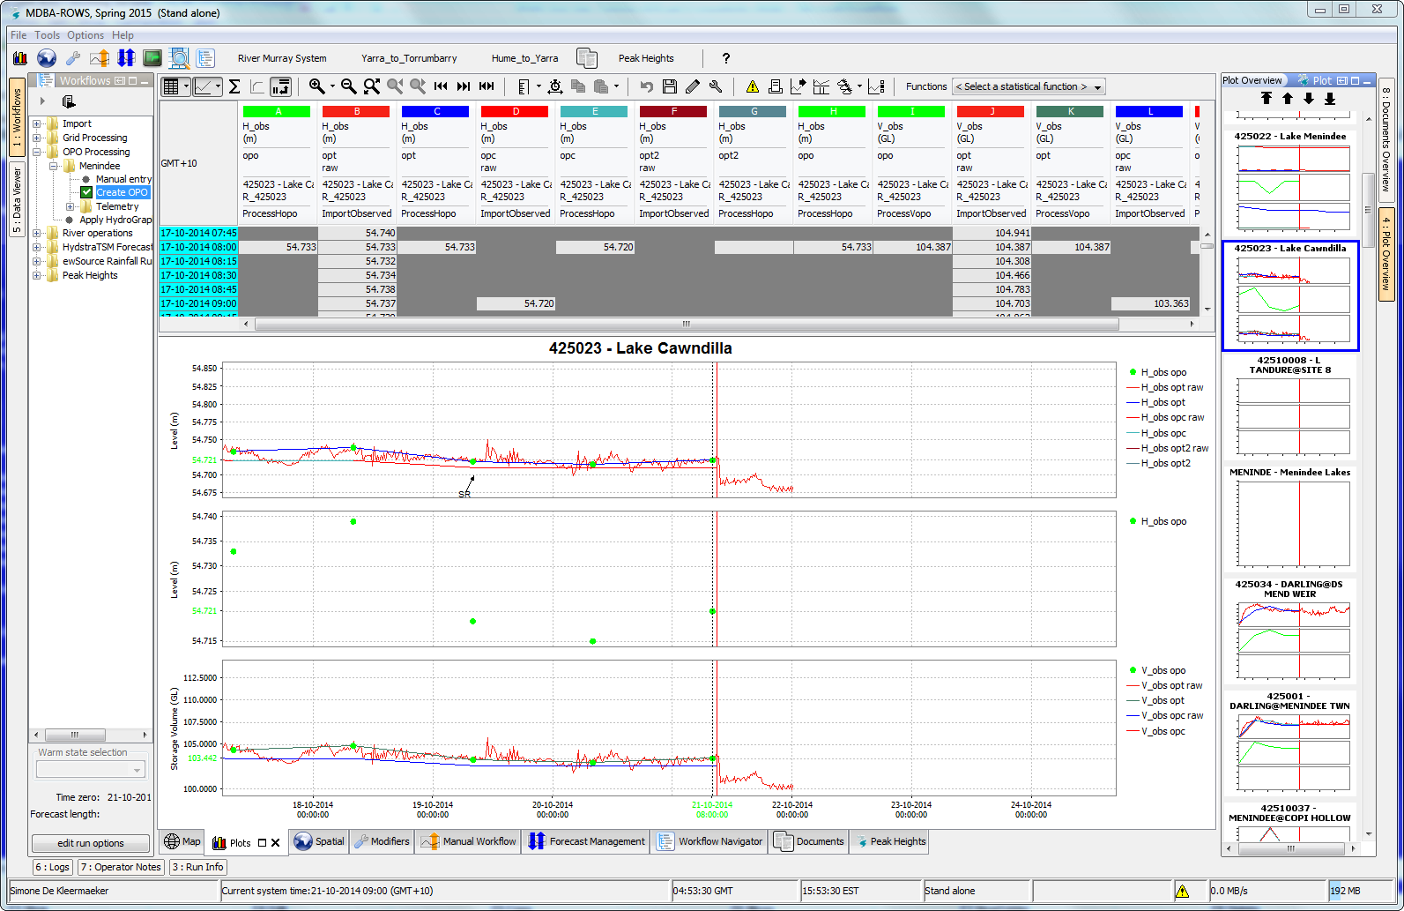*
3. Investigate the raw telemetry data and any results from the automatic validation;  
   The raw telemetry is processed into the OPO series.   
   For navigation, use the buttons (SHFT-F3 and SHFT-F4) or the arrow keys on the keyboard.  
   Enable edit mode (CTRL+ALT+E) and place the cursor in Table.