|  |  |
| --- | --- |
| How to | D:\projecten\1210326 MDBA ROWS (local, See N)\C. Report - advise\Workshops\2015-02 workshop 3 UAT, end user training\Screenshots\DELTARES_ENABLING_RGB.pngData entry |
| Description | Step by step description of how to perform a specific task in ROWS. |
| Comments | The *italic* phrases correspond to the red markings in the screenshots.  Please be aware that the screenshots may deviate slightly from the application |
| version | 2015-02 |

Shortcuts:

|  |  |  |
| --- | --- | --- |
| **Shortcut** | **What** | **Where** |
| CTRL-ALT-E | Switch to edit mode | Plots |
| SHFT-F4 | Next location | Plot overview |
| SHFT-F3 | Previous location | Plot overview |
| Keyboard arrows | Similar behaviour to Excel | Plots, in Table view, while in edit mode |
| Enter | Store changes permanently in database | Plots, while in edit mode |
| Context menu | Overview of all edit option | Plots, in Table view, while in edit mode |

Overview of steps

1. Select workflow *Data Entry;*
2.  Open *Plot* display and the *Plot Overview* display;  
   Go to the *Plot* display, enable *Table view*, you can pivot the plots and tableActivate *edit mode* (CTRL-ALT-E), edited data is coloured magenta
3. Navigate through the *Plot Overview* with SHFT-F4 and SHFT-F3; Save the edits / data entry
4. Context menu in edit mode gives many more options to edit
5. Select workflow *Data Entry* in the *Workflow* Display
6. Open both the *Plot*  and *Plot Overview Display* (right side of the screen). Plot overview gives an overview of the available data (useful for quick quality control scan).   
   Enable *Table View* in the *Plots display*. You can *pivot* graphs and Tables with*.*enable edit mode (CTRL+ALT+E) and place the *cursor* in Table 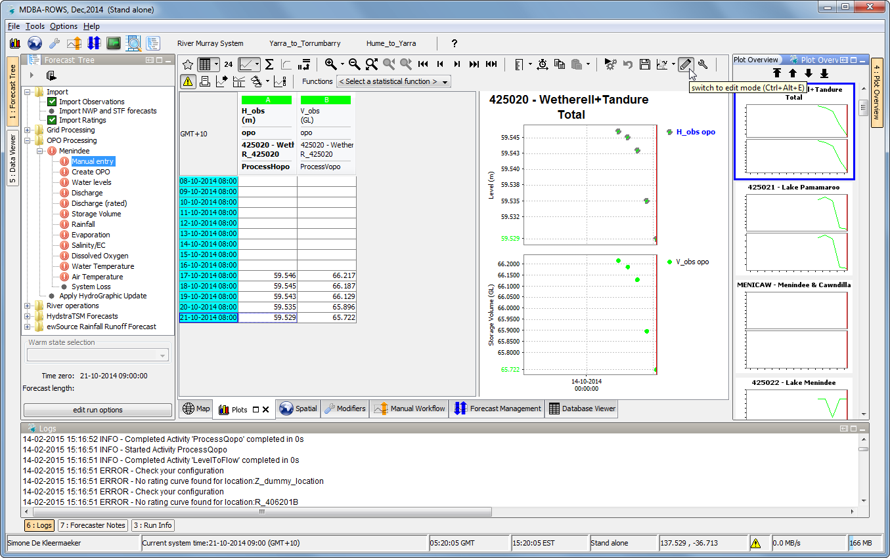
7. In the *Plot Overview* you can see data has been created. For navigation, use the *buttons* (SHFT-F3 and SHFT-F4) or the arrow keys on the keyboard   
   Manual entered (edited) data is coloured *magenta*.   
   When switching to the next location, ROWS will ask you to confirm the edit (enter to accept).   
   The same time slot will keep focus in Table when moving to next location using the shortcuts.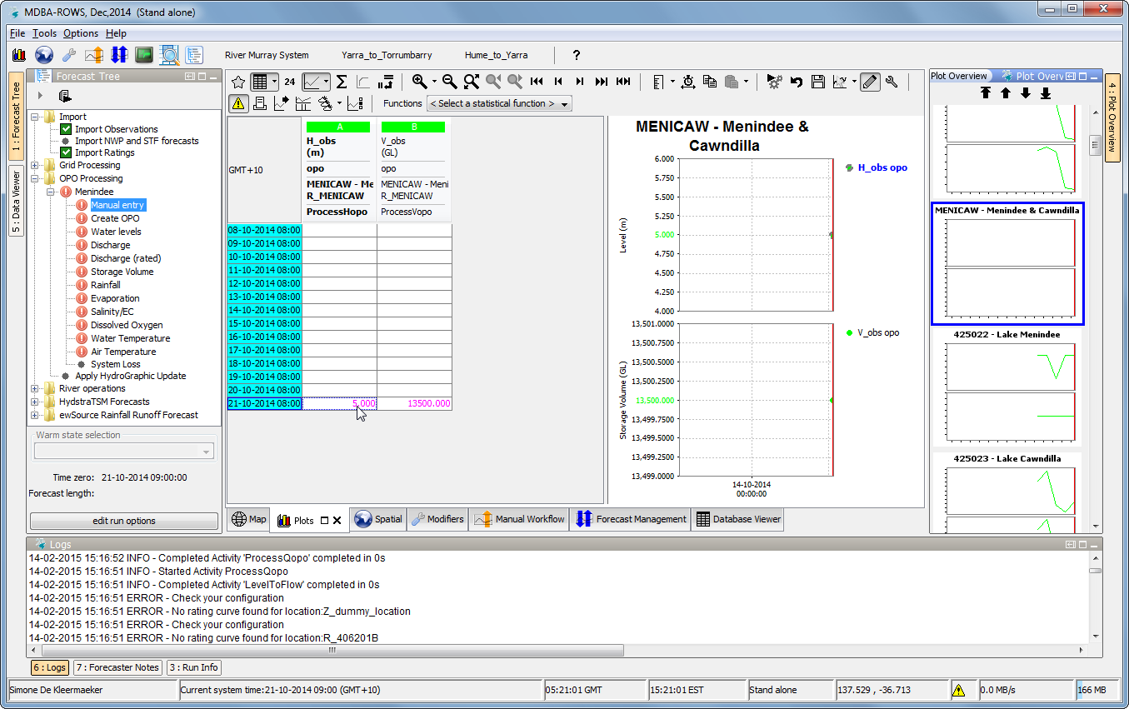
8. *Context menu* (i.e. right mouse click in table) in edit mode gives many more options to edit 