|  |  |
| --- | --- |
| How to | D:\projecten\1210326 MDBA ROWS (local, See N)\C. Report - advise\Workshops\2015-02 workshop 3 UAT, end user training\Screenshots\DELTARES_ENABLING_RGB.pngModify OPO |
| Description | Step by step description of how to perform a specific task in ROWS. |
| Comments | The *italic* phrases correspond to the red markings in the screenshots.  Please be aware that the screenshots may deviate slightly from the application |
| version | 2015-02 |

Shortcuts:

|  |  |  |
| --- | --- | --- |
| **Shortcut** | **What** | **Where** |
| CTRL-M | Switch to modifier mode | Plots |
| SHFT-F4 | Next location | Plot overview |
| SHFT-F3 | Previous location | Plot overview |
| Keyboard arrows | Similar behaviour to Excel | Plots, in Table view, while in edit mode |
| Context menu | Overview of all edit option | Plots, in Table view, while in edit mode |

Overview of steps

1. Select workflow *Data Entry;*
2. Open *Plot Overview* display;   
   Go to the *Plot* display, enable *Table view*, you can pivot the plots and table  
   Activate *modifier mode* (CTRL-M
3. Navigate through the *Plot Overview* with SHFT-F4 and SHFT-F3;  
   Select the parameter / cell you want to modify;   
   Save the modifications, modified data is shown in dark blue
4. A modifier has been created in the *Modifiers* display, for the new modification
5. *Re-run* the workflow at the server
6. Context menu in edit mode gives many more options to edit
7. Select the workflow *Data Entry* in the *Workflow* display; the modifiers will be connected to this workflow
8. Open both the *Plot*  and *Plot Overview Display* (right side of the screen).   
   Enable *Table View* in the *Plots display*. You can *pivot* graphs and Tables with . Activate the *modifier* mode. *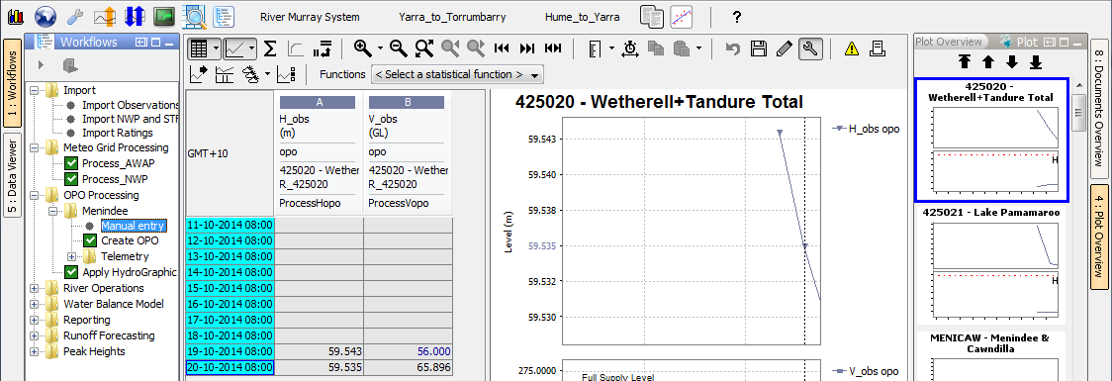*
9. Navigate through Plot Overview with (SHFT-F4 and SHFT-F3) to the location you want to modify and select the series (i.e. column or cell) you want to modify in the Table view. This column will now get a white background, to indicate you can modify it.  
   Save your modifications with . The modified data is shown in dark blue
10. Go to the *Modifier* display to check that a new modifier has been created, corresponding to the change you just made. This modification can be (de-)activated or deleted from the Modifiers display, once the change has been made persistent or is no longer necessary..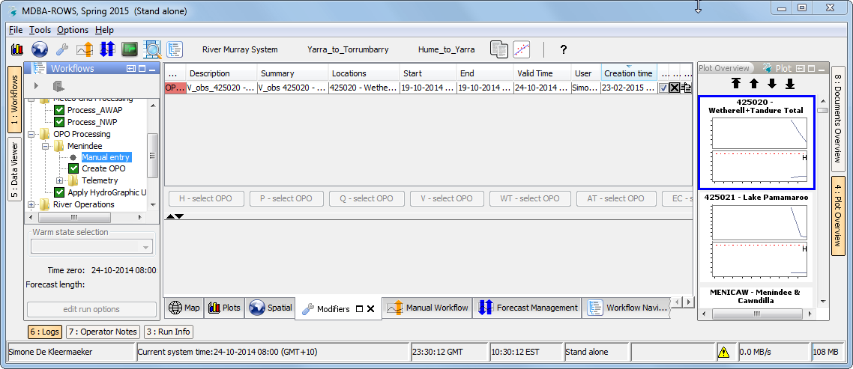



1. *Re-run* the workflow at the server (Shift+F9) 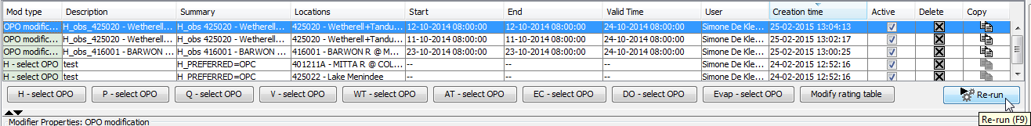
2. *Context menu* (right mouse click in table in *Plots*) in modifier mode has more edit options 