|  |  |
| --- | --- |
| How to | QA of rain gauges |
| Description | How to temporarily excluded the use of rain gauges in ROWS |
| Comments | The *italic* phrases correspond to the red markings in the screenshots.  Please be aware that the screenshots may deviate slightly from the application |
| version | 2018-02 |

  
The observed rain fall from rain gauges is used in displays throughout ROWS, as well as input for models like URBS. When a rainfall gauge is producing faulty data, the operator can manually disable this gauge temporarily in ROWS.

1. Open the Spatial display > Observations (Flood Ops) > Precipitation to analyse the spatial pattern created from the gauge data and look for faulty gauges.
2. Select Workflows > Flood Ops > Import and process observations
3. In the Modifier display, select the faulty gauge and apply a modifier (i.e. set to missing). Change the default start and end time as required.
4. Rerun the workflow and observed how in the Spatial display that the modified gauge is no longer included in the transformations (see insert below)
5. 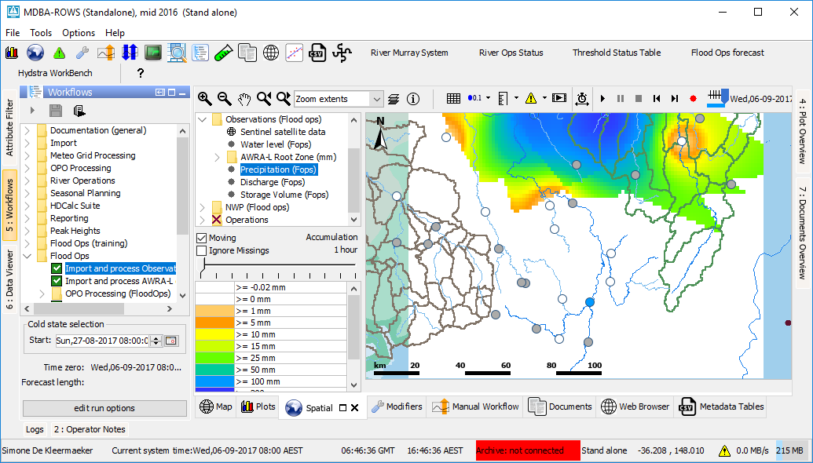By deleting or deactivating a modifier, this change can be undone. The modifier will not be applied after the end date specified by the user.

