|  |  |
| --- | --- |
| How to | D:\projecten\1210326 MDBA ROWS (local, See N)\C. Report - advise\Workshops\2015-02 workshop 3 UAT, end user training\Screenshots\DELTARES_ENABLING_RGB.pngQuality control – Edit or modify quality flags of suspect data |
| Description | Step by step description of how to perform a specific task in ROWS. |
| Comments | The *italic* phrases correspond to the red markings in the screenshots.  Please be aware that the screenshots may deviate slightly from the application |
| version | 2015-02 |

Overview of steps

1. Open the location with suspect data in the *Plots* display
2. Edit the quality flags via the context menu
3. Open the location with suspect data in the *Plots* display  
   Tip: In the Spatial display (see also the How-to on QC\_InspectData) the underlying scalar timeseries can be accessed by clicking on the suspect point on the map. A single click puts the data in the timeseries plot tab, the GUI jumps to the timeseries plots tab when a double click is applied.  
   Open the *Table View*. Validation info and comments can be shown via the drop down menu.   
   Quality labels can be visualized using the Chart drop down menu. A colored bar appears at the x-axis, the table shows different cell colors for doubtful or unreliable data. 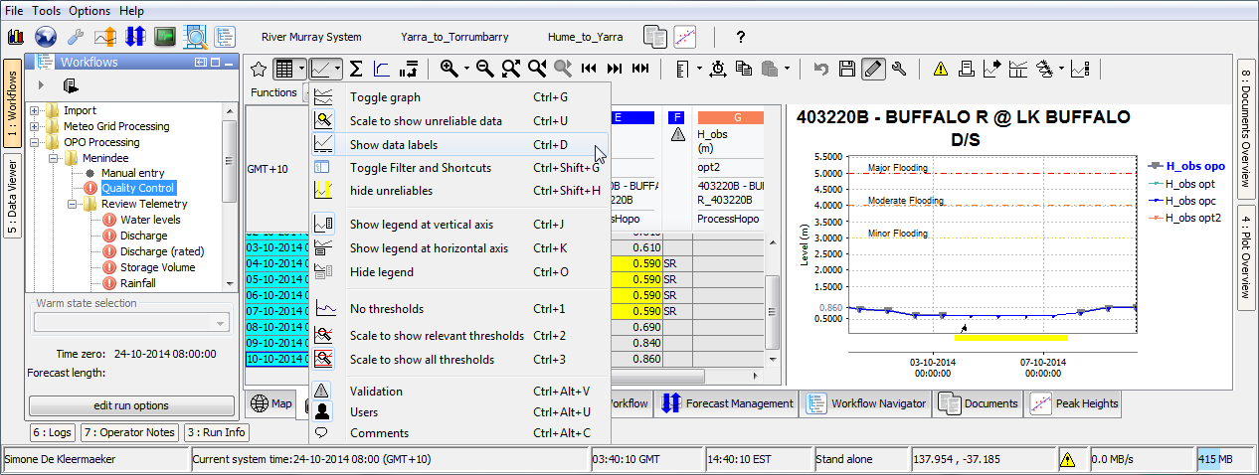
4. 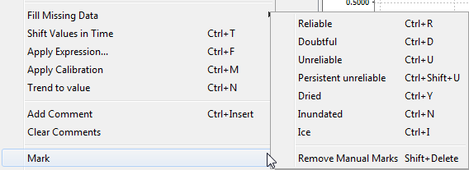Activate edit mode <CTRL-ALT-E>, the data in the white columns are editable. If editing is not allowed the background remains grey. Values can be typed directly in the cell,   
   The context menu contains options like copy-paste values, save values, gap filling and to *Mark* data, i.e. set a quality flag. If you change a flag, the next time the *Quality cotnrol* workflow is executed, this flag will be propagated forwards through the timeseries.  
   *Mark🡪 Persistent unreliable*  sets a sensor to permanent to unreliable <CTRL-SHFT-U>.  
   *Mark🡪 Reliable* marks the sensor as reliable (again)   
   After the actual edit is done save the data <CTRL-S> to the central database. Alternatively, leave the edit mode <CTRL-ALT-E>, the user will be asked to save the edits.