|  |  |
| --- | --- |
| How to | D:\projecten\1210326 MDBA ROWS (local, See N)\C. Report - advise\Workshops\2015-02 workshop 3 UAT, end user training\Screenshots\DELTARES_ENABLING_RGB.pngQuality control - Inspect suspect data (after automatic validation) |
| Description | Step by step description of how to perform a specific task in ROWS. |
| Comments | The *italic* phrases correspond to the red markings in the screenshots.  Please be aware that the screenshots may deviate slightly from the application |
| version | 2015-02 |

Overview of steps

1. Identify suspect data in the Data Viewer
2. Identify suspect data in the *Spatial* display
3. Investigate the time series of any doubtful, unreliable or missing series  
   Show the data labels in the Plot with **CTRL-D; m**ake changes as you see fit
4. Compare the telemetry to the values the operators have communicated separately.
5. Check the system monitor for messages produced by the automatic validation
6. Identify suspect data in the Data Viewer  
   For quality control locations with data flagged by validation are identified with iconsD:\FEWS Allerlei\Icons\nl\wldelft\fews\gui\icons\validation\doubtful.gif, when data is flagged in the period starting from 24 hours before the current system time.
7. Identify suspect data in the *Spatial* display   
   Select *OPO for the parameter* of interest; The *most severe flag* is displayed under the time slider in the top right of the display; Move the time slider to reveal the *locations on the Map*The color scheme of the circles will reflect the timeseries value. Use the Labels button in the toolbar () to shown the value next to the circle. With the validation button ()the color scheme will indicate the quality status of the values shown.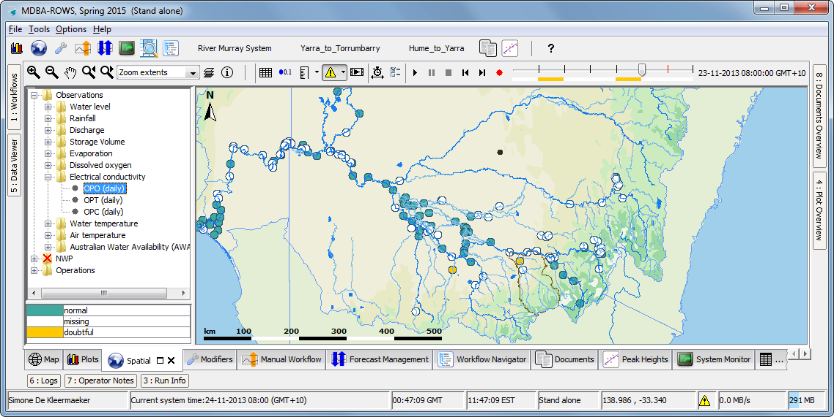
8. 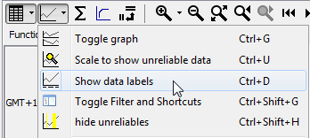Investigate the time series of any doubtful, unreliable or missing series   
   Double click on any location you want to investigate in more detail, a *Plots* display will open for the time series for this location.  
   Visualize the data labels in the Plots display via the Graph options or **CTRL-D**   
   Make changes as you see fit. See How-to on Data Entry for more information.  
   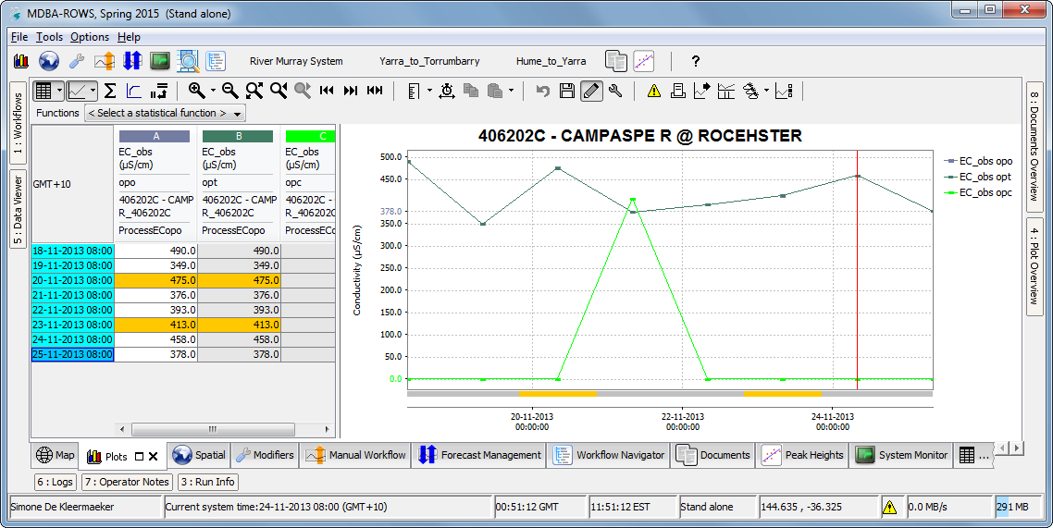
9. Compare the telemetry to the values the operators have communicated separately. For this you can use the same steps as for Data Entry. See this How-to for more info.
10. Open the *System Monitor* display;  
    Filter for message with *External event code: Validation*;  
    Investigate the messages and identify if the rejection is appropriate  
    