|  |  |
| --- | --- |
| How to | D:\projecten\1210326 MDBA ROWS (local, See N)\C. Report - advise\Workshops\2015-02 workshop 3 UAT, end user training\Screenshots\DELTARES_ENABLING_RGB.pngModifying rating curves |
| Description | Step by step description of how to perform a specific task in ROWS. |
| Comments | The *italic* phrases correspond to the red markings in the screenshots.  Please be aware that the screenshots may deviate slightly from the application |
| version | 2015-02 |

Overview of steps

1. Select *Quality Control* in the *Workflows* display
2. Open the *Modifiers* display; select *Modify rating table*; find the *location* you want to modify
3. Modify the rating table. The modified values are shown in dark blue
4. Press the Apply button to change the rating curve for the specified period.  
   Re-run the workflow to store the modifier in the central database (server side).
5. Make modifications persistent by exporting and re-importing the modified rating curve.



1. Select *Quality Control* in the *Workflows* display
2. Open the *Modifiers* display; select *Modify rating table*; find the *location* to modify *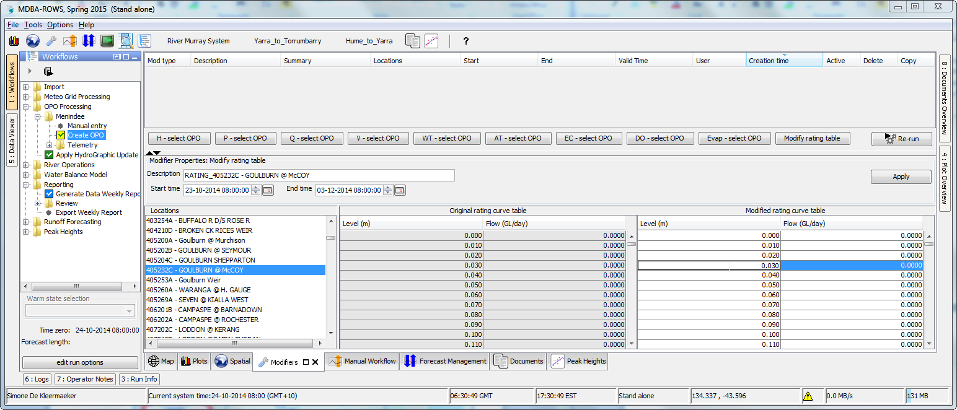*
3. Modify the rating table. The table shows two sets of columns; the first two columns are the values for the default rating curve, the last two columns are the values for the modified rating curve. The modified values are shown in dark blue  
   Add a meaningful description. It is also possible to change the period for which the rating curve modifier is valid, this can be done by changing the start and/or end times in the display.
4. When a new modifier is applied, the modifier is added to the modifier list in the top panel of the display and is stored temporarily in the local database of the OC.   
   By re-running the workflow on the server, the modifier is store in the central database (server side). Now the modifier will be used in the workflows run by the system.
5. New (or modified) rating curves can be introduced in the ROWS database as follows:   
   Export a modified rating using *F12 -> Export -> Ratingcurves*.  
   Import the ratings into ROWS by copying the files in the appropriate ratings import folder on the server and running the workflow to import rating curves manually on the server.   
   Remove the modifier should be removed by the user.  
   Now the modification is made persistent in the database.