|  |  |
| --- | --- |
| How to | D:\projecten\1210326 MDBA ROWS (local, See N)\C. Report - advise\Workshops\2015-02 workshop 3 UAT, end user training\Screenshots\DELTARES_ENABLING_RGB.pngSwitch sensor |
| Description | Step by step description of how to perform a specific task in ROWS. |
| Comments | The *italic* phrases correspond to the red markings in the screenshots.  Please be aware that the screenshots may deviate slightly from the application |
| version | 2015-02 |

Overview of steps

1. Select workflow *Quality Control*; Go to the *Modifiers* display; Select the *parameter*;
2. Select the *location* in question; changed the preferred sensor; give a *description*; press *Apply*
3. The modifier becomes visible and can be (de)activated, or deleted; Re-run the workflow
4. Select workflow *Quality Control*; Go to the *Modifiers* displaySelect the *parameter* in question from row of buttons in the middle of the Modifiers display; 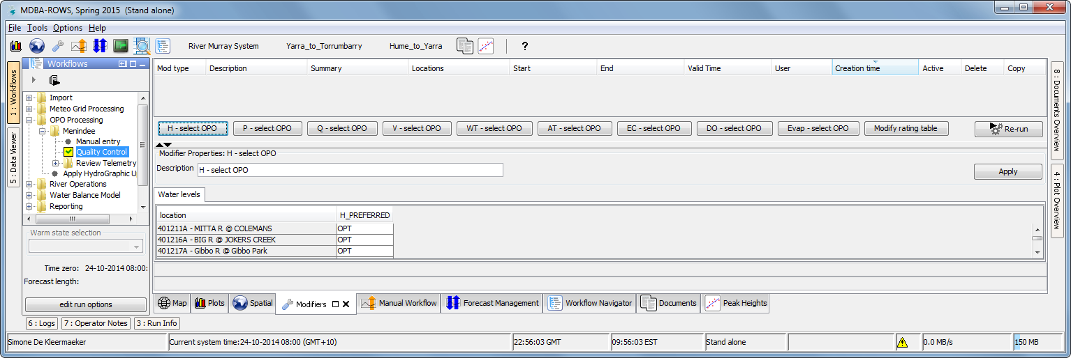
5. Go to the *location* in question; changed the preferred sensor;  
   fill in a meaningful *description*; press *Apply*.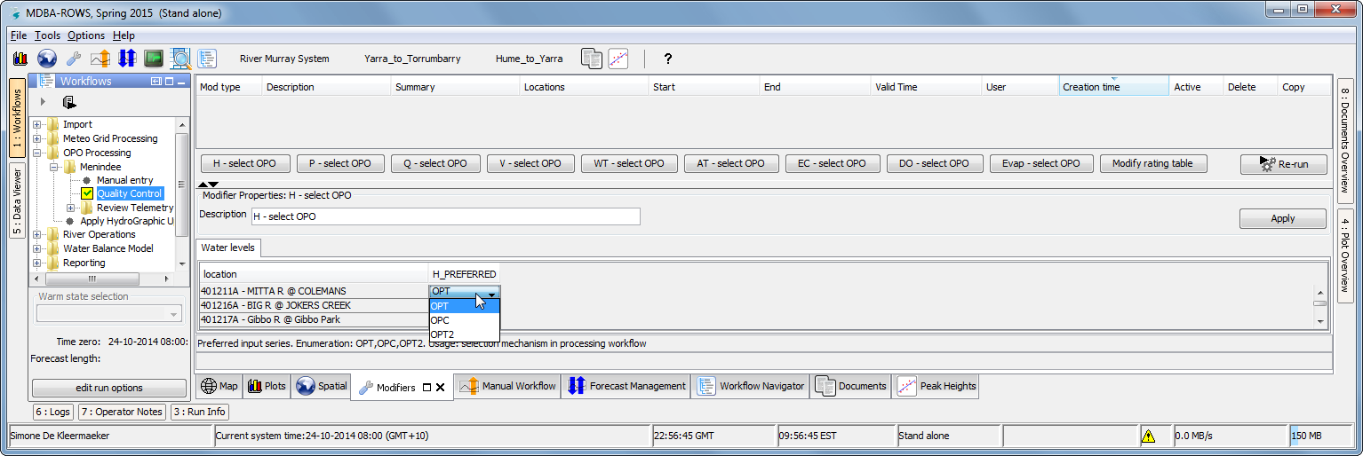
6. 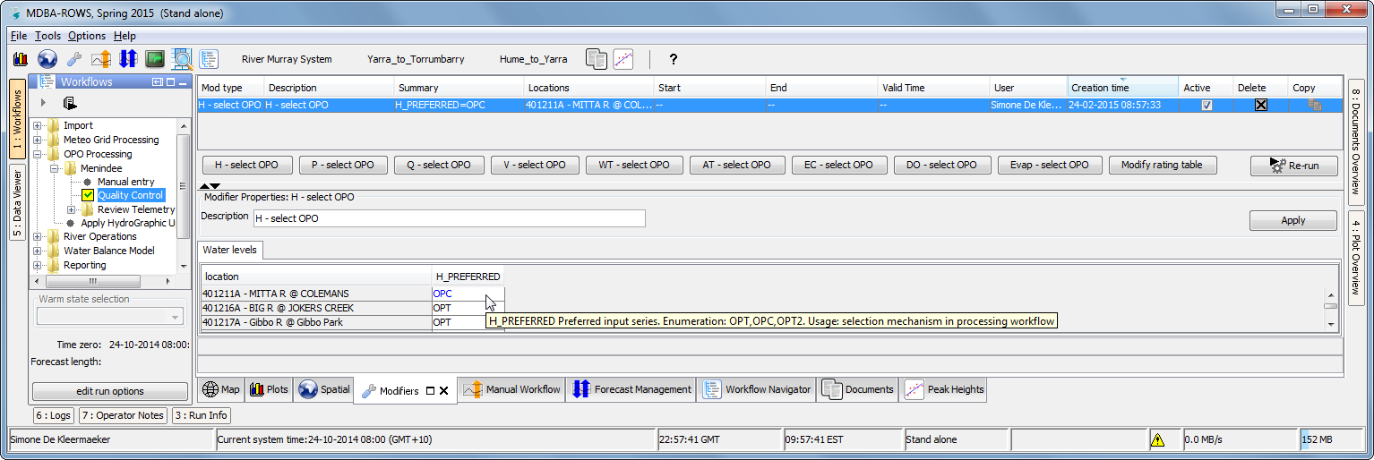The modifier becomes *visible* and can be (de)activated, or deleted;  
   The modifier is marked in *blue*; re run the *workflow* to use the mod (effective per tomorrow)