|  |  |
| --- | --- |
| How to | D:\projecten\1210326 MDBA ROWS (local, See N)\C. Report - advise\Workshops\2015-02 workshop 3 UAT, end user training\Screenshots\DELTARES_ENABLING_RGB.pngPeak Heights |
| Description | Step by step description of how to perform a specific task in ROWS. |
| Comments | The *italic* phrases correspond to the red markings in the screenshots.  Please be aware that the screenshots may deviate slightly from the application |
| version | 2015-02 |

Overview of steps

1. Open the Peak Heights display from the Workflows Display (A).
2. Peak heights control pane (B) with forecast location and support location(s)
3. Display window (C)
4. Open the Peak Heights display from the Workflows Display (A).   
   When a forecast location is selected the peak heights display is activated.   
   It consists of a Peak Heights control pane (B) and a (scatter plot) display window (C). 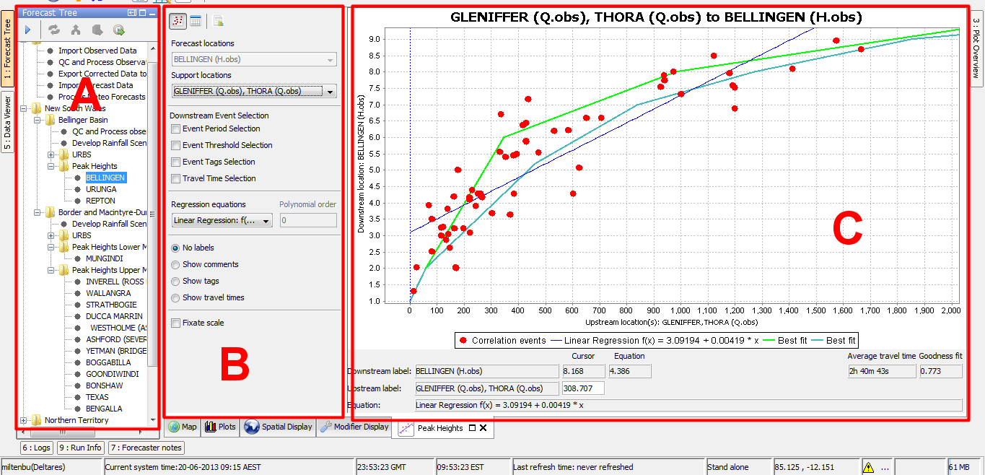
5. In the Peak Heights control pane (B), the forecast location selected from the Workflows Display is shown. The support location that will be used in the peak height relation can be changed from the support locations dropdown list, when more than one support location (or group of support locations) is available. When only one support location (group) is available, the name of the support location is listed and greyed out in the control pane. At the bottom of the Peak Heights control pane, the description of the peak height relation is shown.   
   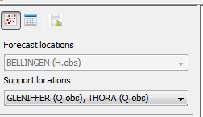 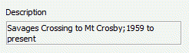
6. The display window shows by default the Peak Heights relationship as a scatter plot (C). This is indicated by the selected icon on the top of the control pane: . Other displays that can be selected are the “Events” display, “Peak Heights vs. Travel Times” display and a report generator.