|  |  |
| --- | --- |
| How to | D:\projecten\1210326 MDBA ROWS (local, See N)\C. Report - advise\Workshops\2015-02 workshop 3 UAT, end user training\Screenshots\DELTARES_ENABLING_RGB.pngPeak Heights – Events Selection |
| Description | Step by step description of how to perform a specific task in ROWS. |
| Comments | The *italic* phrases correspond to the red markings in the screenshots.  Please be aware that the screenshots may deviate slightly from the application |
| version | 2015-02 |

Overview of steps

1. In the Peak Heights control pane, include/exclude events from the event set.
2. Event Period Selection
3. Event Threshold Selection
4. Event Tags Selection
5. Travel Time Selection
6. In the Peak Heights control pane, include/exclude events from the event set.   
   Events which do not fulfill the selection criteria are greyed out in the scatter plot and peak heights vs. travel time displays and removed from the Events display and the report. The calculated regression equation will be based on the selected events.  
   The events can be restricted on the basis of a number of criteria. The selection is based on the forecast (downstream) location event data set.
7. 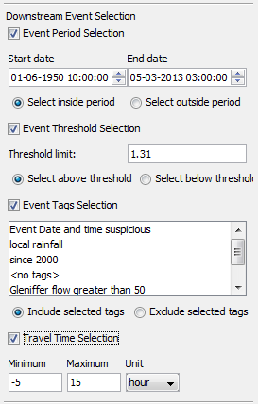Event Period Selection.   
   A period can be defined inside or outside which data points should be included in the analysis. The earliest and latest date of all peak height data that involves a specific location, either as support location or forecast location are set as boundaries.
8. Event Threshold Selection   
   A threshold can be defined relative to the forecast location below or above which data points should be included in the analysis.
9. Event Tags Selection  
   One or more tags of data points can be selected. Data points that have a corresponding tag are either included or excluded from the analysis.
10. Travel Time Selection  
    Events can be filtered based on calculated travel time from support to forecast locations, based on the event times. When times are not available for events, these events will be kept in the selection. Only integers can be entered in the Travel time fields.