|  |  |
| --- | --- |
| How to | D:\projecten\1210326 MDBA ROWS (local, See N)\C. Report - advise\Workshops\2015-02 workshop 3 UAT, end user training\Screenshots\DELTARES_ENABLING_RGB.pngPeak Heights vs Travel Time |
| Description | Step by step description of how to perform a specific task in ROWS. |
| Comments | The *italic* phrases correspond to the red markings in the screenshots.  Please be aware that the screenshots may deviate slightly from the application |
| version | 2015-02 |

Overview of steps

1. Activate the Events Display with the icon on the top of the control pane
2. Activate the Events display with the icon on the top of the control pane: 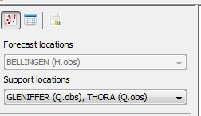.  
   The events tab shows the events used in the regression function in a tabular form. The list includes the dates, forecast level, support level and travel time of the selected events. These can be sorted by clicking on the header of each column.