|  |  |
| --- | --- |
| How to | D:\projecten\1210326 MDBA ROWS (local, See N)\C. Report - advise\Workshops\2015-02 workshop 3 UAT, end user training\Screenshots\DELTARES_ENABLING_RGB.pngPeak Heights – Scatter Plot Display |
| Description | Step by step description of how to perform a specific task in ROWS. |
| Comments | The *italic* phrases correspond to the red markings in the screenshots.  Please be aware that the screenshots may deviate slightly from the application |
| version | 2015-02 |

Overview of steps

1. Activate the Scatter Plot Display with the icon on the top of the control pane
2. Legend below the scatter plot is linked to the crosshair in the plot
3. Activate the Scatter Plot Display with the icon on the top of the control pane: 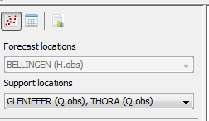. Color, style and size of the visualized events in the scatter plot are pre-configured. The plot has a title showing the support and forecast location names and parameters.   
   Tool tips with event information are displayed when the cursor is placed on an event point in the plot. 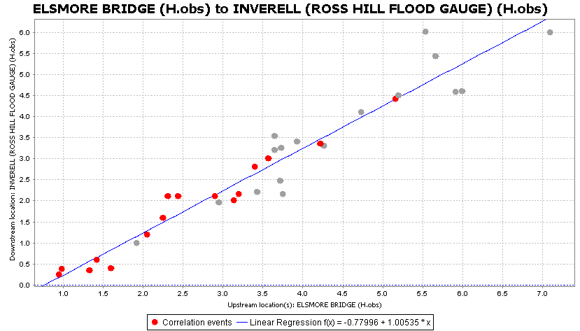
4. When clicking anywhere in the plot window, a crosshair is created that will stay visible in the window. Below the scatter plot, the discharges or water levels at the support location (X) and at the forecast location are displayed (Y).  
   The Cursor column indicates the values for the support location and the forecast location at the location of the cursor on the graph. The forecast height computed with the regression relation is displayed in the equation column; this computed value assumes an X-value as indicated by the cursor. The values associated with the crosshair are also depicted below the graph (in blue) in the Selection column.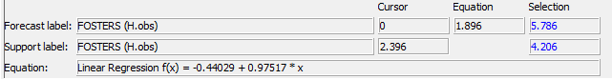The regression formula used to compute the forecast value is also given, in addition to the *goodness of fit*, which is expressed as an R2 (R-squared) value. The typical travel time computed from the selected events is presented in the field *Average travel time*.