|  |  |
| --- | --- |
| How to | D:\projecten\1210326 MDBA ROWS (local, See N)\C. Report - advise\Workshops\2015-02 workshop 3 UAT, end user training\Screenshots\DELTARES_ENABLING_RGB.pngDelft-FEWS Explorer |
| Description | Step by step description of how to perform a specific task in ROWS. |
| Comments | The *italic* phrases correspond to the red markings in the screenshots.  Please be aware that the screenshots may deviate slightly from the application |
| version | 2015-02 |

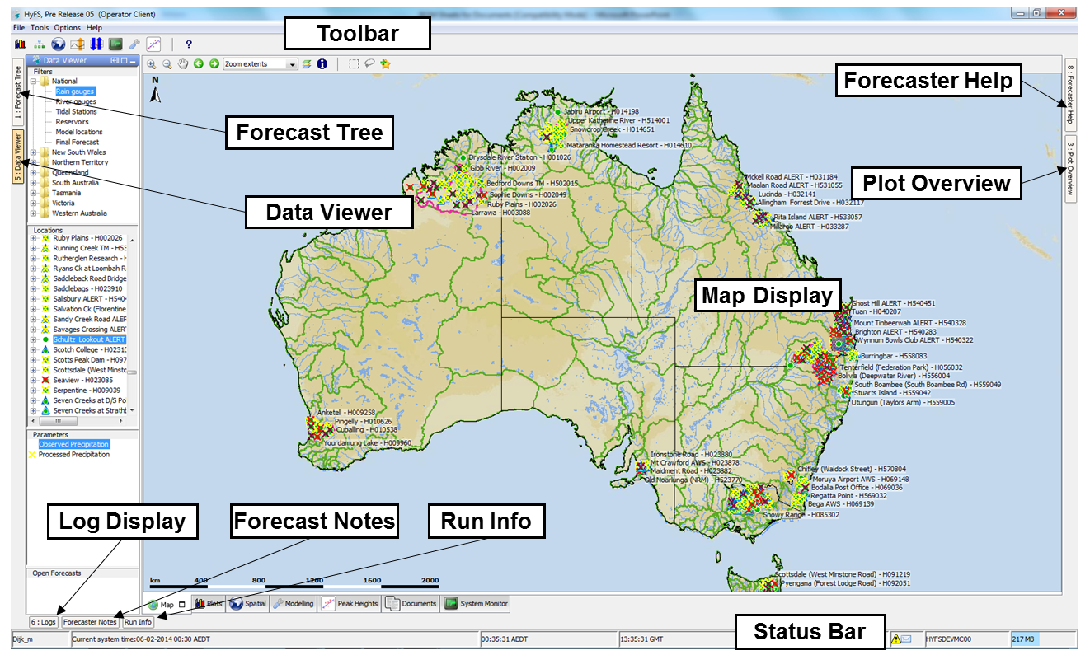

After starting ROWS, the *Explorer* is shown. More displays can be activated from the Tools Menu.

* *Data Viewer*: contains a list of location filters for viewing observed and forecast scalar time series. Via the *Filters* box of the *Data Viewer* (tab on left side) meteorological and hydrological locations can be selected and displayed on the map. The filters limit the number of locations displayed on the map and in the list box. The available filters show either all available meteorological stations or the hydrological stations of the selected region or basin.
* *Workflows*: this tree guides the user through the process.
* *Map*: shows the configured maps with observed and forecast location icons on top.
* *Plots:* includes the data editor and data display with time series for selected locations.
* *Spatial:* includes a data display for gridded time series and scalar time series.
* *Modifier:* allows the operator to change the default behavior of gauges.
* *Topology:* graphical display of the *Workflows* tree, including the status of each step.
* *Documents:* special display where files selected in the *Documents Overview* will be displayed.
* *Logs*: list of all log messages that are generated on the FEWS OC or Stand Alone.
* *Run info:* basic information on the different workflows that are run together with the modifiers used in the forecast workflows.
* *Operator Notes:* special display where a user can enter information not generated by ROWS. Provides tools to query on forecaster notes stored in the database.
* *Plot Overview*: thumbnails of pre-defined graphs, linked with the nodes in the *Workflows* display. By clicking on a thumbnail, the Plots display will open up with the same graphs.
* *Documents overview:* special display with links to additional information files.

Note: The layout of the displays in the explorer is stored in a Delft-FEWS layout file. From the Explorer *File* menu revert to the default layout of this file or save the current Explorer layout to this local configuration file.