|  |  |
| --- | --- |
| How to | D:\projecten\1210326 MDBA ROWS (local, See N)\C. Report - advise\Workshops\2015-02 workshop 3 UAT, end user training\Screenshots\DELTARES_ENABLING_RGB.pngIcons used in the Workflows display |
| Description | Description of part of the User Interface of ROWS |
| Comments | The *italic* phrases correspond to the red markings in the screenshots.  Please be aware that the screenshots may deviate slightly from the application |
| version | 2016-01 |

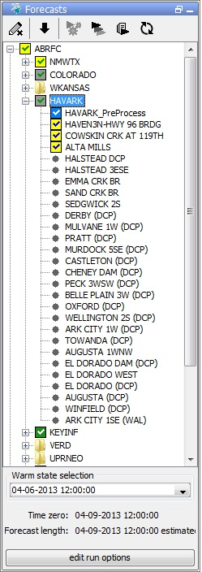  
Icons used in the Workflows display are standard for every Delft-FEWS system.   
This How-To is a copy from the relevant [wiki](https://publicwiki.deltares.nl/display/FEWSDOC/23+Interactive+Forecasting+Displays).

**As part of 2014.02, the color of the forecast icons has changed.**

We still have green and blue boxes with white check mark. They represent a server (green) or local (blue) run, with the same T0 and state settings as shown in the IFD.

Prior to 2014.02 you would not see an icon at all if the T0 in the IFD was different than the T0 of the approved run in the database, or if the state settings in the IFD were different than the state settings of the approved run in the database. For releases starting with 2014.02, you will see multiple icons for the various situations:

A grey box with either a green or blue check mark. A grey box means the T0 of the approved run in the database is different than the one in the IFD. The check mark indicates whether the approved run is a local or a server run.

A yellow box with either a green or blue check mark. A yellow box means the state settings of the approved run in the database are different than the settings in the IFD. For example you might have a different warm state, warm state search interval, or forecast length. The check mark indicates whether the approved run is a local or a server run."