|  |  |
| --- | --- |
| How to | D:\projecten\1210326 MDBA ROWS (local, See N)\C. Report - advise\Workshops\2015-02 workshop 3 UAT, end user training\Screenshots\DELTARES_ENABLING_RGB.pngDelft FEWS Map and Explorer |
| Description | Step by step description of how to perform a specific task in ROWS. |
| Comments | The *italic* phrases correspond to the red markings in the screenshots.  Please be aware that the screenshots may deviate slightly from the application |
| version | 2015-02 |

After initialization the FEWS Explorer will be shown using the default settings for window layout.

By default the FEWS Explorer is presented with the *Maps, Plots, Spatial, Modeling, Peak Heights* and *Documents* displays. More FEWS Explorer displays can be activated from the Tools Menu.

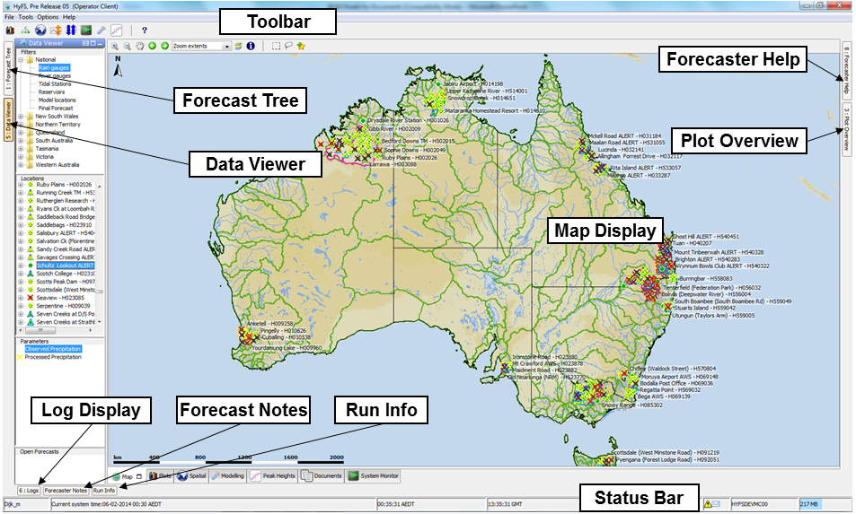

The status Bar at the bottom of the FEWS Explorer provides important information on the user that is logged in, the ROWS system time and the Central ROWS *Master Controller* (MC) server that the ROWS OC is connected to.

When the ROWS OC is running and connected to the ROWS server, the first display to open is the *Data Viewer* together with the *Map display*.

The Data Viewer contains a list of location filters organized per state that contains an overview of the time series of interest.

The Map shows the locations of the selected filter with the status of the selected data. When selecting the rain gauges or river gauges, the status of observed data can be seen. It is important to check if there are red or yellow crosses (icons) indicating that recent observed data is missing. If the icons show exclamation marks it means the observed levels or flows have exceeded warning thresholds.