|  |  |
| --- | --- |
| How to | D:\projecten\1210326 MDBA ROWS (local, See N)\C. Report - advise\Workshops\2015-02 workshop 3 UAT, end user training\Screenshots\DELTARES_ENABLING_RGB.pngOperator notes display – add a message |
| Description | Step by step description of how to perform a specific task in ROWS. |
| Comments | The *italic* phrases correspond to the red markings in the screenshots.  Please be aware that the screenshots may deviate slightly from the application |
| version | 2015-02 |

Operator Notes can be used to enter messages manually to the system. The display is located at the bottom of the Explorer. These messages are linked to the Workflows tree through the nodes.

Overview of steps

1. Open the *Operator Notes* display at the bottom of the screen
2. Add a message; fill in the Message Creation display
3. The message is shown in the *Operators Notes* and will be synchronized to the other users.
4. Open the *Operator Notes* display at the bottom of the screen
5. Add a message, by clicking the add message button.   
   A message can be made specific to a node in the *Workflows* display, by selecting this node before you add a message. If no node is selected, the note is always visible.   
   In the *Messages Creation* display a correct *Log time* can be entered, the *Log Level* selected, as well as a *User*, *Event Code* and *a Log Template*.  
   By default the Current system time is entered as well as the user name. The Log template can be used to assist the forecaster with a new message.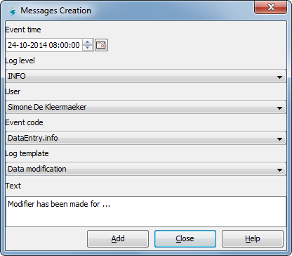
6. The Operators Notes display now includes one message. The message will be synchronized to the server side and from there to the other users.