|  |  |
| --- | --- |
| How to | D:\projecten\1210326 MDBA ROWS (local, See N)\C. Report - advise\Workshops\2015-02 workshop 3 UAT, end user training\Screenshots\DELTARES_ENABLING_RGB.pngPlots display and Table View |
| Description | Step by step description of how to perform a specific task in ROWS. |
| Comments | The *italic* phrases correspond to the red markings in the screenshots.  Please be aware that the screenshots may deviate slightly from the application |
| version | 2015-02 |

  
The *Plots* display offers graphical representation of scalar time series data. It is always available in the Explorer tabs, more displays can be opened from the Explorer toolbar or Tools menu.

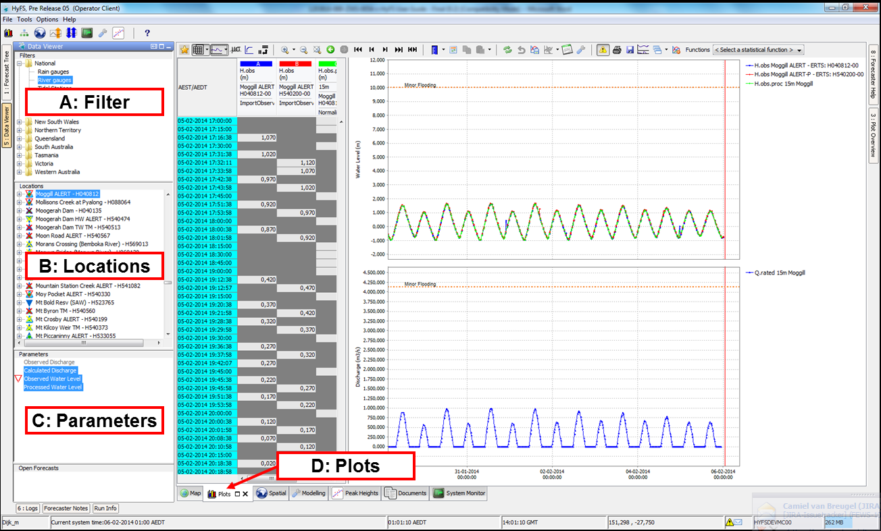

To view one or more time series of observed data:

1. Select the filter in the left hand list box of the *Data Viewer display* which contains the parameters/locations to be viewed.
2. Choose a location in the *Map* display by clicking on the icon.   
   Alternatively select the locations from the list of locations in the list box on the left hand side
3. Select a parameter from the list of parameters available at that location. If the parameter name is grayed out this parameter is not available at that location.   
   Note: Multiple location/parameter selections can be made using the <CTRL> or <SHIFT> key when selecting.
4. Select the *Plots* tab  to create a plot of the selected location and parameter combination. Note ‘new’ plots (named Plots 1, 2 etc.) can be ‘locked’  while the main Plots window will keep updating with new selections.

Shortcuts with the mouse:

|  |  |
| --- | --- |
| Scroll wheel | Zoom in and out |
| Right mouse button (click) | Context menu (e.g. copy to clipboard) |
| Right mouse button (hold down) | Pan, works in Plots, Spatial and Map |

The Plots display toolbar offers many options, with even more in the drop down list of the buttons.



Some important Buttons

|  |  |
| --- | --- |
| Show/hide table | Undo changes |
| Show/hide Thresholds and labels | Save changes |
| Show/hide Rating Curves | Go to edit mode |
| Pivot plot and table | Create modifiers |
| Zoom out to full length | Show previous forecasts |
| Toggle elevation/unit | Show/hide time serie |
| Adjust display time |  |

The show / hide graph button  contains additional features in a drop-down list.

|  |  |
| --- | --- |
|  | In this list it is possible the adjust the scaling of the graph to include unreliable data . Clean the unreliable data from the graph by selecting the option to hide unreliable data .  Other features in this list include the options to show validation flags, user comments and the user that edited the data. |

*Table View* in *Plots* shows the exact times and values of the time series in the graph.   
Colors in table header correspond to colors in graph

|  |  |  |  |
| --- | --- | --- | --- |
| **Date color** | **Meaning** | **Table font** |  |
| Green | first data value at start of day | Black | Original data |
| Light blue | historical data before System time | Dark blue | Modified data |
| Dark blue | forecast data after System time | Magenta | Manual entered data |
|  |  | Dark blue | Edited (corrected) data |
|  |  | **bold** | Modified flag of data |