|  |  |
| --- | --- |
| How to | D:\projecten\1210326 MDBA ROWS (local, See N)\C. Report - advise\Workshops\2015-02 workshop 3 UAT, end user training\Screenshots\DELTARES_ENABLING_RGB.pngRating curve data display |
| Description | Step by step description of how to perform a specific task in ROWS. |
| Comments | The *italic* phrases correspond to the red markings in the screenshots.  Please be aware that the screenshots may deviate slightly from the application |
| version | 2015-02 |

  
Rating curves can be visualized in the *Plots* display together with the water level time series and rated flow time series for all locations where rating curves are available. To activate the rating curve display feature, select the rating curve button from the time series display toolbar. The following rating information will be visible to the user:

1. Rating Table, with a stage and a discharge column.
2. Rating Curve, graph of “A”. “Discharge” on the horizontal, “Stage” on the vertical axis.
3. Quality flags in rating table, meaning is as in the regular time series graph/table.
4. Comment, such as source, highest rating.
5. Quality bar, depicting flags (defined in C), meaning as in the regular time series graph/table.
6. Site name, as defined in the configured rating, and validity period for the rating curve.

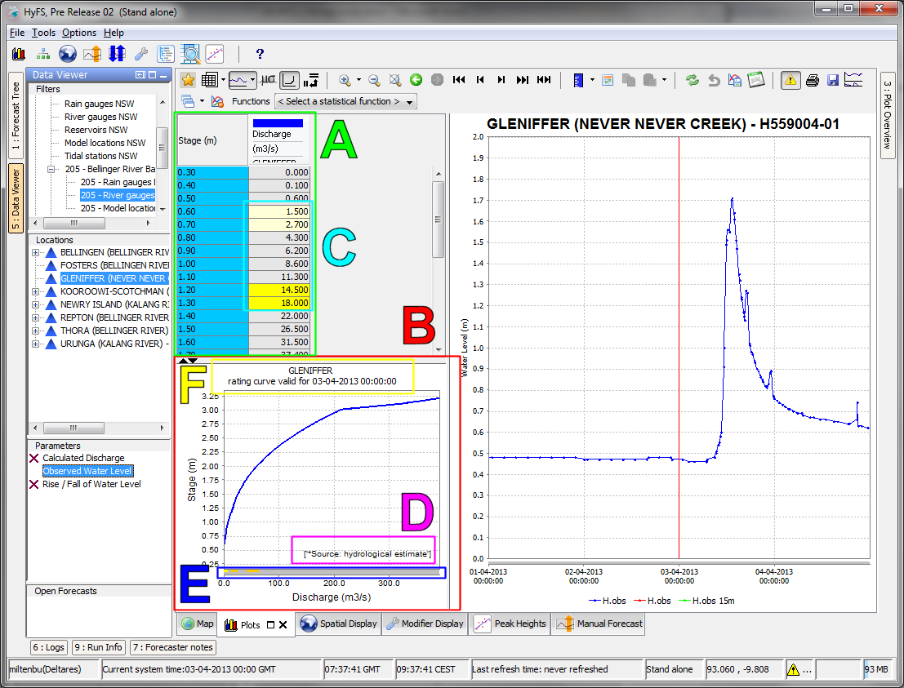

Comments (D) can be toggled on/off via the Chart drop-down menu or <CTRL+ALT+C>.   
Data labels (E) can be toggled on/off via the Chart drop-down menu of <CTRL+ALT+D>.  
Thresholds can be toggled on/off the Chart using CTRL+1.

From all the rating curves with the same given location id, the rating curve that is valid for the given time is shown. It is also possible to have different rating curves with the same location id, the same rating curve type and overlapping valid periods, as long as they have different qualifier ids. This makes it possible to have rating curves with valid periods that only have a start date (no end date), which are valid until the rating curve with the next start date becomes valid. In this case, the rating curve with the most recent start date will be shown.

The rating curve can be modified and quality flags can be set via the Modifier display (see separate How-to memo).