|  |  |
| --- | --- |
| How to | D:\projecten\1210326 MDBA ROWS (local, See N)\C. Report - advise\Workshops\2015-02 workshop 3 UAT, end user training\Screenshots\DELTARES_ENABLING_RGB.pngSpatial display |
| Description | Step by step description of how to perform a specific task in ROWS. |
| Comments | The *italic* phrases correspond to the red markings in the screenshots.  Please be aware that the screenshots may deviate slightly from the application |
| version | 2015-02 |

1. Open the Spatial display with the icon in the tool bar or select the Spatial display tab (A). On the left side of the Spatial display a list of data filters is displayed in a tree view (B).
2. Select the desired filter (B). The selection will be displayed on the map either as dots for scalar data, as polygons for area average rainfall, or as grids for radar and NWP rainfall data.
3. Use the buttons on the top (C) to animate the time series, or select specific time steps.
4. With the accumulation slide bar (D) select one of the predefined accumulation period. Set the time to which the accumulation is to be made in the time slider at the top. Hovering over the location will display a pop-up with accumulation over the chosen period for that location.

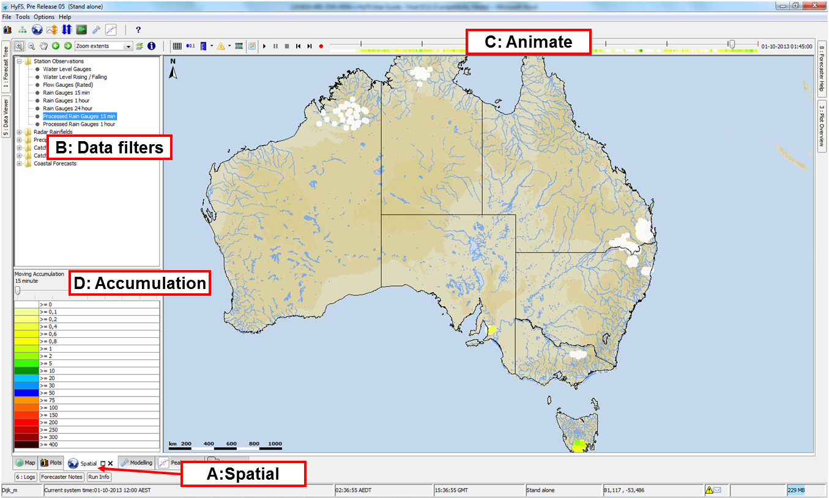

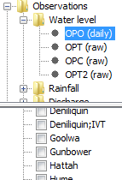It is possible for some of the spatial display data to filter on attributes of the grid locations. When the attribute filter can be used the *Locations Attributes Filter* button is activated in the Spatial display toolbar. With this filter activated, a new list is shown on the left of the display with the different grid attributes under the Model attribute. When selecting or deselecting the regions the individual grids can be shown or hidden from the display.

This filter mechanism in the data tree is introduced to minimize the number of elements in the Spatial display. The default is to show all the time series of the same type in the filter and allow the forecaster to show or hide time series based on location attributes.

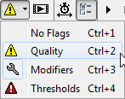

With the Flags button, you can show flag information for quality, modifiers or threshold information. When selecting one of the flag option the colors on the map and legend will change accordingly.

Use the Labels button to shown the value next to the circle.