|  |  |
| --- | --- |
| How to | Run the RTC-Tools models |
| Description | Step by step description of how to perform a specific task in ROWS. |
| Comments | The *italic* phrases correspond to the red markings in the screenshots.  Please be aware that the screenshots may deviate slightly from the application |
| version | 2018-02 |

# **How to operate the RTC-Tools model**

Note: A short background on the model is given at the end of this HowTo.

The release and inflow time series and the optimization goals can be set as a Modifier. By default, the model takes the URBS Upper Murray Forecast unless an inflow forecast modifier is active.

Both the simulation and optimization model of RTC-Tools, have been organized in three runs:

* Run Hume Dam …: a local run to experiment with the release and other settings
* Save Hume Dam …: to save the run persistently on the server for sharing with others
* Run Ensemble Hume Dam …: to run the models with the URBS ensemble forecast.



Follow the steps below to conduct a run and inspect the results.

1. Select the node to run in the Workflows tree (1a) and select the Modifiers tab (1b)
2. Click the Hume Release Forecast, the Hume Inflow Forecast or the Kiewa Forecast button (2a), specify the timeseries (2b), update the name if needed and click Apply (2c)
3. For the optimization model, click the RTC-Tools Goals parameter button (3a) and select which goals to include and with what priority (highest priority is most important). Update the modifier name if needed and Click Apply to save your settings (3b).
4. Run the model, either via the rerun button on the form (4a) or by the play-button in the workflow-tree (4b)
5. Inspect the results by selecting the Plots tab at the bottom of the application (5a)

Be aware: if you have specified a manual inflow forecast as modifier, then the URBS inflow forecast is overruled, also for the ensemble. You can deactivate the modifier via the checkboxes in the overview table (6)

# **Background of the RTC-Tools model**

The RTC-Tools model for Hume Dam routes the inflow from the upstream URBS model into a release. Two calculation modes are available: a simulation mode and optimization mode.

The simulation model requires a reservoir inflow time series and a reservoir release time series. Given those series, it computes the resulting reservoir volume and water level, and it computes how much will be released through the turbine, the bottom outlets and the spillway.

The optimization model works slightly different as it tries to achieve multiple goals as prioritized and specified by the user. The following options can be selected and given a priority to attain.

* Use Surcharge Target Water level (fixed at: 192.25m+MSL)
* Use Release scenario target (the release timeseries specified)
* Use Downstream flow target (at Doctor’s Point)
* Minimize Spill
* Minimize Release

When selecting a release target, the timeseries needs to be specified. Whether this release target is met, depends amongst others on the priority of the release target versus other targets.

# Test script

## Preparations

Prepare data for Delft-FEWS

* Copy the local data store with test data to the folder “localDataStore”
* Open Delft-FEWS
* When asked, upgrade the datastore to 2017.02 format
* Set the system time to: Wed,31-08-2016 09:00:00 (AET time-zone)

Prepare the URBS module

* In the Workflows display, run   
  Flood Ops > Prepare system > Prepare URBS modules folder

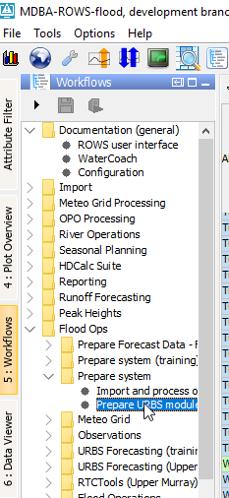

* Run the workflow “Run Upper Murray – ToHumeDam:

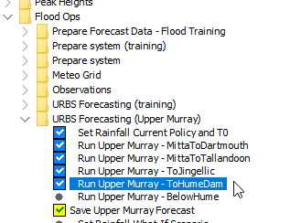

* Run the workflow “Save Upper Murray Forecast”.

Inflow data for the RTC-Tools model has now been generated with the hydrological model URBS

|  |  |  |
| --- | --- | --- |
| Action | Pass | Remarks |
| Prepare Delft-FEWS |  |  |
| * Copy the local data store with test data to the folder “localDataStore” |  |  |
| Startup ROWS 2018.02 |  |  |
| * When asked, upgrade the datastore to 2017.02 format. The LDS contains: rating curves and processed observations |  |  |
| * Set the system time of ROWS is Wed 31-08-2016 09:00 AEST |  |  |
| Run URBS |  |  |
| * Open the Workflows display, run Flood Ops > Prepare system > Prepare URBS modules folder |  |  |
| * In the Workflows display, run Flood Ops >URBS Forecasting (Upper Murray) > Save Upper Murray Forecast |  |  |
| Run RTC-Tools Simulation |  |  |
| * In the Workflows display, run  Flood Ops > RTC-Tools (Upper Murray) >  Run HumeDam Simulation |  |  |
| Run RTC-Tools Optimization |  |  |
| * In the Workflows display, run  Flood Ops > RTC-Tools (Upper Murray) >  Run ToHumeDam - Optimization |  |  |