|  |  |
| --- | --- |
| How to | Test script for the RTC-Tools models |
| Description | Step by step description of how to perform a specific task in ROWS. |
| Comments | The *italic* phrases correspond to the red markings in the screenshots.  Please be aware that the screenshots may deviate slightly from the application |
| version | 2018-02 |

  
Note: A description of how to run the model can be found in a separate HowTo.

Prepare data for Delft-FEWS

* Copy the local data store with test data to the folder “localDataStore”
* Open Delft-FEWS (ROWS)
* When asked, upgrade the datastore to 2017.02 format
* 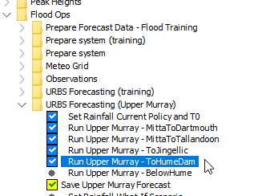Set the system time to: Wed,31-08-2016 09:00:00 (AET time-zone)

Prepare the URBS module.   
In the Workflows display, run:

* Flood Ops > Prepare system > Prepare URBS modules folder
* Flood Ops > URBS Forecasting >
  + Run Upper Murray – ToHumeDam
  + Save Upper Murray Forecast

Inflow data for the RTC-Tools model has now been generated with the hydrological model URBS

Test script for RTC-Tools models.

|  |  |  |
| --- | --- | --- |
| Action | Pass | Remarks |
| Prepare Delft-FEWS |  |  |
| * Copy the local data store with test data to the folder “localDataStore” |  |  |
| Startup ROWS 2018.02 |  |  |
| * When asked, upgrade the datastore to 2017.02 format. The LDS contains: rating curves and processed observations |  |  |
| * Set the system time of ROWS is Wed 31-08-2016 09:00 AEST |  |  |
| Run URBS |  |  |
| * Open the Workflows display, run Flood Ops > Prepare system > Prepare URBS modules folder |  |  |
| * In the Workflows display, run Flood Ops >URBS Forecasting (Upper Murray) > Save Upper Murray Forecast |  |  |
| Run RTC-Tools Simulation |  |  |
| * In the Workflows display, run  Flood Ops > RTC-Tools (Upper Murray) >  Run HumeDam Simulation |  |  |
| Run RTC-Tools Optimization |  |  |
| * In the Workflows display, run  Flood Ops > RTC-Tools (Upper Murray) >  Run ToHumeDam - Optimization |  |  |