|  |  |
| --- | --- |
| How to | D:\projecten\1210326 MDBA ROWS (local, See N)\C. Report - advise\Workshops\2015-02 workshop 3 UAT, end user training\Screenshots\DELTARES_ENABLING_RGB.pngReviewing operational flow and salinity forecast for publishing |
| Description | Step by step description of how to perform a specific task in ROWS. |
| Comments | The *italic* phrases correspond to the red markings in the screenshots.  Please be aware that the screenshots may deviate slightly from the application |
| version | 2017-01 |

General description and steps:  
MDBC\_OPS operational data, both historical and forecast from the ops sheets are routinely imported into ROWS and this how-to guide describes the steps taken to verify and QA the operational forecast for publication to the web

Overview of steps

1. Export the latest historical and forecast from MDBC Ops sheets by executing “Dump Data” from MDBC Ops. This will export 14 days of historical and 30 days of forecast (if available) to ROWS.
2. 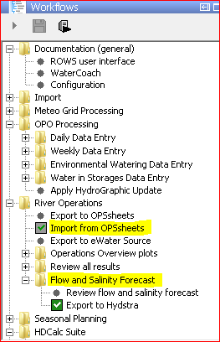Select and execute “**Import from OPSheets**” workflow in ROWS. This will import MDBC Ops data into ROWS (See A).
3. Select “Flow and Salinity Forecast” workflow node and child nodes for visualisation and QA. Selecting this workflow node will activate the plot display environment. If the plot display not enabled, it can be enabled by clicking on Plot icon on the toolbar.

Once the data has been imported, you can visualise and edit the data prior to exporting to Hydstra for online publication.

**A**

The plot display environment and the export to Hydstra is configured to show and export only the latest data imported from MDBC Ops (ie less than 1 day old). The date of latest available forecast is show on the horizontal legend (See B).

Plot overview windows allows you to cycle through the list of sites for which forecast is exported to Hydstra for publication (See C) .

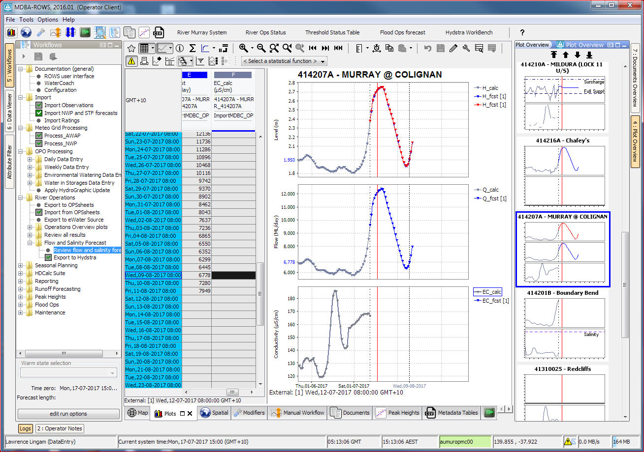

**B**

**C**

**D**