|  |  |
| --- | --- |
| How to | URBS - Modify URBS model parameter for Initial Loss (IL) |
| Description | Modify URBS parameter for initial loss based on AWRA-L soil moisture data |
| Comments | The *italic* phrases correspond to the red markings in the screenshots.  Please be aware that the screenshots may deviate slightly from the application |
| version | 2018-02 |

  
The AWRA-L product from the Bureau is ingested automatically. If needed, this data can be imported manually as well from the Workflows display > Flood Ops > Import and process AWRA-L data.

You can view the results in several ways:

* *Spatial* > Obs. (Flood Ops) > *AWRA-L* (both raw data, and processed to URBS submodels)
* *Plot Overview* linked to the AWRA-L import node, showing the AWRA-L Soil Moisture data and the derived Initial Loss for each day. (See also HowTo_URBS_Parameters_Initialization)
* *Modifiers* display linked to the Run URBS nodes, showing the IL value -at the start of the simulation- for the relevant sub-model as *guidance* for the IL value that **you can modify**.

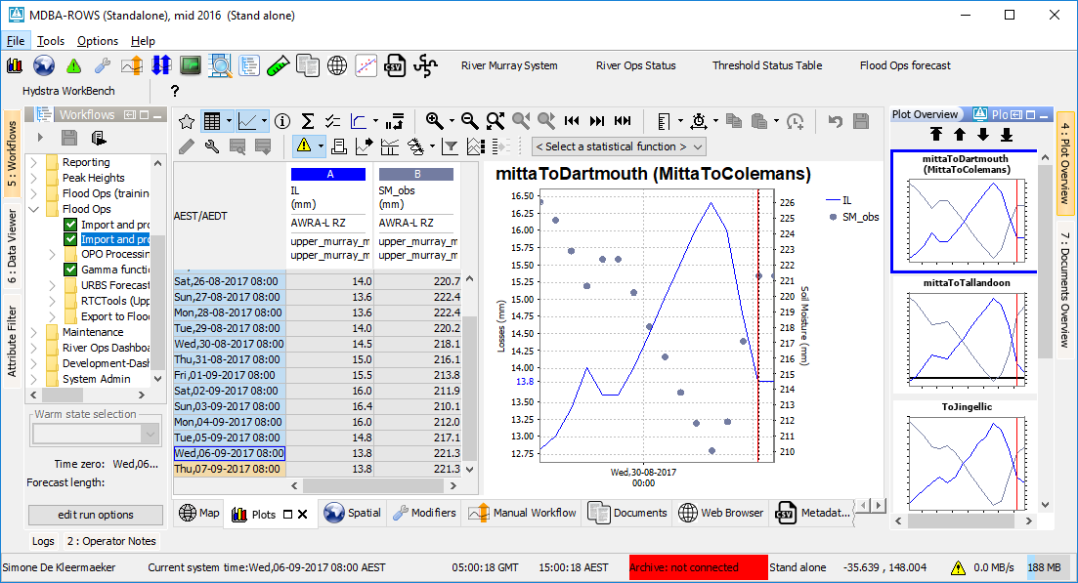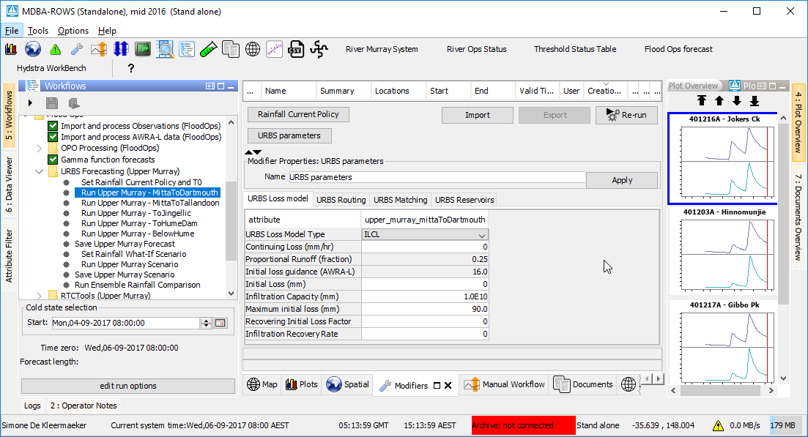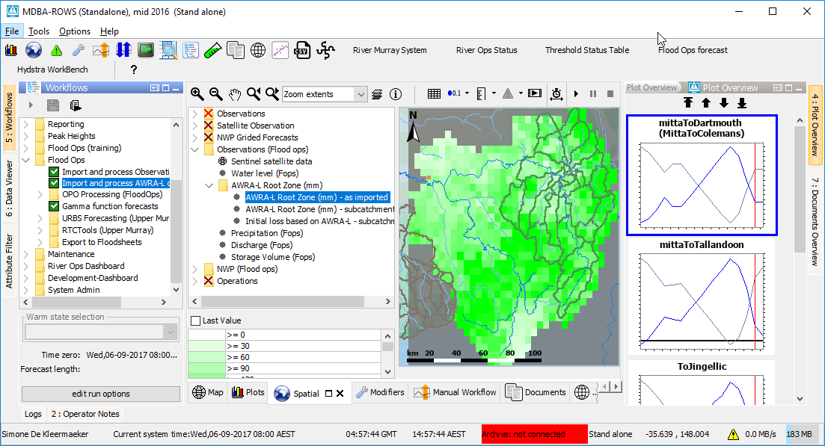

* This modifier (like the others) is passed on to URBS through the .ini file (see Modules folder).