|  |  |
| --- | --- |
| How to | D:\projecten\1210326 MDBA ROWS (local, See N)\C. Report - advise\Workshops\2015-02 workshop 3 UAT, end user training\Screenshots\DELTARES_ENABLING_RGB.pngModifiers advice |
| Description | Advice when modifying URBS model parameters or other modifiers |
| Comments | *italic* phrases taken from the book “Flood Forecasting: a Global Perspective”.  Please be aware that the screenshots may deviate slightly from the application |
| version | 2016-01 |

See HowTo\_URBS\_URBSParameters for more detailed information on how and when to use URBS model parameter modifiers.

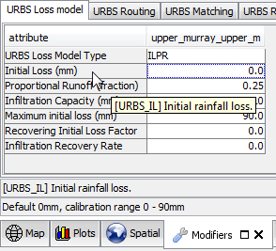

Within the Modifiers display, for each modifier advice (when available) will be visible on the left bottom of the screen.

When you hover over a modifier, the attribute id and description will appear. This same information is also displayed in the left bottom of the corner of the modifiers display.

**Furthermore, please refer to the Calibration summary reports for each subcatchment for the recommended value for most of the URBS model parameters (based on the performed calibration).**