|  |  |
| --- | --- |
| How to | FloodOps– Generate unit hydrograph |
| Description | How to generate a unit Hydrograph based on the Gamma function |
| Comments | “quotes” refer to the screenshots, which may deviate from the application |
| version | 2018-02 |

  
A Unit Hydrograph with an hourly timestep can be generated by use of the so-called gamma function. This series is currently not exported or used but can inform the forecasting process.

1. Select Workflows > Flood Operations > Gamma function forecast
2. In the Modifier display, modify the parameters as required:
   1. Peak Q: Peak flow [ML/day], is added to latest observation
   2. Peak timing: Timing peak flow [days from now]
   3. AREA: Catchment area [acres].
3. 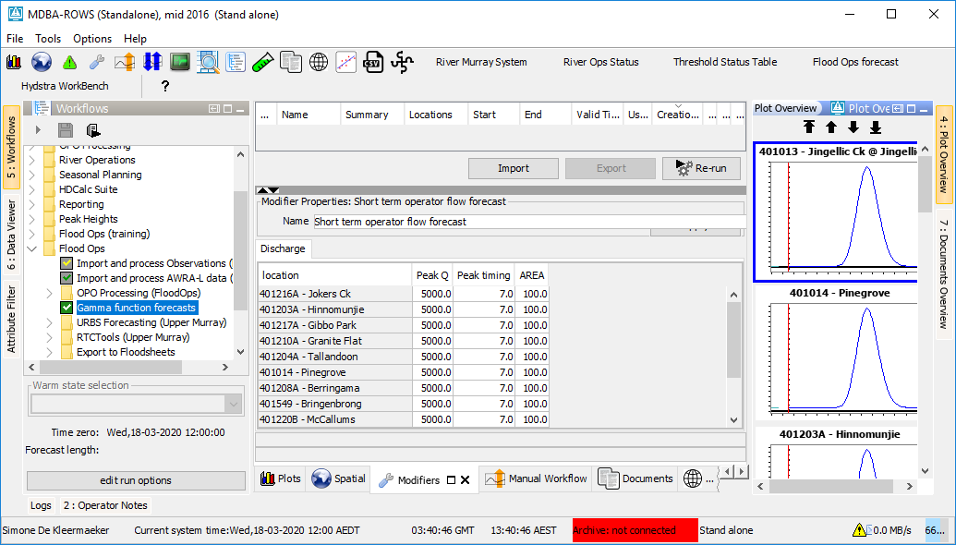Apply and (Re-)run the task, the unit hydrographs appear in the Plot Overview.

