|  |  |
| --- | --- |
| How to | D:\projecten\1210326 MDBA ROWS (local, See N)\C. Report - advise\Workshops\2015-02 workshop 3 UAT, end user training\Screenshots\DELTARES_ENABLING_RGB.pngWaterCoach – Create an training event |
| Description | Create an LDS from archived data and create script(s) for it |
| Comments | Please be aware that the screenshots may deviate slightly from the application |
| version | 2016-01 |

After you’ve downloaded data from the archive and imported in a Stand Alone application (see separate How\_To), you can create a WaterCoach event.

## Prepare localDataStore

1. Set system time to last available observation
2. Archive Processing – Processing all observation data using the archive post processing workflow  
   Process Forecast – Processing all NWP data in the 6-hour interval (select Batch forecast: start and end time). This is because the minimum time interval of the NWP data is 6 hours
3. 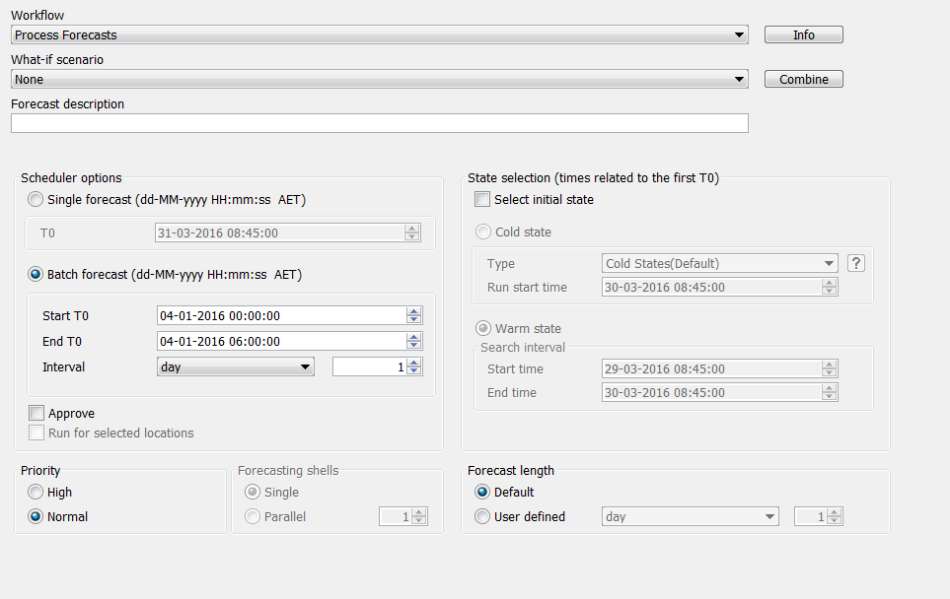Spend time checking your local data store in Spatial display – and be careful not to create any simulated data or modifiers by running a model.   
   Spot check every x hours (by changing current system time) if data is complete. It’s a check to see if the event was tagged properly  
   NOTE: Don’t run any models or create modifiers!!!!
4. Make a backup of your local data store and all the data for the water coach event!

## Integrate localDataStore in WaterCoach ScenarioScriptDatabase

1. Create a local ScenarioScriptDatabase folder on your local disk
2. Change reference to SSD in the global.properties to this local folder   
   (i.e. WATERCOACH\_SCENARIO\_DATABASE\_PATH)
3. Create a folder for the event in the SSD and copy your LDS there   
   (e.g. <scenario\_name>/localDataStore/local.fdb)
4. Copy and rename one of the existing water coach scripts to start from  
   (e.g. <scenario\_name>/<script\_name>/script\_config.xml)
5. update "script\_config.xml", meaning startDate, StopDate  
   Don’t use displayStart when you’re still developing the script, this will only be confusing.  
   When you add displayStart you could use the date and start time of the training, to keep the watercoach / fews time in check with the wall clock time.