|  |  |
| --- | --- |
| How to | D:\projecten\1210326 MDBA ROWS (local, See N)\C. Report - advise\Workshops\2015-02 workshop 3 UAT, end user training\Screenshots\DELTARES_ENABLING_RGB.pngWaterCoach – Set-up |
| Description | How to set-up a training environment |
| Comments | Please be aware that the screenshots may deviate slightly from the application |
| version | 2016-01 |

The WaterCoach needs to be run with Delft-FEWS 2016.01 or up.

## WaterCoach set-up

Since Delft-FEWS 2016.01 WaterCoach is embedded in Delft-FEWS. This means that a WaterCoach display is added to the configuration. In line with the current use of permissions, this display will have permission “WaterCoach”, accessible by all Forecasters. The user can toggle the WaterCoach display on and off via the Permissions menu.

WaterCoach makes use of canned data (i.e. localDataStores or LDS) from old events and scripts tailored to these events, with associated files. These files are stored in a folder structure referred to as the scenarioScriptDatabase (SSD), which can be stored in a central location (i.e. network drive). At the start of the WaterCoach session, the necessary LDS is copied to the SA system as part of standard WaterCoach functionality. The script and associated files are not copied locally, but accessed over the network during the training session.

To be able to send through messages from the script, a logging category “WaterCoch” needs to be added to Log4jConfig.xml. This means this file differs between the client and the stand alone WaterCoach application.

## WaterCoach participant mode

At the moment, the participant mode is not relevant for MDBA. This might change in the future.

WaterCoach can be run in participant mode, to replicate a live system better. In this mode, all participants connect to the localDataStore of the master application. The participant application now acts as an operator client, with the master application being the centralDataBase. Any tasks run “on server” in a participant, will be visible to all.

To run WaterCoach in participant mode, the master application needs to start a vjdbc server. This can be started manually via the F-12 menu of Delft-FEWS. The vdjbc server requires port access through the firewall.

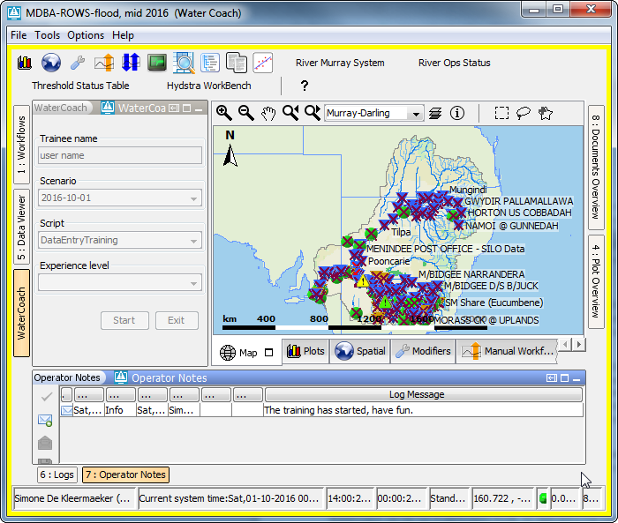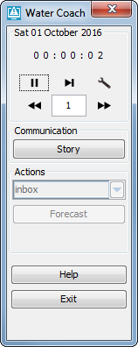To connect to WaterCoach in participant mode, the participants have to know the name of the computer on which the Master is running, as well as the port that is used for the vjdbc-server. This information can be communicated by the trainer via email after the master application has been started. Currently, this information needs to be added to the clientConfig.xml of the participant.