How to | Test document
Description | Step by step description of how to perform a specific task in ROWS.
Comments | The italic phrases correspond to the red markings in the screenshots. Please be aware that the screenshots may deviate slightly from the application
version | 2015-02


Model Initialization
URBS is a semi-distributed, event based, non-linear network model which has been incorporated into the FEWS flood modelling platform for the real time operation. The following are the steps for the model initialization.
Steps:
- Select an event start date 2 days before the onset of any rainfall.
- Select an initial baseflow value for Dartmouth and Hume Dam such that you get a fit to the observed water level in either dam using the baseflow values (See Figure 1.1 and 1.2). Adjust if necessary.
- Select an Initial Loss (IL) value based on the AWRA root zone moisture content on the event start day. (See Figure 2.1, 2.2, 2.3, 2.4 for IL estimation over Mitta Mitta to Colemans, Mitta Mitta to Tallandoon, To R_jingellic and Below Hume sub-catchment respectively)
- As rain starts to fall and water levels start to rise, adjust the adopted initial loss value if necessary from (c) to get a better fit to the observations.
- Item (d) may need to be repeated as more rain occurs.
* Recommended routing parameter values are provided in Table 1.0.

Figure 1.1: Initial Dartmouth Dam Baseflow
Figure 1.2: Initial Hume Dam Baseflow
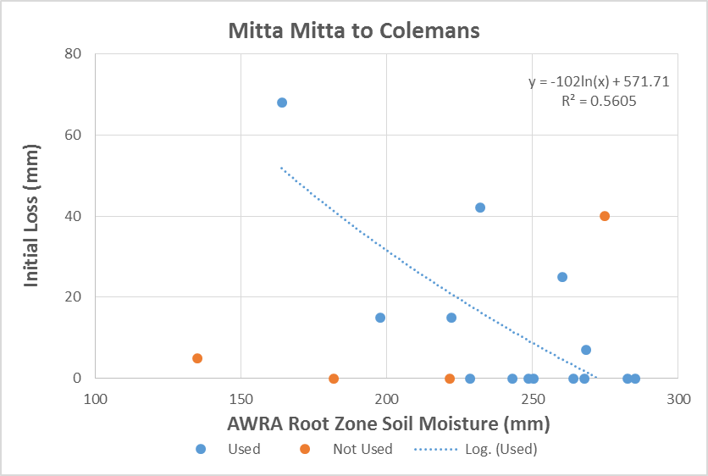
Figure 2.1: Initial Loss estimation from AWRA RZSM over “Mitta Mitta to Colemans” sub-catchment.
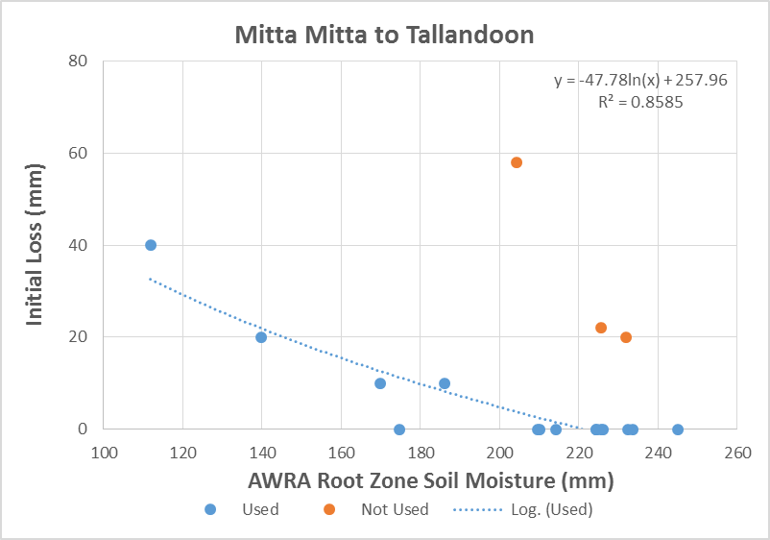
Figure 2.2: Initial Loss estimation from AWRA RZSM over “Mitta Mitta to Tallandoon” sub-catchment.
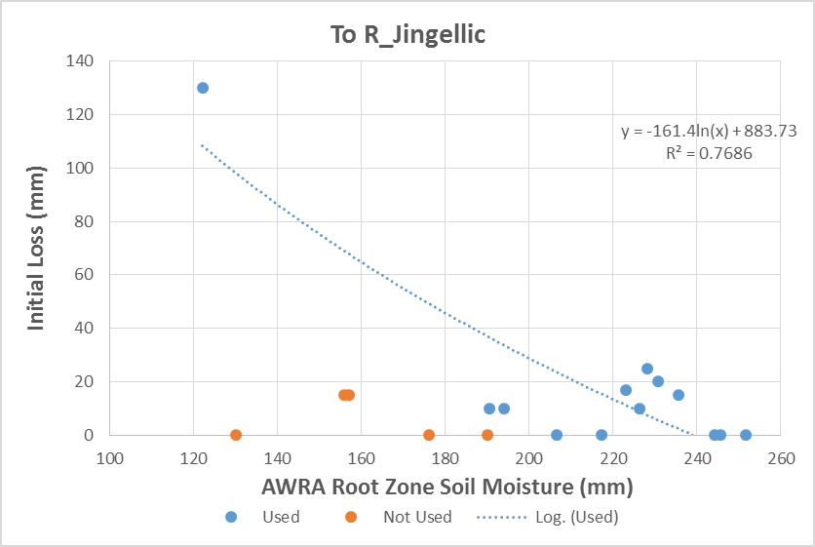
Figure 2.3: Initial Loss estimation from AWRA RZSM over “To R_Jingellic” sub-catchment.
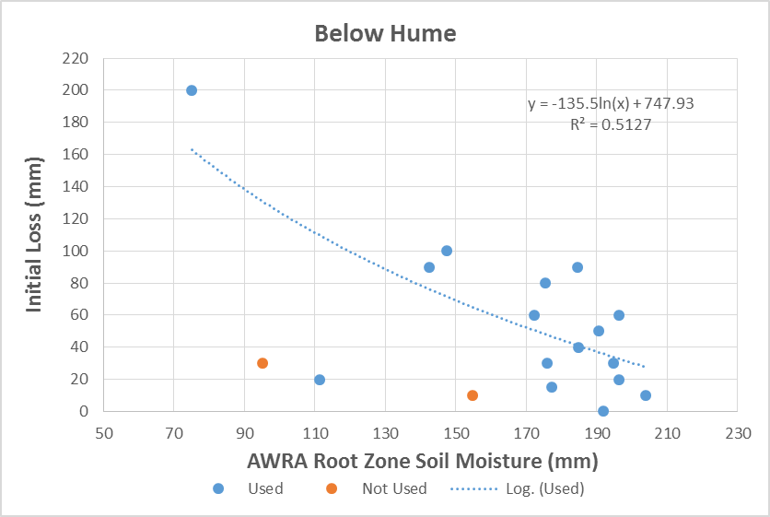
Figure 2.4: Initial Loss estimation from AWRA RZSM over Below Hume Dam sub-catchment.
Table 1.0: Recommended routing parameters for the model shown in the table below.
Model | Channel Routing (α) | Sub-area routing (β) | Sub-area routing exponent (m)
Mitta Mitta to Colemans | 0.27 | 4.0 | 0.8
Mitta Mitta to Tallandoon | 0.27 | 4.0 | 0.8
To R_Jingellic | 0.30 | 4.0 | 0.8
To Hume | 0.25 | 4.0 | 0.8
Below Hume | 0.36 | 4.3 | 0.8

