5/30/18 - was able to create the home page but am working on its design right now. able to decide whether it should be arrows or boxes and decided to do a 9 digit grid which will randomly choose between 1 and 9 to place in each slot and then the user clicks the matching boxes to match the pattern. this will increase the difficulty.

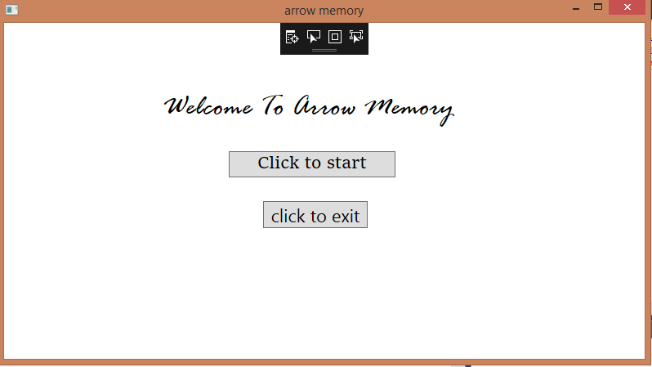

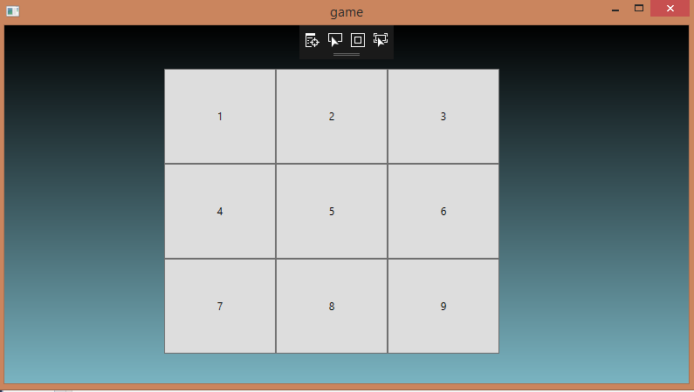

6/4/18 - working on the grid design for the numbers 1-9 will make it so they have infinite time to enter the pattern. first want it to display a glow behind the selected pattern number before i work on user input.