Homework/Assignment #2: Distributed Systems
Name: Bolando john lawrence Date9/20/2025:
Course:BSIT-3
Subject:

Instructions: Answer the following questions and complete the tasks. Be clear, concise, and provide examples where necessary.
Part A: Short Answer Questions
- Define distributed computing in your own words and explain its main purpose.
distributed computing is when multiple networked computers work together to accomplish a single task

- List and briefly explain four advantages of distributed systems. Provide an example for each.
- Resource Sharing
  - Computers in a distributed system can share hardware, software, and data. This eliminates the need for every machine to have all resources installed locally.
  - Example: Google Drive allows users to access shared files stored on distributed servers from any device.

- Scalability
  - Distributed systems can easily expand by adding more machines (nodes) to handle growing workloads without major redesigns.
  - Example: Amazon Web Services (AWS) scales up or down automatically to meet demand for applications like Netflix streaming.

- Fault Tolerance & Reliability
  - Even if one machine fails, the system continues running by redistributing tasks to other nodes. This ensures high availability.
  - Example: Banking systems use distributed databases so that transactions are processed reliably even if one server goes down.

- Performance Improvement (Speed)
  - Tasks are divided among multiple computers, allowing parallel processing that speeds up execution of complex problems.
  - Example: Scientific simulations (like weather forecasting) run on distributed supercomputers to process massive calculations faster.

- Differentiate between client-server and peer-to-peer models in terms of:
- Control
- Scalability
- Reliability
The client-server model and the peer-to-peer (P2P) model differ mainly in control, scalability, and reliability. In the client-server model, control is centralized, with a server managing resources and clients depending on it. For example, Facebook’s servers handle user data. In contrast, P2P is decentralized, where peers share resources directly, as seen in BitTorrent. In terms of scalability, client-server systems can become overloaded as more clients join, while P2P networks become stronger since each new peer adds resources. Lastly, client-server models are less reliable because if the server fails, the whole system may crash, like Gmail during server downtime. P2P systems, however, are more reliable, since the network continues to function even if some peers drop out, as in blockchain networks.

- Explain the role of middleware in distributed systems. Why is it often called the 'glue' of distributed computing?
Middleware in distributed systems is software that sits between the operating system and the applications running on different machines in the network. Its main role is to provide a common platform and services—such as communication, data exchange, authentication, and resource management—that allow distributed components to work together seamlessly as if they were part of a single system.

- Provide two real-world examples of distributed systems you use daily and describe which architecture (client-server or P2P) they follow.
1. Google Search / Gmail
- Architecture: Client-Server
- Explanation: When you use Google Search or Gmail, your device acts as the client while Google’s servers store, process, and deliver the information. All requests go through powerful centralized servers, which manage billions of queries and emails securely.

2. BitTorrent File Sharing
- Architecture: Peer-to-Peer (P2P)
- Explanation: When downloading a file using BitTorrent, there is no central server holding the entire file. Instead, pieces of the file are shared directly among peers. Each peer can be both a downloader (client) and uploader (server), making the system highly scalable and resilient.

Part B: Comparative Task
Create a comparison chart showing at least 5 differences between client-server and peer-to-peer architectures. Use examples to support your answer.
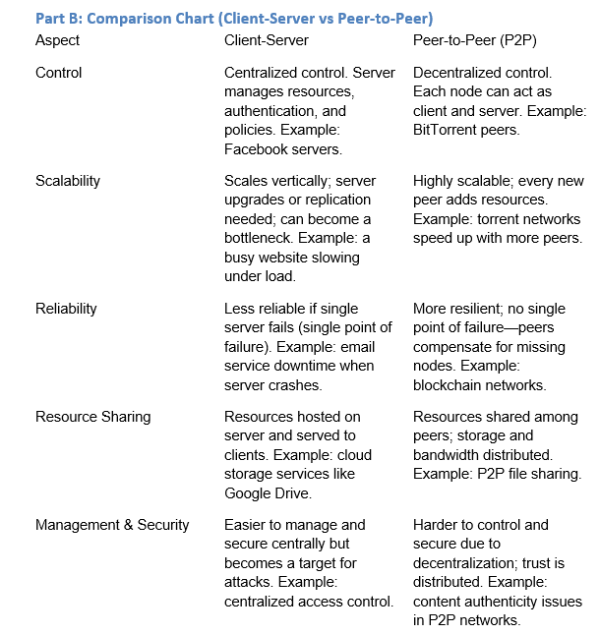
Part C: Applied Research Task
1. Research one type of middleware technology (e.g., RabbitMQ, Kafka, gRPC, or ODBC).
- What is it used for?
Apache Kafka is an open-source distributed event-streaming platform used to build real-time data pipelines and streaming applications. It is designed for high-throughput, low-latency ingestion and processing of continuous event data.

- How does it help in communication between distributed components?
Kafka acts as a durable, distributed log: producers publish events to topics and consumers read them independently. This decouples services (producers and consumers need not be online at the same time), provides buffering, allows event replay, and supports fault-tolerant, scalable message delivery — making reliable asynchronous communication between distributed components possible.
- Provide a practical example of its use in industry.
Large companies such as LinkedIn, Netflix, Uber and others use Kafka for activity tracking, inter-service communication in microservices architectures, metrics collection, and real-time analytics. LinkedIn originally developed Kafka for activity stream processing and many organizations now use Kafka as their messaging backbone.
2. Imagine you are tasked to design a distributed system for a university online library.
- Which architecture (client-server or peer-to-peer) would you choose? Why?
I would choose the client-server architecture.
The main reason is that a library system requires centralized control and consistency. All the books, journals, and student records must be stored securely in one place and managed according to university rules. With client-server, the university’s servers hold the digital library resources, while students and faculty access them as clients. This ensures that data is accurate, policies like borrowing limits are enforced, and access is restricted only to authorized users.

- How could middleware be applied in your design?
In designing a distributed system for a university online library, middleware would play a crucial role in ensuring smooth communication and integration between different components of the system. Middleware acts as the connecting layer between clients and backend services, making the system function seamlessly as one unit despite its complexity.

Part D: Reflection
In a short paragraph (5–7 sentences), explain:

- Why distributed systems are important in today’s digital world.
Distributed systems are important in today’s digital world because they allow applications and services to be scalable, reliable, and efficient. By spreading tasks across multiple computers, they can handle millions of users, process vast amounts of data, and ensure services remain available even if some machines fail.
- What new insight you learned from this topic that surprised you the most.
The new insight that surprised me the most is how middleware plays such a vital role in distributed systems. I learned that it acts as the “glue” that connects different components, allowing them to communicate and work together seamlessly.

Submission Guidelines
- Typewritten, 2–3 pages in length. You can use this template for your answer.
- Include your name, course, and date.
- Submit in Word format via Google Classroom.

