LABORATORY EXERCISE 3

ROUTING AND MVC STRUCTURE

Learning Objectives
By the end of this laboratory exercise, students should be able to:
- Understand CodeIgniter's MVC (Model-View-Controller) architecture and routing system.
- Configure custom routes in `app/Config/Routes.php`.
- Create a controller with multiple methods and their corresponding views.
- Implement navigation between pages in a CodeIgniter application.
- Utilize GitHub to track and manage project versions.

Prerequisite student experiences and knowledge
Before starting this exercise, students should have:
- Basic knowledge of HTML, CSS, and PHP.
- Familiarity with CodeIgniter's file structure.
- Experience using a local web server (XAMPP/WAMP/LAMP).
- Understanding of basic Git commands and GitHub usage.
- Ability to use a text editor/IDE such as Visual Studio Code.

Background
CodeIgniter follows the MVC architecture, separating application logic into Models, Views, and Controllers. Routing in CodeIgniter determines which controller and method are executed based on the URL. Understanding how to set up routes and navigate between pages is essential for building dynamic and maintainable applications. GitHub will be used for version control and documenting each stage of development.

Materials/Resources
- Personal Computer with Internet Access
- XAMPP/WAMP/LAMP server installed
- CodeIgniter Framework (latest version)
- Visual Studio Code or any code editor
- Git and GitHub Account
- Web Browser (Chrome, Firefox, etc.)
Laboratory Activity
Step 1: Project Setup
- Open your previously created CodeIgniter project ITE311-LASTNAME.
- Run the local server and confirm the project is working: http://localhost/ITE311-LASTNAME

Step 2: Create a Home Controller
- Navigate to app/Controllers/ and create a file named Home.php.
- Add the following methods:
  - index() → Loads a homepage.
  - about() → Loads an about page.
  - contact() → Loads a contact page.

Step 3: Configure Routes
- Open `app/Config/Routes.php`.
- Add custom routes for:
  - `/` → `Home::index`
  - `/about` → `Home::about`
  - `/contact` → `Home::contact`

Step 4: Create Views
- Inside `app/Views/`, create:
  - `index.php` (Homepage)
  - `about.php` (About Page)
  - `contact.php` (Contact Page)
- Add navigation links between the pages in each view using HTML anchor tags.

Step 5: Test Navigation
- Run the application and test:
  - Homepage → About → Contact
- Ensure that the navigation works correctly and each page displays its content.

Step 6: Push to GitHub
- Stage and commit your migration and seeder files:
git add .
git commit -m "Added Home controller, routes, and views for basic navigation"

Output / Results
- Screenshot of the homepage, about page, and contact page.
- Screenshot of `Routes.php` configuration.
- A screenshot of the GitHub repository with the latest commit is attached.

QUESTIONS:
- Explain the role of the controller in CodeIgniter's MVC structure.

In CodeIgniter’s MVC structure, the controller acts as the middleman between the model and the view. It receives the user’s request, processes it, and decides what to do next. If data is needed, the controller communicates with the model, then passes the information to the view for display. It also handles application logic such as validation and redirection. In short, the controller directs the flow of the application, making sure the model and view work together smoothly.

- Why is routing important in a web application?

Routing is important because it maps URLs to the correct controllers and methods, making web applications more organized, secure, and user-friendly.

- How does GitHub help in tracking changes in your CodeIgniter project?

GitHub helps in tracking changes in a CodeIgniter project by storing the project’s version history. Every update or modification is saved as a commit, allowing developers to review past changes and restore previous versions if needed. It also makes collaboration easier, since multiple developers can work on the same project while keeping track of who made specific changes. This ensures better project management, teamwork, and accountability.

Output / Results
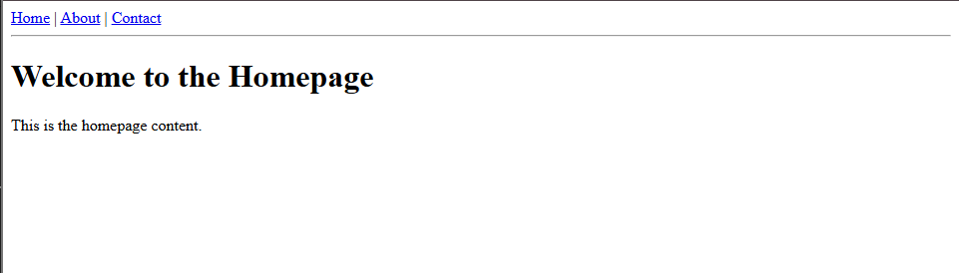



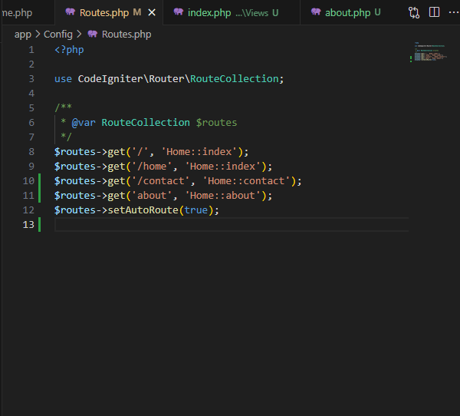

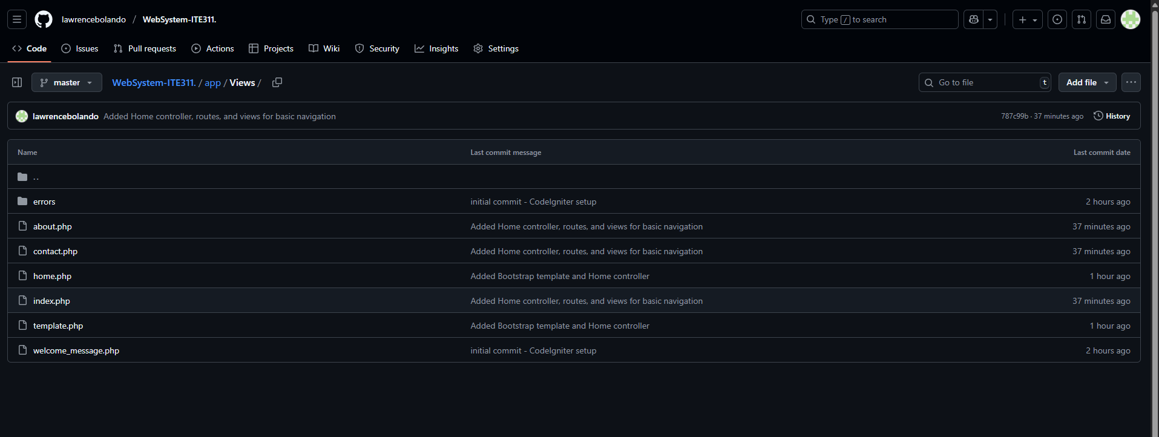

Conclusion
In conclusion, building a CodeIgniter project with proper controllers, routing, and views demonstrates the importance of MVC in organizing web applications. Using GitHub ensures version control and smooth collaboration, while routing provides clean navigation for users. Altogether, these tools and practices make development more efficient, secure, and manageable.

