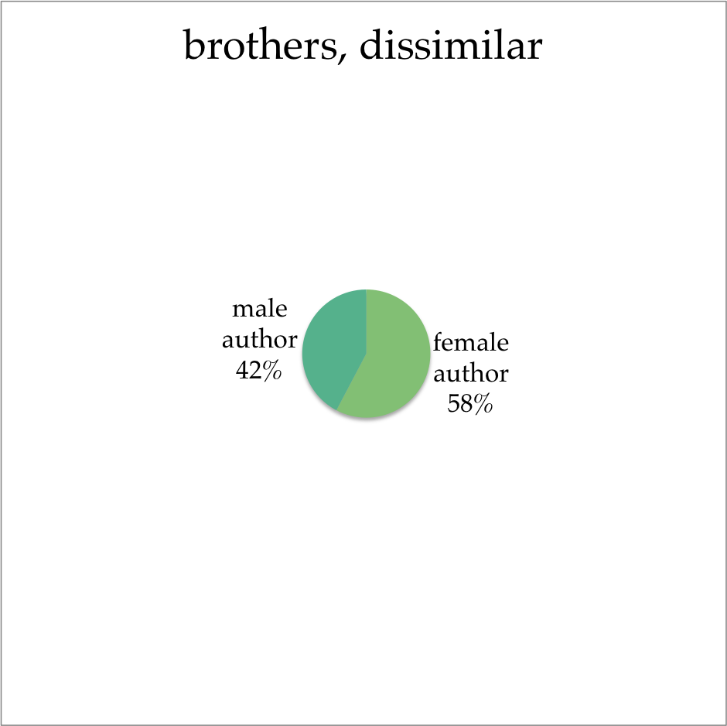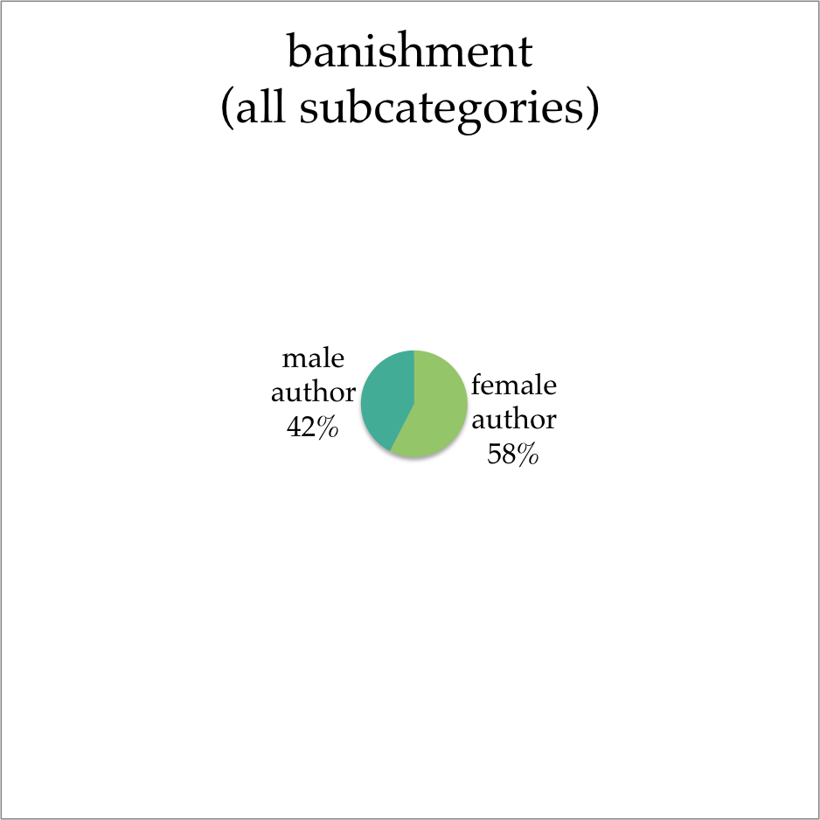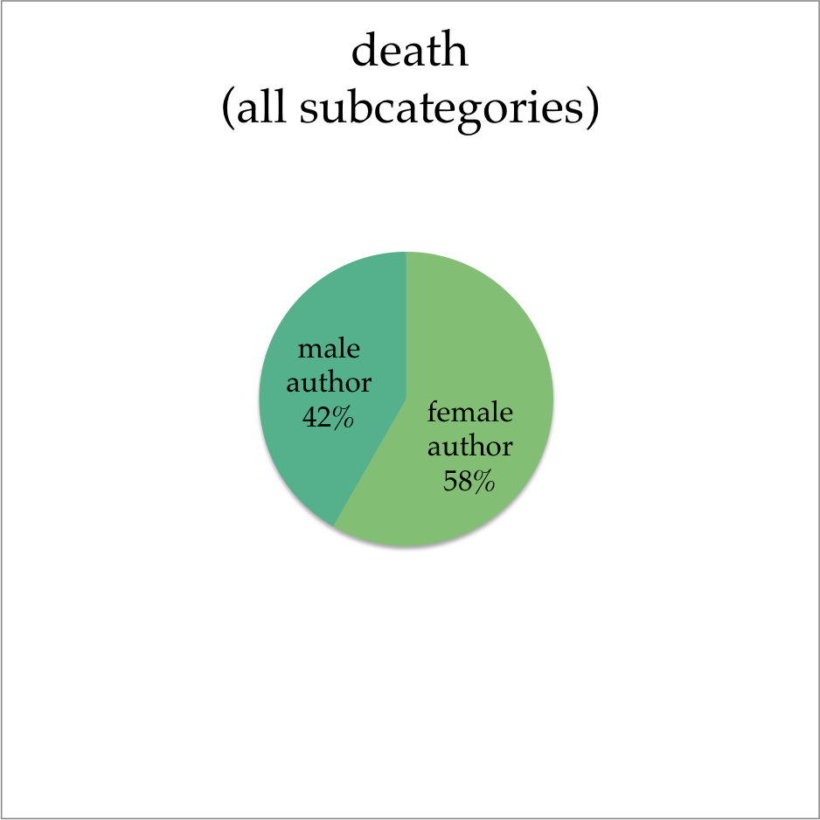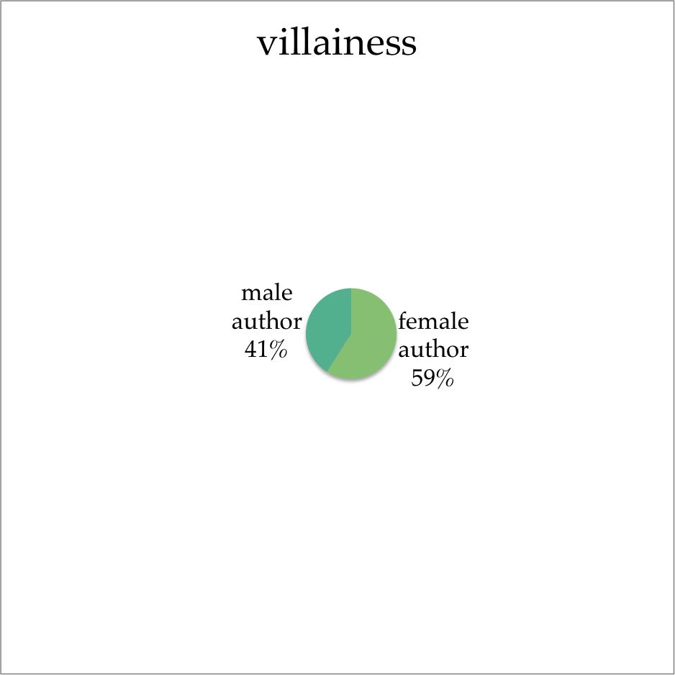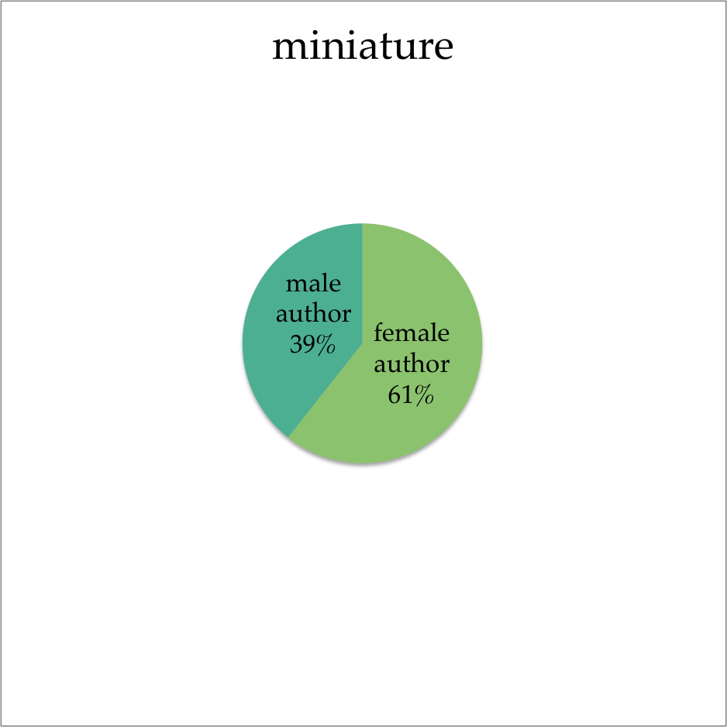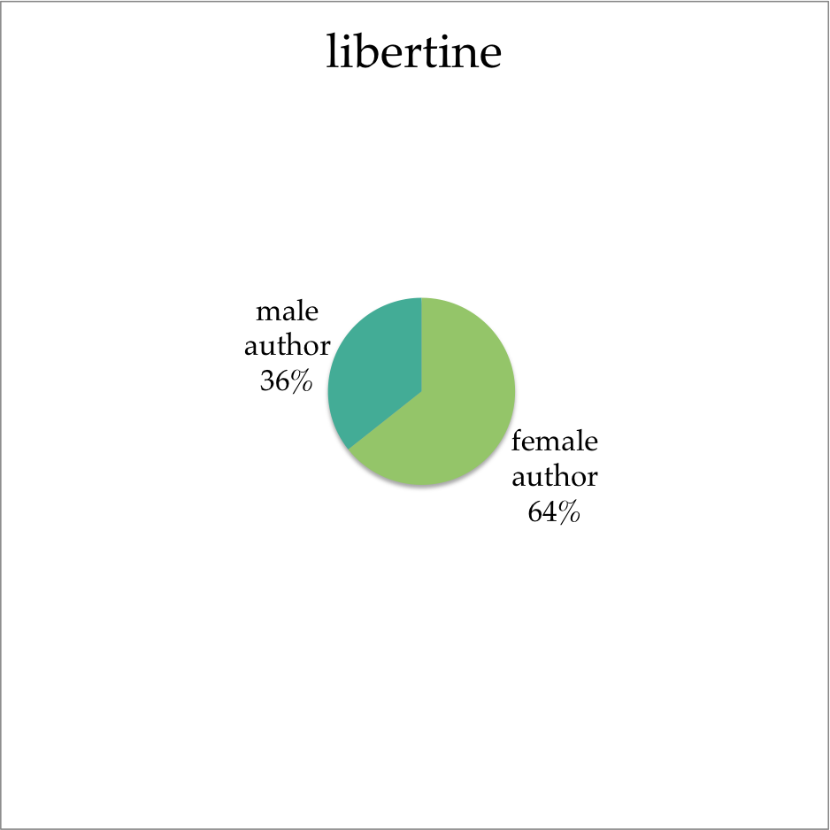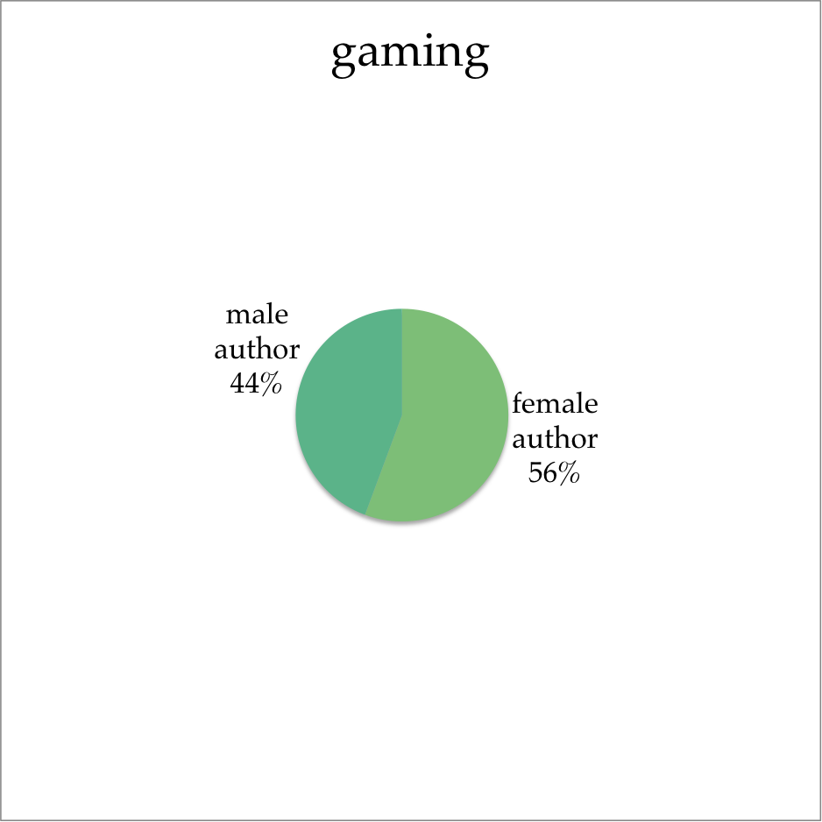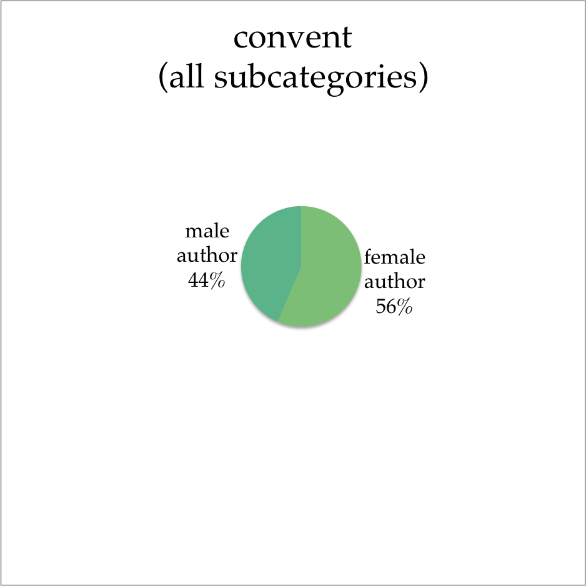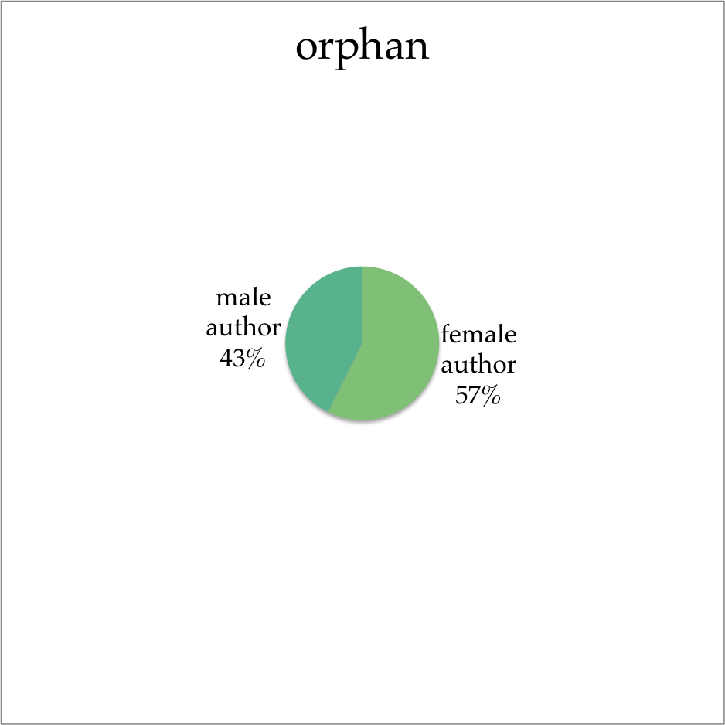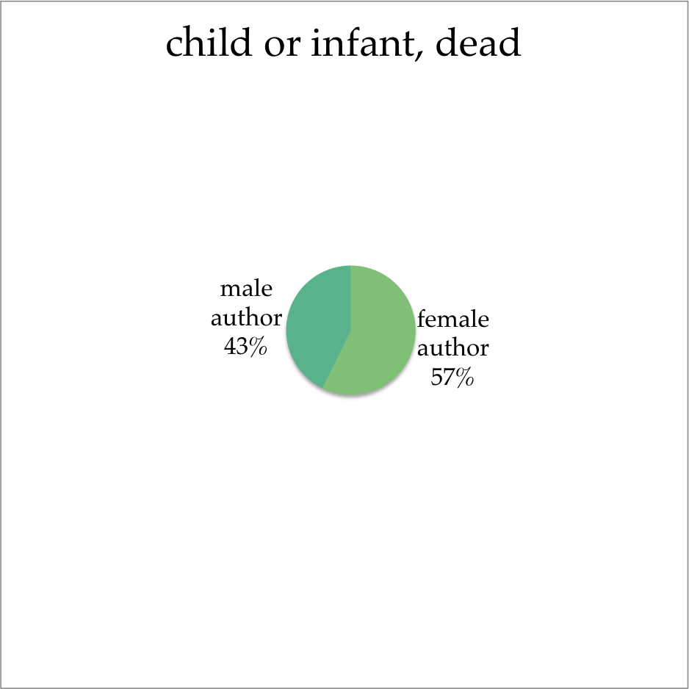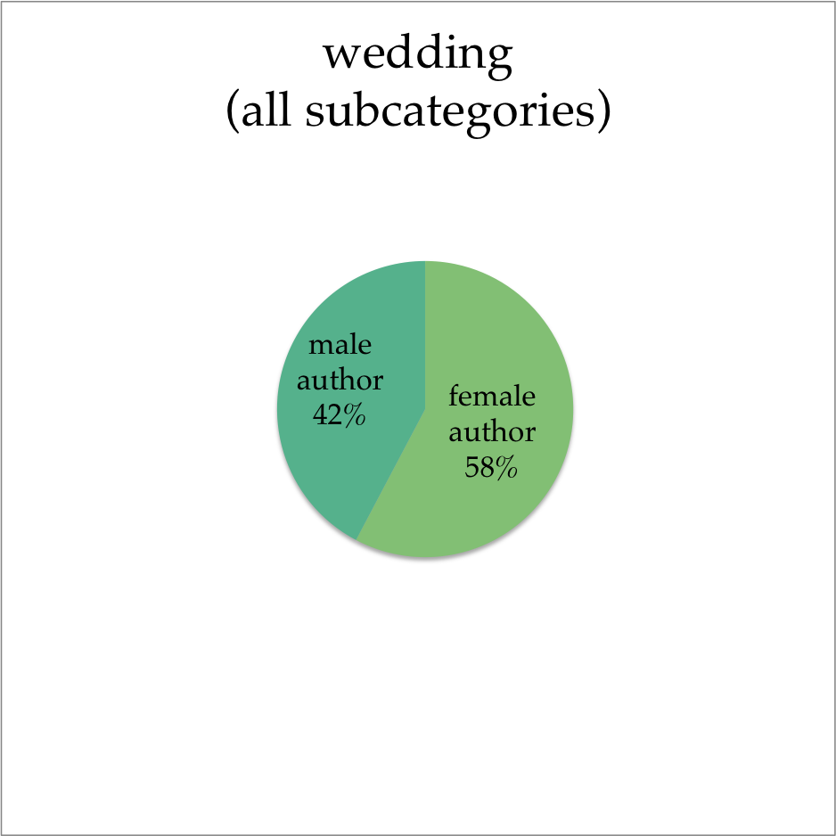

**Figure 6**: gendered authorship of books containing death (emotionally induced, pre-nuptial, or sad/pious).

**Figure 4**: gendered authorship of books containing banishment (legal and extralegal).

**Figure 2**: gendered authorship of books containing miniature portraits.

**Figure 3**: gendered authorship of books containing villainesses.

**Figure 1**: gendered authorship of books containing libertines.

**Figure 5**: gendered authorship of books containing dissimilar brothers.

**Appendix A: Motif Charts**

**Figure 10**: gendered authorship of books containing convents (corrupt, escape from, eviction from, as haven, as prison).

**Figure 8**: gendered authorship of books containing dead children or infants.

**Figure 7**: gendered authorship of books containing weddings (aborted, clandestine, counterfeit, forced, interrupted, by specter clergyman).

**Figure 11**: gendered authorship of books containing gambling.

**Figure 9**: gendered authorship of books containing orphans.

Figure 1: male vs female authorship of books containing libertines.

Figure 1: male vs female authorship of books containing libertines.

Figure 1: male vs female authorship of books containing libertines.

Figure 1: male vs female authorship of books containing libertines.

Figure 1: male vs female authorship of books containing libertines.

Figure 1: male vs female authorship of books containing libertines.

Figure 1: male vs female authorship of books containing libertines.

Figure 1: male vs female authorship of books containing libertines.

Figure 1: male vs female authorship of books containing libertines.

Figure 1: male vs female authorship of books containing libertines.

Figure 1: male vs female authorship of books containing libertines.

Figure 1: male vs female authorship of books containing libertines.

Figure 1: male vs female authorship of books containing libertines.

Figure 1: male vs female authorship of books containing libertines.

Figure 1: male vs female authorship of books containing libertines.

Figure 1: male vs female authorship of books containing libertines.

Figure 1: male vs female authorship of books containing libertines.

Figure 1: male vs female authorship of books containing libertines.

Figure 1: male vs female authorship of books containing libertines.

Figure 1: male vs female authorship of books containing libertines.

Figure 1: male vs female authorship of books containing libertines.

Figure 1: male vs female authorship of books containing libertines.

Figure 1: male vs female authorship of books containing libertines.

Figure 1: male vs female authorship of books containing libertines.

Figure 1: male vs female authorship of books containing libertines.

Figure 1: male vs female authorship of books containing libertines.

Figure 1: male vs female authorship of books containing libertines.

Figure 1: male vs female authorship of books containing libertines.

Figure 1: male vs female authorship of books containing libertines.

Figure 1: male vs female authorship of books containing libertines.

Figure 1: male vs female authorship of books containing libertines.