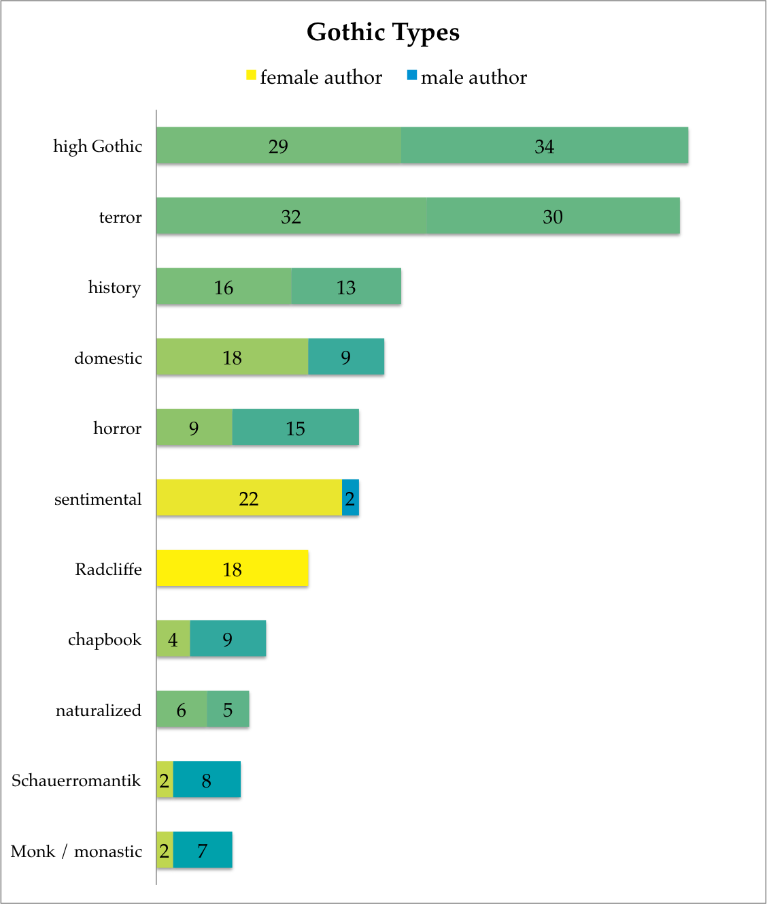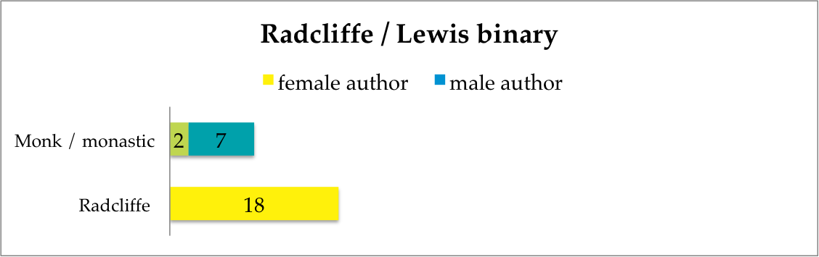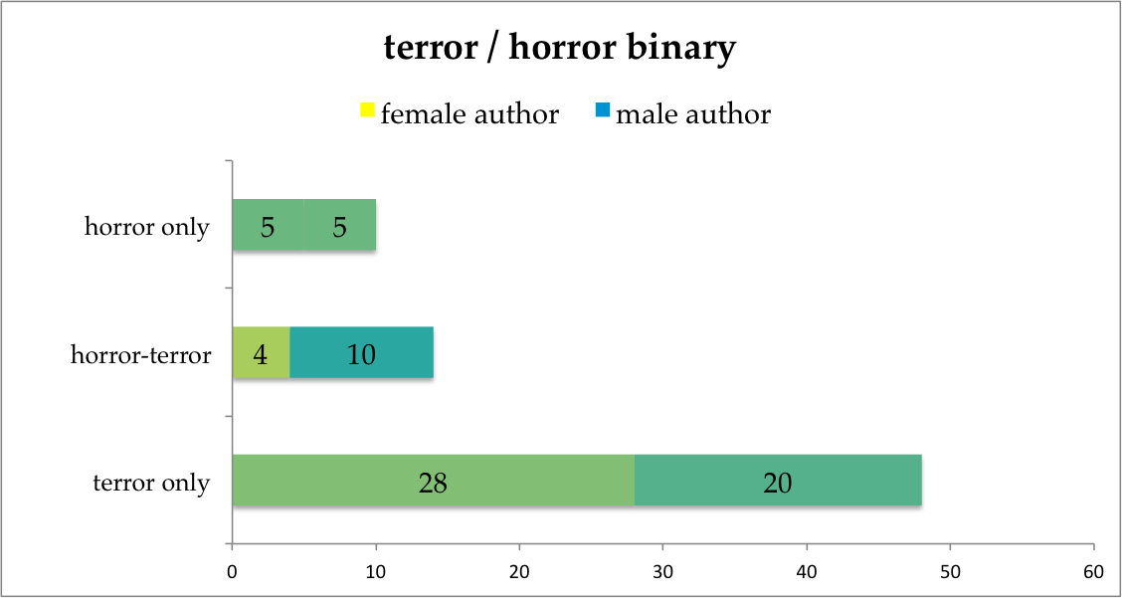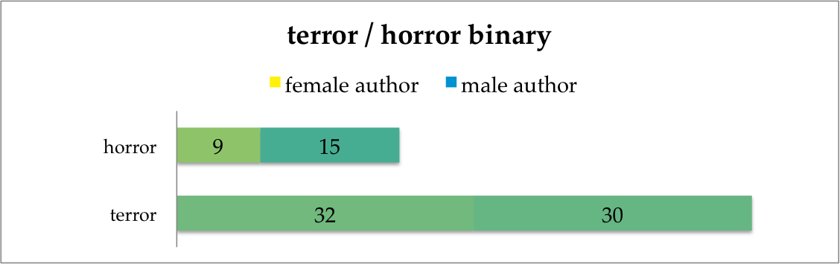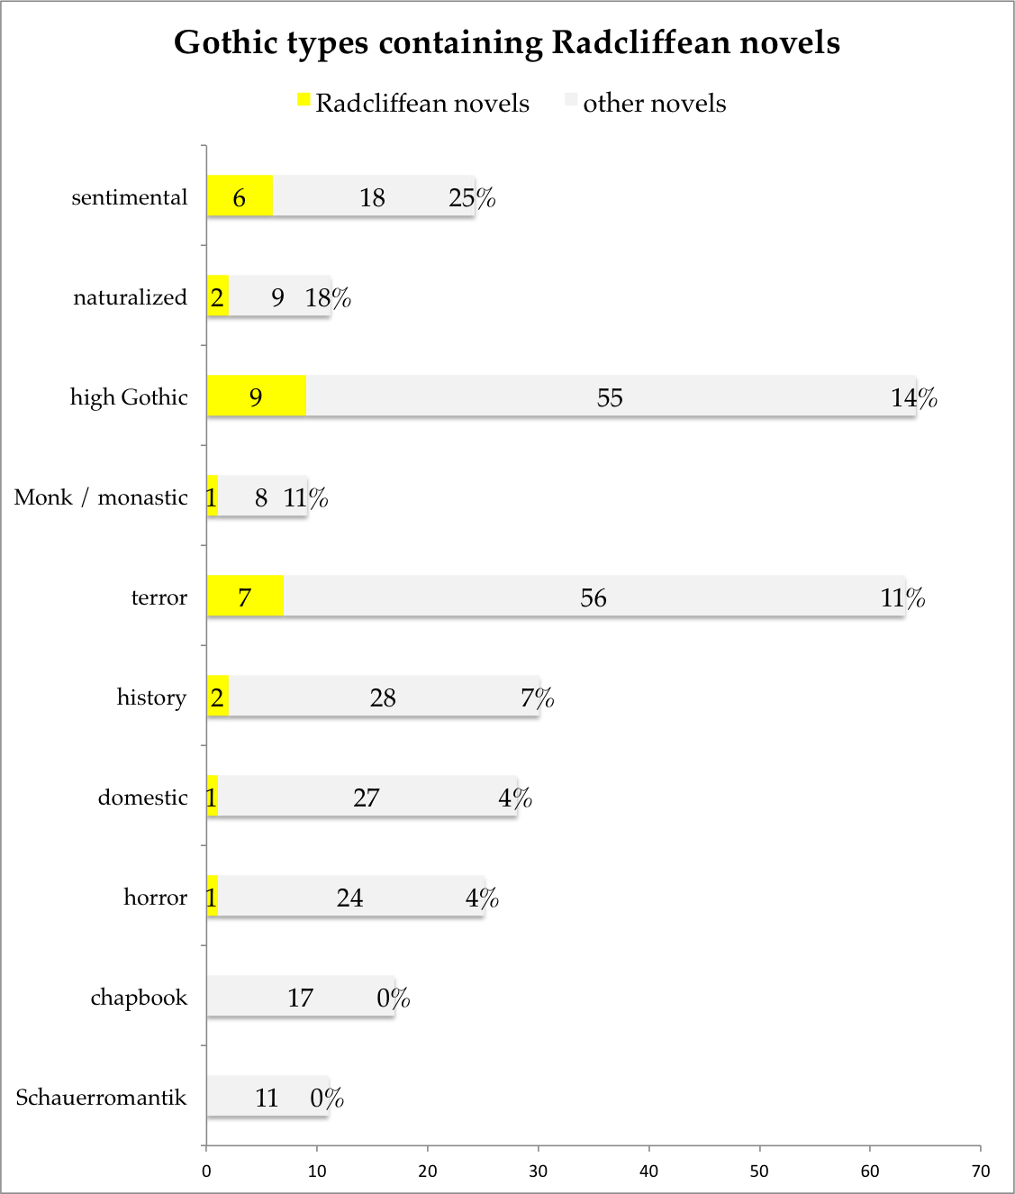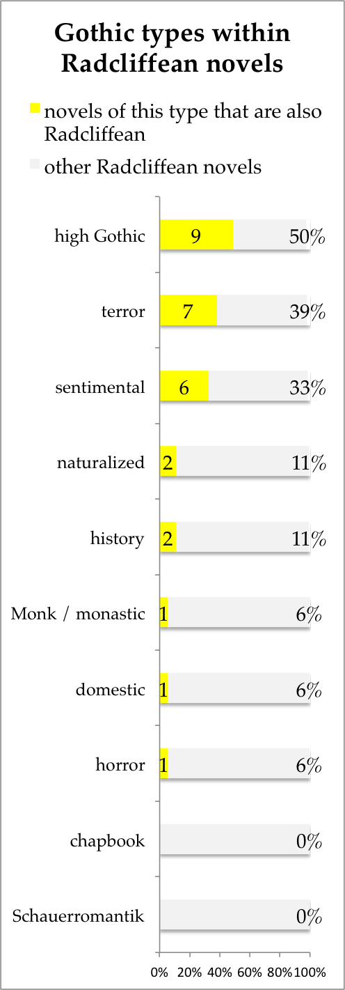

**Figure 95**: Gendered authorship of the eleven most popular Gothic types. Note that Gothic types are not mutually exclusive, so that, e.g., the ‘terror’ Gothic and the ‘high Gothic’ sets may refer to many of the same books.

**Appendix B: Frederick Frank’s Genre Types**

**Figure 98**: The same data on gendered use of Gothic types as in Figure 95, but placing Ann Radcliffe’s and Matthew Lewis’s ‘schools’ in proximity for comparison.

**Figure 97**: Gendered authorship of horror and terror, this time treating horror and terror as mutually exclusive. The fourteen books described as operating in both modes are no longer counted twice, but instead form a new category.

**Figure 96**: The same data on gendered use of Gothic types as in Figure 95, but placing horror and terror in proximity for comparison.

**Figure 99**: The most common Gothic types, arranged according to the percentage of novels of each type which are also tagged as Radcliffean. If we know, for example, that we have a ‘history’ Gothic novel, we also know that there is only a 7% chance that this novel is Radcliffean.

**Figure 100**: The most common Gothic types, arranged according to their prevalence within the eighteen Radcliffean novels.